1. **Introduction**

The **Online Blood Donor's Database Management System** is a comprehensive and meticulously designed platform dedicated to addressing a critical need in healthcare – the availability of safe and timely blood donations. This system is not just an interface; it's a lifeline, connecting donors and blood requesters (Members) in need in a seamless, secure, and efficient manner.

The fundamental objectives of this system go beyond merely providing a web interface. It's about creating a culture of voluntary blood donation and ensuring that life-saving blood is readily available to those facing medical emergencies.

* 1. **Key Highlights**
* **User Interface:** At the heart of this system is a captivating homepage, replete with motivational quotes, a user-friendly navigation bar, and swift access to vital sections. The user segmentation feature tailors the experience for Blood Donors, Blood Requesters (Members), and Administrators, ensuring that everyone finds what they need with ease.
* **User Registration:** The process of becoming a registered user, whether as a Blood Donor or a Blood Requester (Member), is not just a formality. It involves stringent verification procedures, including One-Time Password (OTP) validation, to safeguard data and user identities.
* **User Features:** Once registered, users gain access to a spectrum of features, allowing them to manage their profiles, search for potential donors based on specific criteria, and initiate contact seamlessly. It's about enabling interaction and making the process as hassle-free as possible.
* **Admin Features:** Behind the scenes, the administrator plays a pivotal role in maintaining the integrity of the system. The admin panel provides comprehensive oversight of all user activities, ensuring that the platform remains secure and responsive. The admin can also take action on reports and feedback to further improve the system.

This documentation is not just a list of technical details; it's a blueprint for building a system that has the potential to save lives. From the user interface to the admin's capabilities, this document serves as a guiding light for the development team, providing a clear path to creating a platform that encourages voluntary blood donation and delivers critical support during medical crises.

As we delve into the specific functionalities and requirements of the Online Blood Donor's Database Management System, we invite you to envision the real-world impact this system can have. It's not just software; it's a lifeline, connecting humanity and fostering a sense of responsibility towards each other.

1. **Objective and Scope of the Project**
   1. **Objective**

**The primary objective** of the Online Blood Donor's Database Management System is to create a robust and user-centric platform that fosters the crucial act of blood donation and fulfills the urgent blood requests of individuals in need. The overarching goal is to ensure a steady and readily accessible supply of blood for those facing medical emergencies.

* 1. **Scope**

The scope of this project encompasses the development of a comprehensive platform featuring a well-crafted user interface. It includes distinct user segmentation tailored for Blood Donors, Blood Requesters (Members), and the system's administrative role. The system is designed to streamline the registration process, offer user-specific features, and provide administrative tools to manage donor and requester activities efficiently.

**The project's scope covers the following key aspects:**

* **User Interface Design:** A visually engaging homepage with a navigation bar, motivational quotes, and clear links to specific user segments.
* **User Registration:** Registration functionalities for Blood Donors and Blood Requesters (Members), including user verification through OTPs.
* **User Features:** Tailored features for Blood Donors and Blood Requesters (Members) to interact, manage their profiles, and search for potential donors.
* **Admin Features:** Administrative tools to monitor and oversee user activities, including the ability to handle reports and ensure platform integrity.
* **Reporting and Management:** A robust reporting system that allows users to report any concerns or issues, promoting a safe and trustworthy environment.
* **User Verification and OTP Functionality:** Secure user verification and OTP functionality to maintain data integrity and security.
* **Secure Login and Profile Management:** Ensuring that user accounts and data remain secure and accessible only to authorized individuals.

The project's primary objective and comprehensive scope serve as the foundation for the development of the Online Blood Donor's Database Management System. The system's ultimate aim is to save lives and foster a culture of voluntary blood donation for the betterment of society.

1. **Theoretical Background**
   1. **Frontend**

The part of a website that the user interacts with directly is termed the front end. It is also referred to as the ‘client side of the application. It includes everything that users experience directly: text colors and styles, images, graphs and tables, buttons, colors, and a navigation menu. HTML, CSS, and JavaScript are the languages used for Front End development. Responsiveness and performance are the two main objectives of the Front End. The developer must ensure that the site is responsive i.e. it appears correctly on devices of all sizes no part of the website should behave abnormally irrespective of the size of the screen. **[1]**

* **HTML (Hypertext Markup Language)**

HTML stands for Hypertext Markup Language. It is used to design the front-end portion of web pages using a markup language. HTML is a combination of Hypertext and Markup language. Hypertext defines the link between web pages.**[1]**

* **CSS (Cascading Style Sheets)**

Cascading Style Sheets fondly referred to as CSS is a simply designed language intended to simplify the process of making web pages presentable. CSS allows you to apply styles to web pages.**[1]**

* **JavaScript**

JavaScript is a famous scripting language used to create magic on sites to make the site interactive for the user. It is used to enhance the functionality of a website to run cool games and web-based software. Applicable in both front-end and back-end, JavaScript is key to becoming a good developer.**[1]**

* **Bootstrap**

Bootstrap is a popular front-end framework that provides a collection of pre-designed HTML, CSS, and JavaScript components. It offers a responsive grid system, CSS styles, and interactive components such as buttons, forms, navigation menus, modals, and carousels. Bootstrap simplifies the process of building responsive and mobile-first websites by providing a consistent and customizable foundation. It utilizes CSS classes and JavaScript plugins to enhance the visual appearance and functionality of web pages.[2]

* **jQuery**

jQuery is a fast, lightweight, and feature-rich JavaScript library. It simplifies common JavaScript tasks, such as DOM manipulation, event handling, animation, and AJAX interactions. jQuery provides a concise syntax and a wide range of built-in functions that abstract away cross-browser inconsistencies. It allows developers to write less code and achieve the same results, increasing productivity and efficiency.[3]

* 1. **Backend**

The backend is the server side of the website. It stores and arranges data, and also makes sure everything on the client side of the website works fine. It is part of the website that you cannot see and interact with. It is the portion of software that does not come in direct contact with the users. The parts and characteristics developed by backend designers are indirectly accessed by users through a front-end application. Activities, like writing APIs, creating libraries, and working with system components without user interfaces or even systems of scientific programming, are also included in the backend.**[1]**

* **PHP (Hypertext Preprocessor)**

PHP is a popular server-side scripting language primarily used for web development. It is embedded within HTML code and executed on the server before the result is sent to the client’s web browser. PHP is known for its simplicity, flexibility, and wide community support. It can be used to generate dynamic web pages, handle form submissions, interact with databases, and perform various server-side tasks.**[4]**

* **MySQL**

MySQL is an open-source relational database management system (RDBMS). It is widely used for storing, managing, and retrieving structured data. MySQL follows the client-server model, where the MySQL server handles data storage and retrieval while client (e.g., PHP applications) interact with the server. MySQL supports SQL (Structured Query Language) for defining and manipulating databases, tables, and data. It offers features such as data integrity enforcement, indexing, transactions, and scalability.**[5]**

1. **Problem Definition**

Blood donation is a critical and often life-saving component of modern healthcare. While it plays a pivotal role in addressing emergencies, surgeries, and various medical conditions, there exist several challenges that impede the efficient management of blood donation processes. The Online Blood Donor's Database Management System is designed to address these challenges and provide an effective solution to the following key problems:

* **Inefficient Blood Donation Coordination**
* **Challenge:** One of the primary challenges in the realm of blood donation is the coordination of donors and recipients. Coordinating blood donation efforts, especially in time-sensitive situations, can be a complex and daunting task. Many blood donation requests go unfulfilled due to the lack of an organized and rapid system to connect donors with those in need.
* **Solution:** Our system addresses this challenge by providing a seamless and user-friendly platform for both blood donors and blood requesters (Members). It facilitates quick and efficient connections, ensuring that blood donation requests are met promptly. The platform streamlines the entire process, making it easier for both donors and recipients to interact, thereby reducing the time it takes to arrange a blood donation.
* **Limited Blood Donor Visibility**
* **Challenge:** Another prevalent issue is the lack of visibility for potential blood donors. People willing to donate blood may not always be aware of the demand for blood donations in their locality or region, leading to underutilized resources.
* **Solution:** Our system increases the visibility of blood donation requests. It provides a dynamic platform where donors can readily see blood donation requests, events, and requirements within their community. This heightened visibility encourages donors to respond promptly, making it possible for them to be proactive in contributing to their local communities.
* **Verification and Security**
* **Challenge:** Ensuring the security and authenticity of user information is a paramount concern in any online platform. The inclusion of anonymous and unverified users can present significant risks and challenges to the platform's integrity and user safety.
* **Solution:** To mitigate these concerns, our system employs a stringent verification process. Users are required to undergo identity validation, often using One-Time Passwords (OTPs) sent to their registered email. This robust verification process not only assures the authenticity of users but also enhances the overall security of the platform.
* **User Segmentation**
* **Challenge:** Different categories of users, including Blood Donors, Blood Requesters (Members), and Administrators, possess distinct needs and requirements. Providing a tailored experience for each user type is essential to ensure that the platform serves its diverse user base effectively.
* **Solution:** Our system addresses this challenge through careful user segmentation. This ensures that users are provided with access to features and functionalities specifically designed to meet their unique needs. For instance, Blood Donors are directed towards actions that allow them to donate blood efficiently, while Blood Requesters (Members) can access the tools needed to find and connect with potential donors.
* **Reporting and Accountability**
* **Challenge:** Like any online platform, there exists the potential for misuse or malpractice. Users need to have a reliable means to report concerns or inappropriate behavior, while administrators must have the necessary tools to address these reports effectively.
* **Solution:** The system provides robust reporting mechanisms. Both donors and requesters (Members) can report any concerns or issues they encounter on the platform. The administrator is equipped with the authority and tools to investigate and address reported incidents appropriately. This accountability feature ensures that the platform maintains its integrity and remains a safe and reliable resource for all users.
* **Ease of Accessibility**
* **Challenge:** Ensuring that users can navigate the system with ease, access the necessary information, and utilize the platform's features is paramount to its success.
* **Solution:** Our user interface design is rooted in providing an accessible, engaging homepage experience. It incorporates clear navigation, motivational quotes, and user-specific login/signup links to inspire users and make the platform approachable. These design elements enhance the user experience and contribute to the overall user-friendliness of the system.

By addressing these complex challenges, the Online Blood Donor's Database Management System aims to create a cohesive and efficient platform. This platform's objective is to connect blood donors with those in need, cultivate a strong and sustainable blood donation culture, and contribute significantly to the overall health and well-being of communities and healthcare systems.

1. **System Analysis and Design via user Requirements**

The system analysis and design process for the Online Blood Donor's Database Management System is closely aligned with the user requirements outlined in the documentation. The user requirements serve as the foundation for understanding the needs and expectations of various user groups, including Blood Donors, Blood Requesters (Members), and Administrators. Let's relate the system analysis and design process to the documented user requirements:

* **User Interface Design:** The user requirements emphasize the importance of an engaging homepage and a user-friendly navigation bar. During the system analysis and design phase, the development team will focus on creating a visually appealing and responsive user interface. This involves wire framing, prototyping, and ensuring that the interface meets the expectations of users from different categories.
* **User Registration:** The user registration process is a critical component of the system. The system analysis will delve into the specifics of user registration, including the OTP validation process. Design considerations will include user onboarding, data collection, and the integration of security measures to safeguard user identities.
* **User Features:** The user requirements outline specific features for Blood Donors and Blood Requesters (Members) to interact, manage profiles, and search for potential donors. During system analysis and design, these features will be detailed and designed in a way that aligns with user expectations. This may involve creating user personas to understand the unique needs of each user group.
* **Admin Features:** The administrator's role is crucial in maintaining platform integrity, as mentioned in the user requirements. The system analysis will identify the tools and functionalities required by administrators to oversee user activities and respond to reports and feedback. Designing an effective admin panel will be a part of this process.
* **Reporting and Management:** The user requirements highlight the need for a robust reporting system. System analysis will define the reporting mechanisms, including what types of issues can be reported and how they will be processed. Design considerations will ensure that reporting is straightforward and accessible to users.
* **User Verification and OTP Functionality:** The stringent user verification process, including OTP functionality, is crucial for data security. During system design, the mechanisms for user verification and the integration of OTPs will be outlined and implemented in a way that aligns with user security expectations.
* **Secure Login and Profile Management:** Security and data integrity are key user concerns. System design will address secure login procedures and profile management to ensure that user accounts and data are protected, meeting user expectations for privacy and security.
* **User Segmentation:** The user requirements stress the importance of tailored experiences for different user categories. System design will define how user segmentation will be implemented, ensuring that each user group has access to the features and functionalities that cater to their specific needs.

1. **Feasibility Study**

A feasibility study is an analysis that assesses all aspects of a business proposal. This includes economic, legal and technical aspects. Accounting for these elements means that businesses can ascertain whether they can complete a project successfully and whether the yielded results justify the use of resources. This preliminary study also helps identify any potential problem areas in a project so that you can remedy them before you set a plan in motion. Once you've completed a feasibility study, you can determine whether a project goes ahead or gets abandoned. [6]

* 1. **Why Feasibility Study is required?**

Feasibility studies are important because they can assist in the formation of business plans and cross-functional assignments. Here are some specific reasons why a feasibility study is important:

* **Reassure banks and investors:** A feasibility study can convince investors that a project is worth investing in and can therefore boost the amount of project spending you have at your disposal.
* **Facilitate new business developments:** A business considers several factors if it wants to expand its operations. Feasibility studies allow you to determine any obstacles, necessary resources and how your new undertakings stand in terms of the current market.
* **Prevent risk:** Feasibility studies provide crucial information regarding a project's success and shortcomings, allowing management to eliminate risk when undertaking new business ventures.
* **Create effective plans:** The information gathered from a feasibility study can help you implement a realistic and actionable plan for your project.
* **Identify project issues:** If a feasibility study concludes that your project isn't viable, you can make alterations to accommodate a new plan. This means you can retain what's working while eliminating any issues.
* **Reduce investment:** A feasibility study provides an accurate account of a project's demands, meaning you can identify any areas where you can reduce costs before the project gets underway.[6]
  1. **Conclusion :-**

In conclusion, a feasibility study serves as a crucial step in the decision-making process for any business venture. By systematically evaluating economic, legal, and technical aspects, this analysis not only provides a comprehensive understanding of the project's viability but also aids in the development of robust business plans. The importance of feasibility studies is underscored by several key factors.

Firstly, these studies act as a persuasive tool, reassuring banks and investors about the project's potential, thereby enhancing the available funding. This financial support is vital for successful project execution.

Secondly, feasibility studies facilitate new business developments by helping organizations navigate through various considerations when expanding operations. By identifying obstacles, required resources, and market positioning, businesses can make informed decisions about their growth strategies.

Furthermore, feasibility studies play a critical role in risk management. They offer insights into potential success and shortcomings, enabling proactive risk mitigation measures. This proactive approach is instrumental in preventing costly mistakes and ensuring the success of new business ventures. [6]

1. **System Planning**

**7.1. Introduction to Ms Office Project 2003:-**

Microsoft Office Project 2003, part of the renowned Microsoft Office suite, is a powerful project management software designed to assist individuals and organizations in planning, executing, and tracking projects with precision and efficiency. Released as an integral component of the Office 2003 lineup, Project 2003 offers a comprehensive set of tools and features tailored to meet the diverse needs of project managers, team members, and stakeholders.

This robust project management solution empowers users to create detailed project plans, allocate resources, track progress, and manage timelines effectively. With its user-friendly interface and integrated functionalities, Microsoft Office Project 2003 facilitates seamless collaboration, enabling teams to work together cohesively towards project success.

Key features of Microsoft Office Project 2003 include dynamic scheduling, task management, resource allocation, and reporting capabilities. The software allows for the creation of Gantt charts, critical path analysis, and other visual representations to enhance project visibility and decision-making. Additionally, its integration with other Microsoft Office applications streamlines data sharing and communication, fostering a cohesive project management environment.[7]

**7.2 Project Life Cycle Used:-**

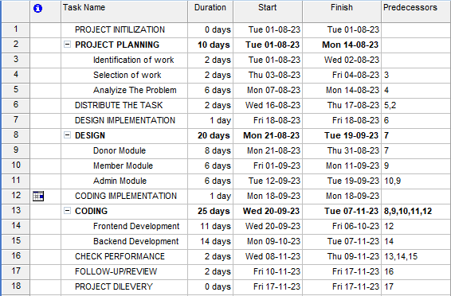

**7.3 PERT CHART:-**

In Microsoft Office 2007, creating a PERT (Program Evaluation and Review Technique) chart involves using the drawing tools available in applications like Microsoft Word or PowerPoint. A PERT chart is a graphical representation of a project's timeline, showing the sequence of tasks and their dependencies.[7]

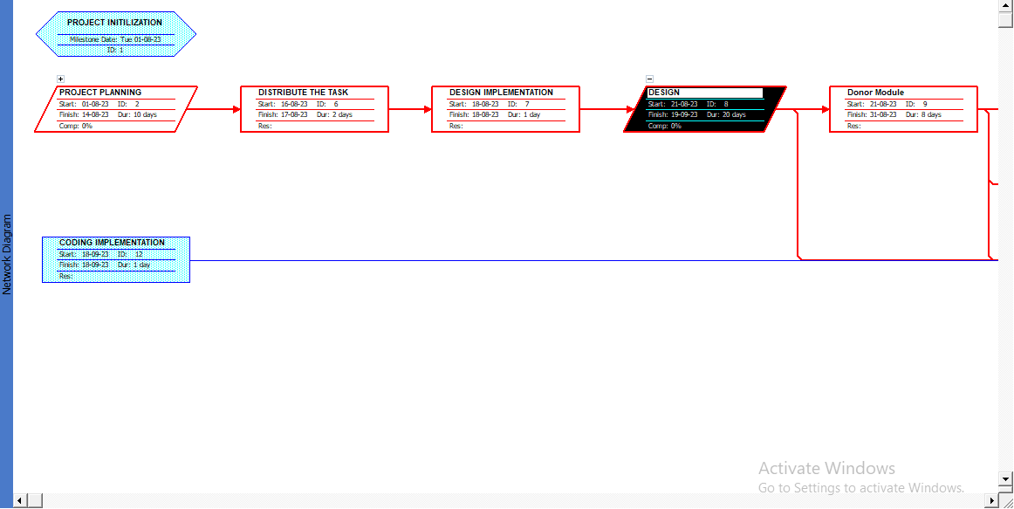

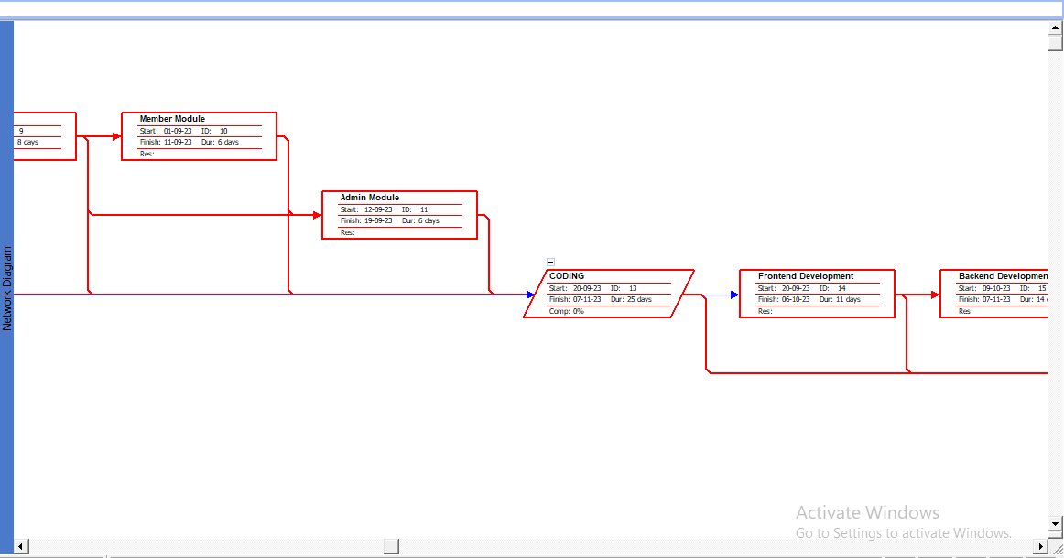

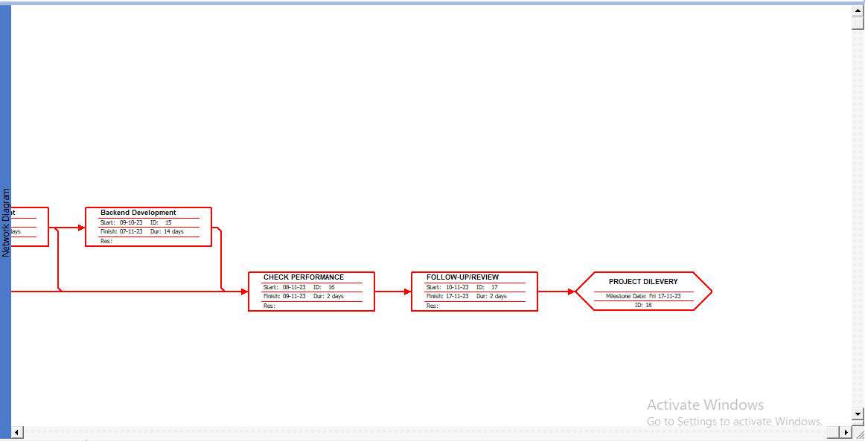

**7.4 GANTT Chart:-**

In Microsoft Office 2007, a Gantt chart is a visual representation of a project schedule that shows the start and finish dates of different elements of a project. It's a powerful tool for project management, providing a timeline view of tasks, their durations, and the dependencies between them. While Office 2007 does not have a dedicated Gantt chart feature. [7]

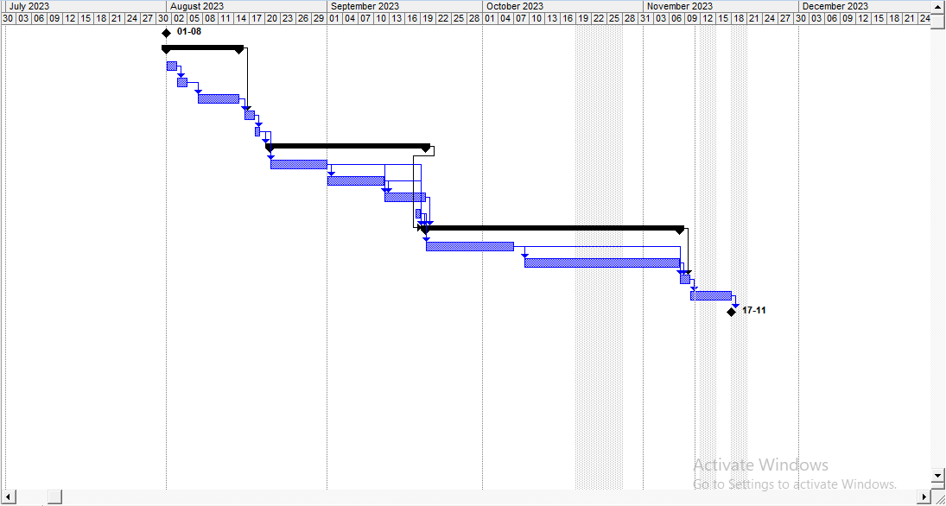

1. **Software Requirement Specification**
   1. **Introduction:-**

## Purpose

The Online Blood Donors Database Management System .Software Requirements Specification (SRS) document outlines the requirements for the development of a web-based platform that connects blood donors with individuals in need of blood donations. This document serves as a reference for developers, project managers, and stakeholders involved in the The Online Blood Donors Database Management System project.

## Document Conventions

This document follows standard document conventions for clarity and consistency. Priority levels for requirements are indicated as High, Medium, or Low. Additionally, requirements are identified by a unique identifier (e.g., REQ-1) for reference.

## Intended Audience and Reading Suggestions

This SRS is intended for developers, project managers, marketing staff, users, testers, and documentation writers. Readers are advised to begin with the overview sections (Sections 1 and 2) before delving into specific sections that are relevant to their roles.

## Product Scope

## *The "Online Blood Donor Database Management System" is a virtual platform where people can find the required donors online through this web application, and they can contact each other. Our project aims to foster a strong relationship between people who needs blood on emergency basis and blood donors, operating similarly to an online NGO corporation[8]. Our ultimate milestone is to allow both people who needs blood on emergency basis and blood donors to create profiles with proper verification. The purpose of this website is to assist the most needy people in our society by providing them with blood as soon as possible.*

* 1. **Overall Description:-**

## Product Perspective

Our aim is to address the blood crisis in our society. Our project aims to create strong bonds between donors and requesters based on their specific needs. This initiative has the potential to save many lives.

## Product Functions

The major functions of the OBDDMS include:

* User registration and login for blood donors and blood requesters.
* Profile management for users.
* Users can authenticate themselves through an OTP verification system sent via email.
* Search functionality for blood requesters to find suitable blood donors.
* Reporting system for users to report any issues or concerns.
* Admin dashboard for monitoring and managing users, reports, and system metrics.
* Donor can accept or reject the requester’s request through contact history tab via website.
* Non members and also members can put their opinion through ‘Contact Us’ form.

## User Classes and Characteristics

1. **Blood Donors:** Individuals willing to donate blood**.**
2. **Blood Needy Individuals:** Individuals in need of blood donations.
3. **Admin:** Administrators responsible for managing the platform.

Characteristics of each user class vary based on their roles and privileges within the platform.

## Operating Environment

The Online Blood Donors Database Management System operates in a web-based environment. It is compatible with modern web browsers such as Chrome, Firefox, Microsoft Bing, Brave, Safari etc. and requires internet connectivity greater than 2mbps. The server-side components will be hosted on a specified web serve].

## Design and Implementation Constraints

Constraints include:

* Users must meet specific eligibility criteria for blood donation.
* Security and privacy standards must be followed.
* Users can securely register themselves by means of a robust OTP validation system, ensuring their safe and proper access to the website.
* Both donors and requesters can access each other's contact information, with the option for donors to grant access to requesters through a "Accept Request" button ,for maintaining the utmost confidentiality.
* Donors and requesters are report to each other, and our diligent admin will meticulously scrutinize the reported reasons. Should they find the concerns to be valid and appropriate, the admin may issue a discreet warning through our website, ensuring a fair and just resolution.
* If the reported person is reported by various people repeatedly then admin can block his/her profile.
* The system must be designed to handle potentially sensitive medical information.

## User Documentation

User documentation, including user manuals and on-screen help, will be provided along with the software to guide users in utilizing the platform effectively.

* 1. **External Interface Requirements:-**

## User Interfaces

In this project, we can use HTML to structure our website. CSS will help us implement various styles, while JavaScript will add logical functionality. Bootstrap can assist in applying a styling framework, and PHP and MySQL will enable us to store and fetch all the data for our project.

## Hardware Interfaces

To use our platform, you will need a standard web browser such as Google Chrome, Microsoft Edge, Mozilla Firefox, or Safari, as well as a moderate internet connection.

## Software Interfaces

The Online Blood Donors Database Management System interfaces with web servers, databases, and may incorporate third-party services for email communication and must needed high speed internet connectivity.

## Communications Interfaces

The system will use standard web communication protocols (e.g., HTTP) for user interactions. Email notifications will be sent using email communication protocols (e.g., SMTP).

* 1. **System Features:-**

## User Interface

* + - **Description and Priority**

The user interface provides an engaging homepage with a navigation bar, motivational quotes, and links to user-specific login/signup pages and other users feedback.

* **Stimulus/Response Sequences**

Users can navigate through the interface, access registration/login forms, and explore the platform.

* + **Functional Requirements**

**REQ-1: For Header Section:-**

***Logo :-*** *Our platform's logo serves as a unique identifier.*

***Navigation Links:-***  *A set of essential links is provided for quick access key sections such as Home, Donor Login ,Member Login, About Us, Admin Login and Contact Us.*

***User Segmentation:*** *The user base is categorized into three segments: Blood Donors, Blood Requesters(Member), and Admin. Separate login/signup options are provided for each.*

**REQ-2: For Body Section (Home Page/Landing Page):-**

* *The main body of the home page showcases an engaging image related to blood donation. Accompanying this image are motivational quotes designed to inspire visitors and encourage them to explore our platform and join as donor or requester(Member) .*
* *For Blood Donors: A direct link is incorporated beneath the quote, leading them to the login/signup page tailored for blood donors.*
* *Similarly, for Blood requester(Member): A distinct link is placed to guide them to their respective login/signup page.*

**REQ-3:ForFooter Section:-**

* *The footer section will feature a set of convenient quick links, including Home, About Us, Contact Us, Terms And Conditions, and Privacy Policies.*
* *To enhance our platform's visibility and engagement, social media icons will be incorporated, allowing users to connect with us through various social channels.*
* *A copyright symbol will be displayed to safeguard our content and address copyright concerns.*

**REQ-4:- For Contact Us :-**

* *This section includes a dedicated feedback form where donor as well as requesters (member) not members can share their experiences with our project.*

**REQ-5:- For Anonymous Users/Non Verified Users(Blood Requester(Member) and Blood Donors):-**

* *Non-logged in users will have access to specific sections, including our landing page, motivational quotes, the 'About Us' page, and the 'Contact Us' page.*
* *Blood Needy Individuals who are not logged in will not be permitted to search for blood donors through the platform.*
* *Similarly, non-logged in Blood Donors will not be able to initiate blood donations until they have logged in.*

## User Registration

* **Description and Priority**

*Users can register as blood donors or blood requester(Member), providing necessary details.*

* **Stimulus/Response Sequences**

*Users fill out registration forms, receive verification emails, and enter OTPs for validation.*

* + Functional Requirements

**REQ-6:- For Logged In Users/Verified Users (Blood Requester(Member) and Blood Donors):-**

* *Verified and logged in Blood Donors will have the ability to register their names within our website, contributing to the availability of blood for those in need.*
* *Verified and logged in Blood requester(Member) will have the privilege to search for the required blood donors and establish contact as necessary.*

**REQ-7 For Signup for Blood Requester (Member):-**

* *Upon clicking the signup button, a registration window will open for individuals in need of blood.*
* This registration form will include the following fields:-
* *Name*
* *Email Id*
* *Phone Number*
* *Address*
* *Pin Code*
* *Blood Group*
* *State*
* *City*
* *Picture Upload*
* *Password*
* *Confirm Password*
* *Age*
* *Once the form is completed, users can click on the verification button. Subsequently, a unique one-time password (OTP) will be sent to the user's email. Simultaneously, a pop-up window will appear, allowing the user to input the received OTP.*
* *If the entered OTP matches the one sent to the user's email, they will be successfully redirected to Login window. In case of a mismatch, users will need to re-enter their details in the same manner as before.*

**REQ-8 For Signup for Blood Donors:-**

* *An age field can be added including a constraint of below 18.*
* *The rest process is a replica of the previous process*

**REQ-9 For Log In For Blood Donors:-*.***

* *Once the signup process is completed, donors can log into their profiles by entering their registered email id and password.*
* *If the provided credentials match, donors will be successfully redirected to the Welcome window. However, if there is a mismatch, donor will need to re-enter their details in the same manner as before.*

**REQ-10 For Log In For Blood Requester(Member):-**

* *This process is a replica of the previous login process.*

## User Features

* **Description and Priority**

*After registering users as Blood Donors Or Blood Requester(Member) they can get some specific features which helps them to interacting for the further processes.*

* **Stimulus/Response Sequences**

*In the feature for blood donors, they can maintain their profiles or hide them from others after donating blood. Additionally, a search facility is implemented for requesters(Member), allowing them to search for the required donors for blood donation.*

* + Functional Requirements

**REQ-11 For Features For Blood Donors:-**

* *Upon entering this phase, a welcome message will be displayed in the header section, along with the donor's name.*
* *The left side of the welcome page features a side navigation bar with the following options:-*
* *View Profile: - Allows donors to view their profile (read-only mode).*
* *Edit Profile :- Enables donors to edit their profile (read and write access).*
* *Change Password :- Requires proper verification for updating the password.*
* *Change the availability for donate the blood :- Details for this option are provided below.*
* *Contact History:-This section will contain a list of blood requesters(Member) who can try to connect with that particular blood donor.**Furthermore donor can accept or reject the request of blood requester via this ‘contact history’ section.*
* *Blood Donation Eligibility Criteria (All the options can be visible in the availability tab):- The availability tab includes the rules for blood donation, which encompass:****[ii]***
* *Age between 18-60 years*
* *Hemoglobin not less than 12.5gm/DI*
* *Pulse Between 50 and 100/min with no irregularities.*
* *Blood pressure-systolic 100 to 180 mm Hg and Diastolic 50 to 100 mm Hg.*
* *Temperature-normal*
* *Body weight not less than 45k.g*
* *Any healthy adult both male and female can donate blood in every 3 months.*
* *Donors should not have any conical disease.*
* *After carefully reviewing the above guidelines, donors can decide whether they are eligible for blood donation. If they meet the criteria, they can click on the "Show Profile" button.*
* *The functionality of the "Hide Profile" button is to hide their profile based on their current availability status.*

**REQ-11 For Features For Blood Requester (Member):-**

* *Upon entering this phase, a welcome message will be displayed in the header section, along with the donor's name.*
* *The left side of the welcome page features a side navigation bar with the following options:-*
* ***View Profile: -*** *Allows donors to view their profile (read-only mode).*
* ***Edit Profile :-*** *Enables donors to edit their profile (read and write access).*
* ***Change Password :-*** *Requires proper verification for updating the password.*
* ***Search Donors:-*** *Allows Blood Needy People to search for potential donors.*
* ***View Contact History :-*** *Blood Requesters(Member) can check the status of every blood donors whom blood requester requested for blood.*
* *After clicking the "Search Donors" option, two input fields are displayed: "Enter Pin Code" and "Enter Blood Group".*
* *The next step is to press the search button to find all the donors that match the specified criteria.*
* *Based on the provided credentials, profiles of potential donors are shown to the requester.*
* *To contact their chosen donor, the requester initiates the contact process.*
* *An auto-generated request email , is sent to the donor's email. If the donor is willing to help the donor go to his profile and check contact history where he/she is able to accept or reject the requester.*

*If donor accepts the blood requester(member) certainly the requester got an auto generated acceptance email and both of the contact number will accessible to both of them.*

* *If any malpractice occurs, requesters (Members) are encouraged to report their concerns through the 'Report Donor' button.*
* *Donors can follow the same process by clicking on the 'Report Requester' button.*

## Admin Features

* **Description and Priority**

*There will be one specific admin in our website after logged in , admin is permitted to enter into admin panel where he can maintain donors and requester activity.*

* **Stimulus/Response Sequences**

*In the feature for admin, they can maintain their profiles. Additionally, admin can maintain all the activities done by all the donors and requesters (Member). Also the admin can check all the reports and taking further actions.*

* **Functional Requirements**

**REQ-12 For Admin:-**

* *Upon entering this phase, a welcome message will be displayed in the header section, along with the admin's name.*
* *The left side of the welcome page features a side navigation bar with the following options:-*
* ***Dashboard:-*** *This section displays three key metrics: "Total Donors," "Total Requesters," and "Total Reports.*
* ***View Profile: -*** *Allows donors to view their profile (read-only mode).*
* *Edit Profile :- Enables donors to edit their profile (read and write access).*
* ***Change Password :-*** *Requires proper verification for updating the password.*
* ***View All Donors:-*** *Stores details of all donors.*
* ***View All Requesters:-*** *Stores details of all requesters.*
* ***View All Reports:-*** *Stores all reports, including date and time information.*
* ***View All Site Feedback:-*** *Stores all feedback related to the website, which are given from donor, requester(member) and not member person.*
* ***View all contacted person:-*** *This section contains the relation between the specific donor and requester along with proper date and time.*
* *The admin can review all reports submitted by donors and requesters and verify their accuracy.*
* *If the reports are deemed accurate, an auto-generated warning message is sent to the respective donor's or requester's email.*

*The admin can issue this warning message by clicking the "SEND WARNING" button, located in the "View All Reports” section.*

* 1. **Other Non Functional Requirements:-**

*Non functional requirements (NFRs), also known as quality attributes or software qualities, are essential in software engineering. They define the overall behavior, performance, and user experience of a software system. In addition to the commonly mentioned NFRs like performance, security, and scalability, there are several other nonfunctional requirements that are crucial in software engineering:*

## Usability:

Usability encompasses factors such as user interface design, user experience (UX), and user-friendliness. It measures how easy it is for users to interact with and navigate the software.

## Reliability:

Reliability refers to the software's ability to consistently perform its intended functions without failures or errors. It includes aspects like fault tolerance, error recovery, and system stability.

## Availability:

Availability defines the percentage of time a system is operational and accessible to users. High availability is critical for mission-critical systems that must be accessible 24/7.

## Maintainability:

Maintainability assesses how easily and cost-effectively the software can be updated, modified, or repaired. It includes factors like code readability, modularity, and documentation.

## Portability:

*Portability evaluates how easily the software can be adapted to different environments, platforms, and operating systems. It's essential when software needs to run on various devices or migrate between systems.*

## Scalability:

*Scalability refers to the software's ability to handle increased workloads and user demands. It involves horizontal scalability (adding more servers) and vertical scalability (upgrading existing hardware or software components).*

## Performance Efficiency:

*While performance is a common NFR, it can be broken down further into aspects like response time, throughput, and resource utilization. Performance efficiency ensures that the software meets specific performance benchmarks.*

## Data Integrity and Privacy:

*For applications that handle sensitive data, data integrity and privacy are critical. Ensuring that data is secure, encrypted, and protected from unauthorized access is essential.*

## Safety:

*In safety-critical systems, such as medical devices or autonomous vehicles, safety requirements are paramount. These requirements focus on preventing accidents and minimizing risks.*

## Business Rules

It Includes the rules for blood donation, which encompass:

* Age between 18-60 years
* Hemoglobin not less than 12.5gm/DI
* Pulse Between 50 and 100/min with no irregularities.
* Blood pressure-systolic 100 to 180 mm Hg and Diastolic 50 to 100 mm Hg.
* Temperature-normal
* Body weight not less than 45k.g
* Any healthy adult both male and female can donate blood in every 3 months.
* Donors should not have any conical disease.
  1. **Other Requirements:-**
* Calls to donors and blood recipients cannot be made between 12 A.M. and 5 A.M.
* There is no real-time chat system present in our project.
* There is no payment gateway for receiving funds from users.

1. **Cost And Benefit Analysis**

Cost & Benefit analysis is an important part of this documentation, mainly this part is coming than the Constructive cost estimation model (COCOMO). COCOMO was introduced by Barry. W. Boehm and documentaries in this year of 1981. It is a heuristic method and is a hierarchy of three increasingly details from basic, intermediate, advance COCOMO. In 1997 another version COCOMO2 was introduce. The first version divides the whole project into three categories as Organic, Semidetached and Embedded.

* + **In Organic time the projects have some features like:**
* Team size is small.
* Simple software and relatively strict project.
* The team has good application experience rigid.
* Deliverable lines of code are within 50,000 loc.
  + **In Semidetached COCOMO the rules are as follows:**
* Team size is moderate.
* The team has mixed experienced level.
* Project requirement is rigid to less than rigid.
* Outside interacting is required.
  + **In Embedded COCOMO:**
* Team size is huge.
* Team has high experience level.
* Real time processing application.

Depending on these models we calculate efforts. Development time and person needed.

Effort = a*(kloc)b

Tdev = c*(Effort)d

Person = Effort / Tdev

The values of a, b, c, d are as follows:[8]

|  |  |  |  |
| --- | --- | --- | --- |
| a | b | c | d |
| 2.4 | 1.05 | 2.5 | 0.38 |

[Assume that the loc=25000, kloc=25]

So,

Effort= 2.4*(25)1.05= 2.4*29.3654736= 70.4771366 pm

Tdev= 2.5*(70.4771366)0.38= 2.5*5.038002= 12.595005 m

Person= 70.4771366 /12.595005= 5.59564181 [approx 6]

[Assume that the cost is 600Rs/kloc]

So, the Cost is: Cost= 25*600 Rs= 15000 Rs/ person

Total Cost= 4*15000 Rs = 60000 Rs.

1. **Software Design Specification (SDS)**
   1. **Entity Relationship Diagram (ERD):-**

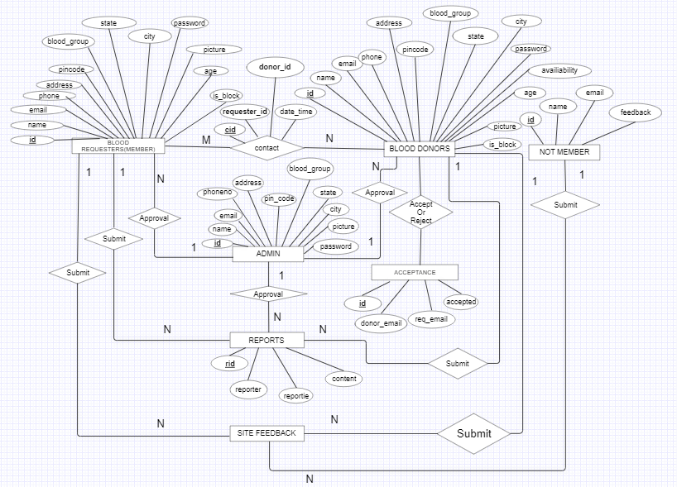

* 1. **Activity Diagram:-**

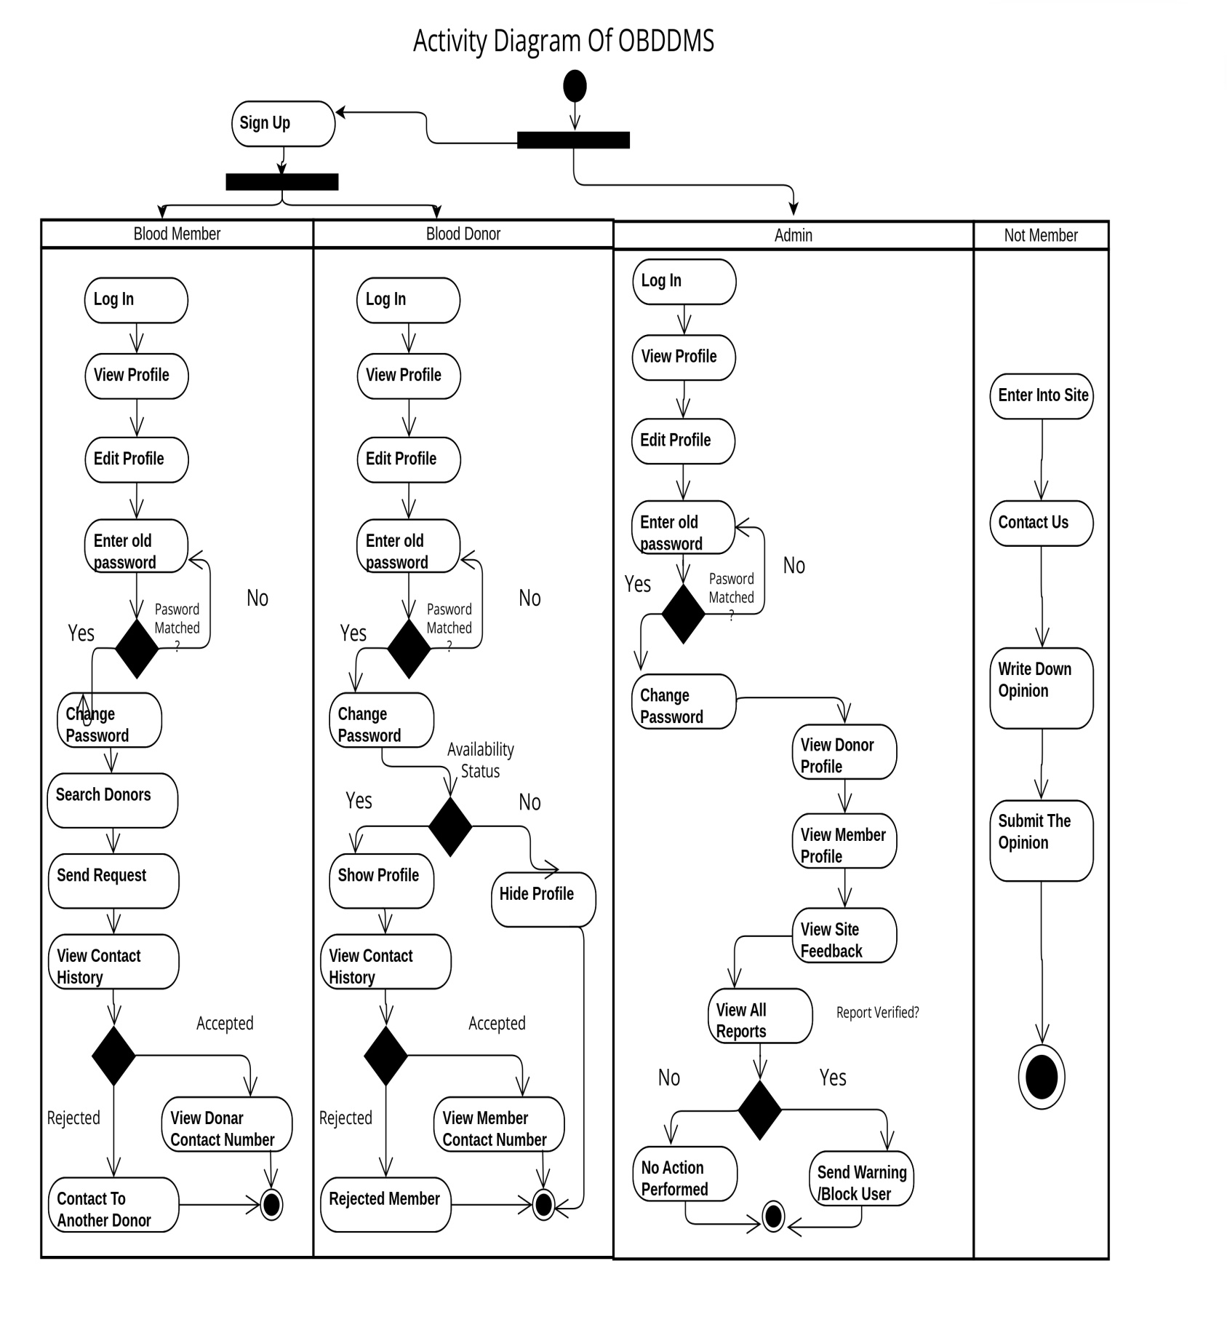

* 1. 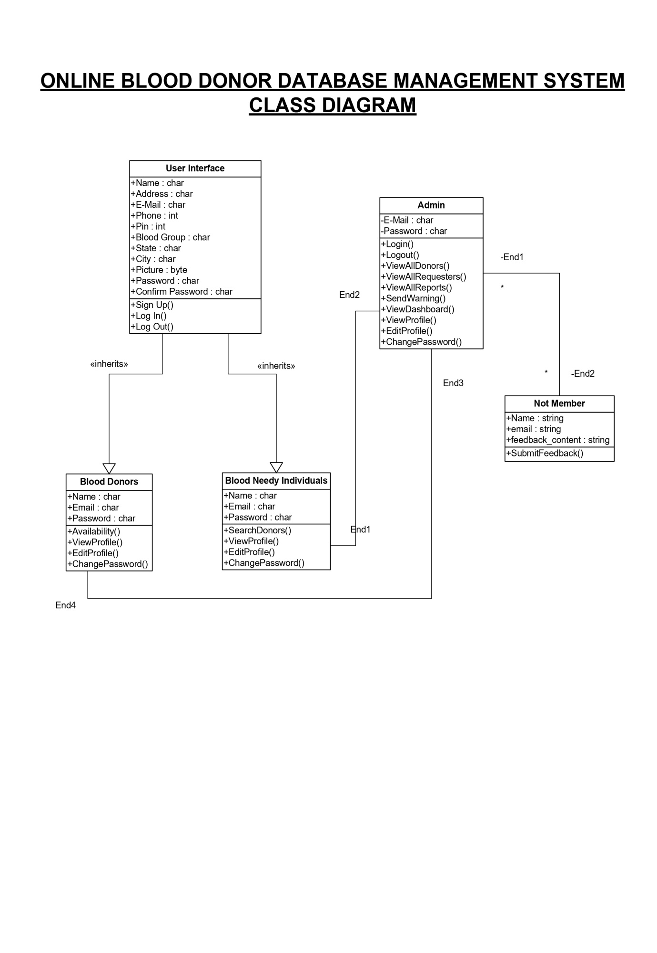**Class Diagram:-**

* 1. **Object Diagram:-**

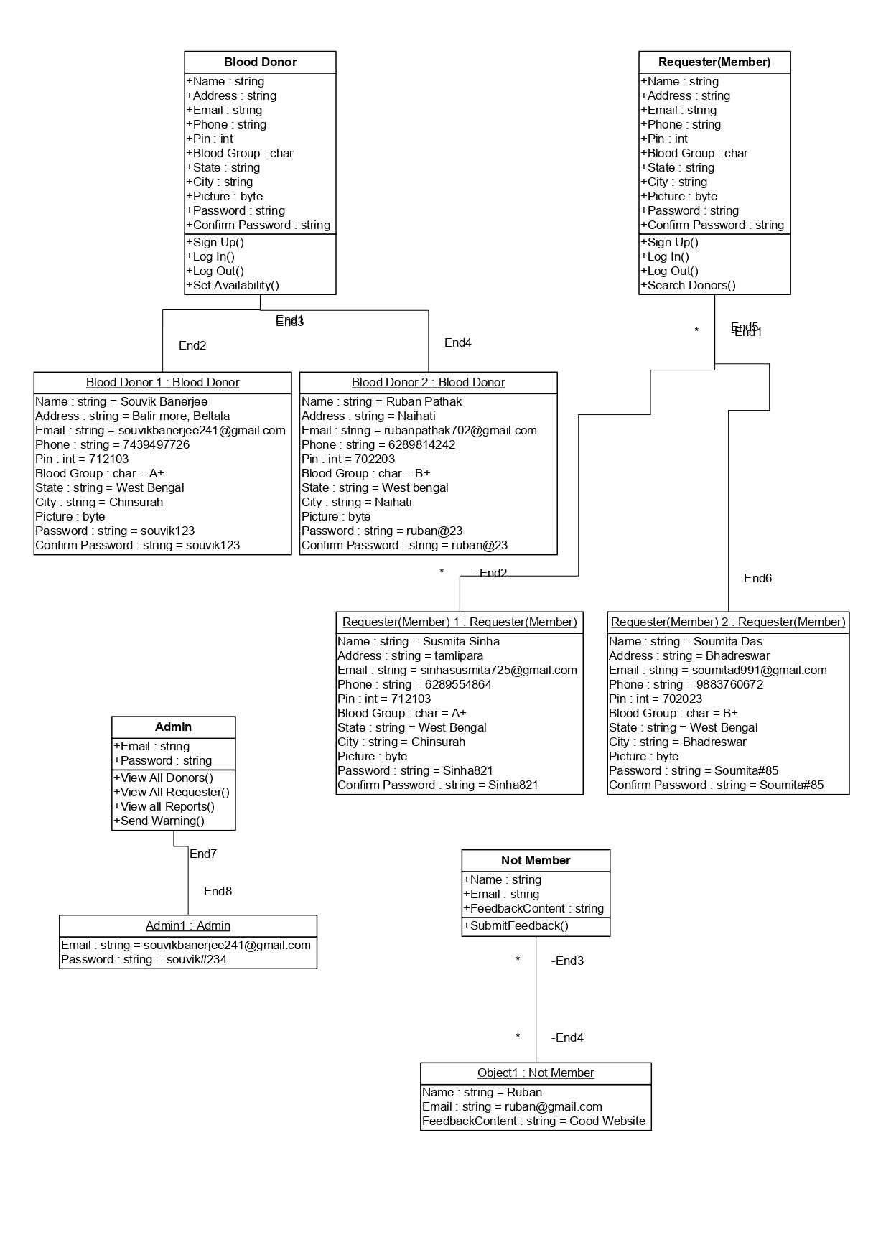

* 1. **State Chart Diagram:-**

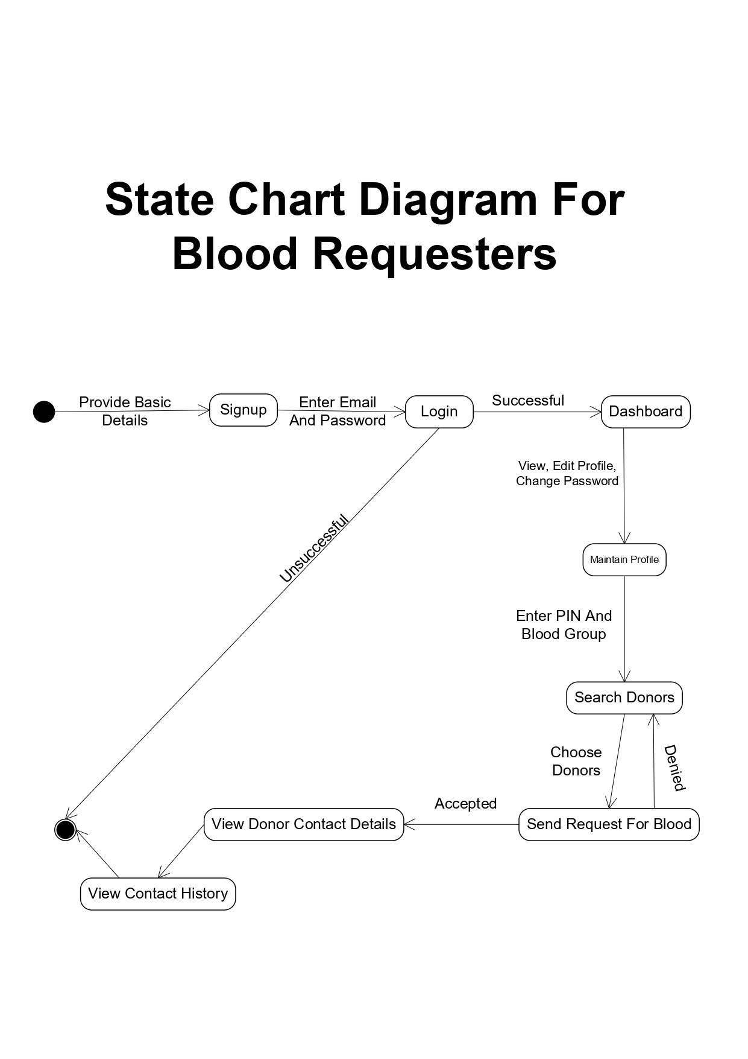

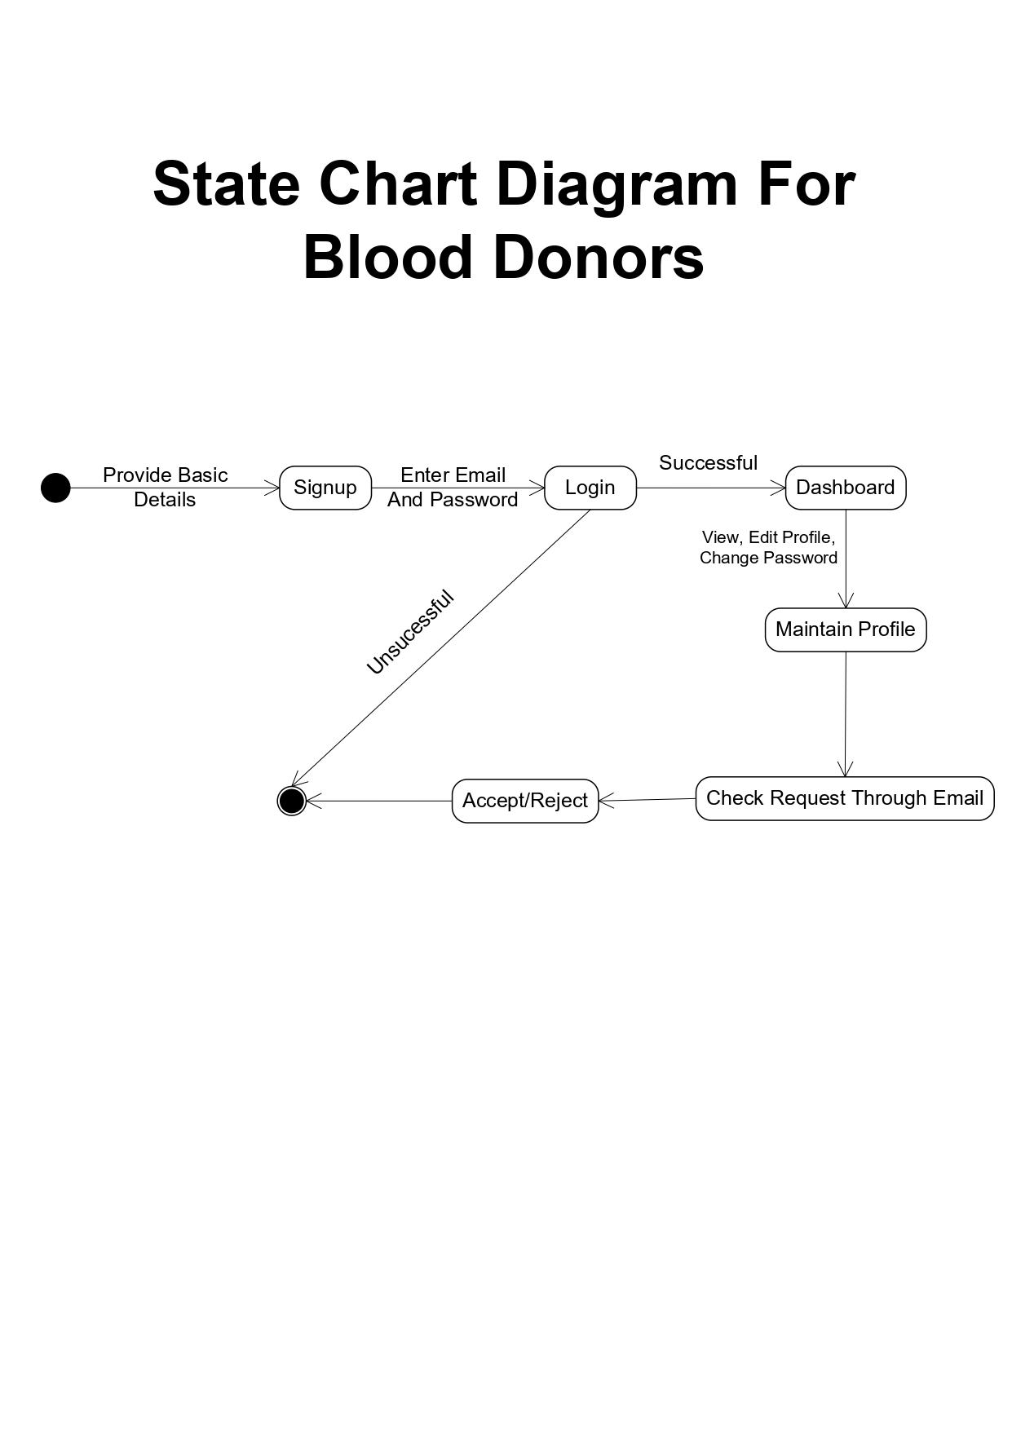

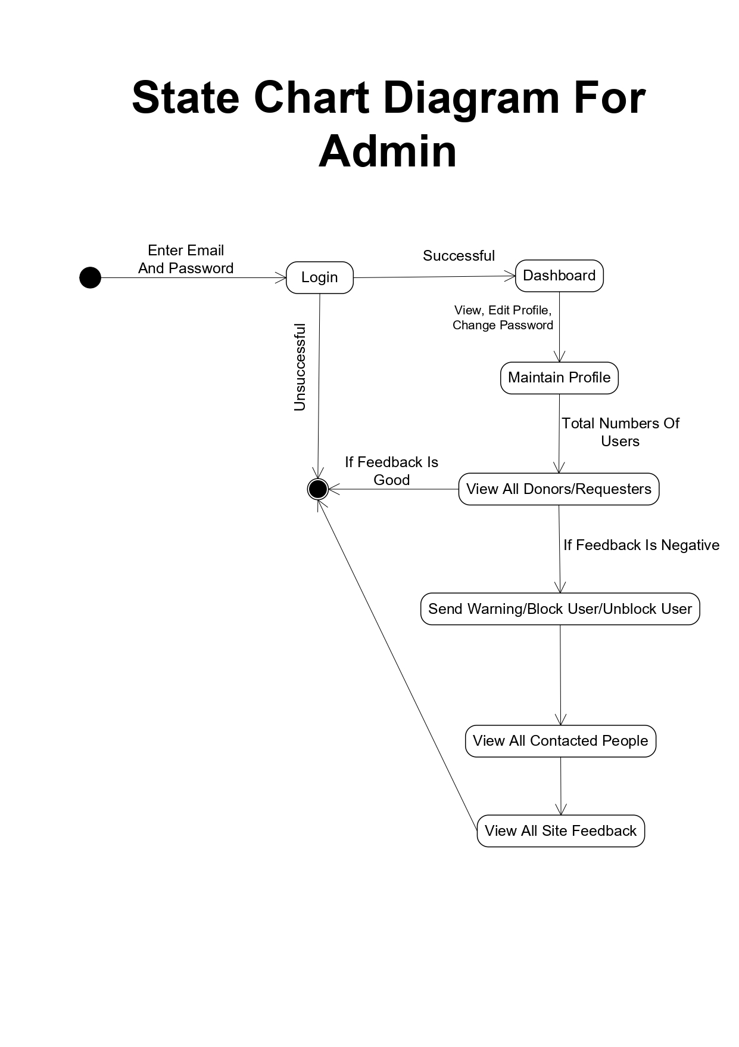

* 1. **Use Case Diagram:-**

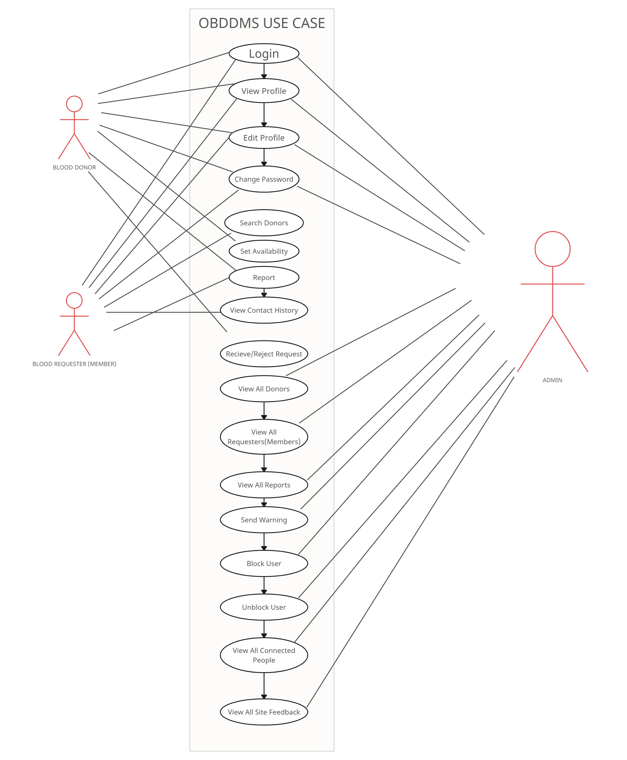

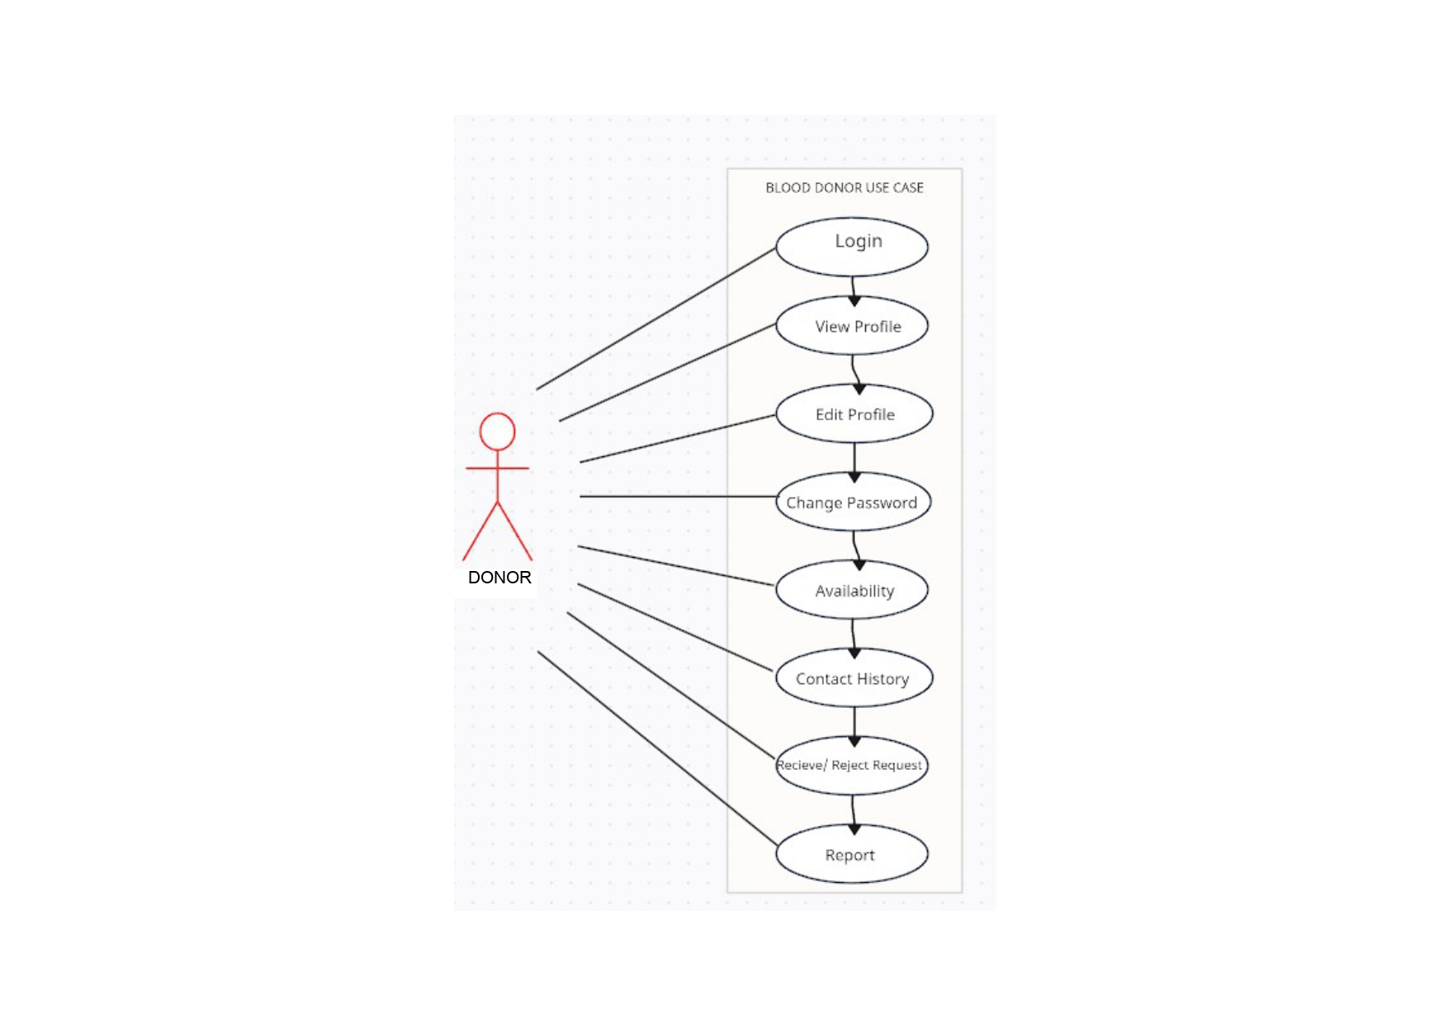

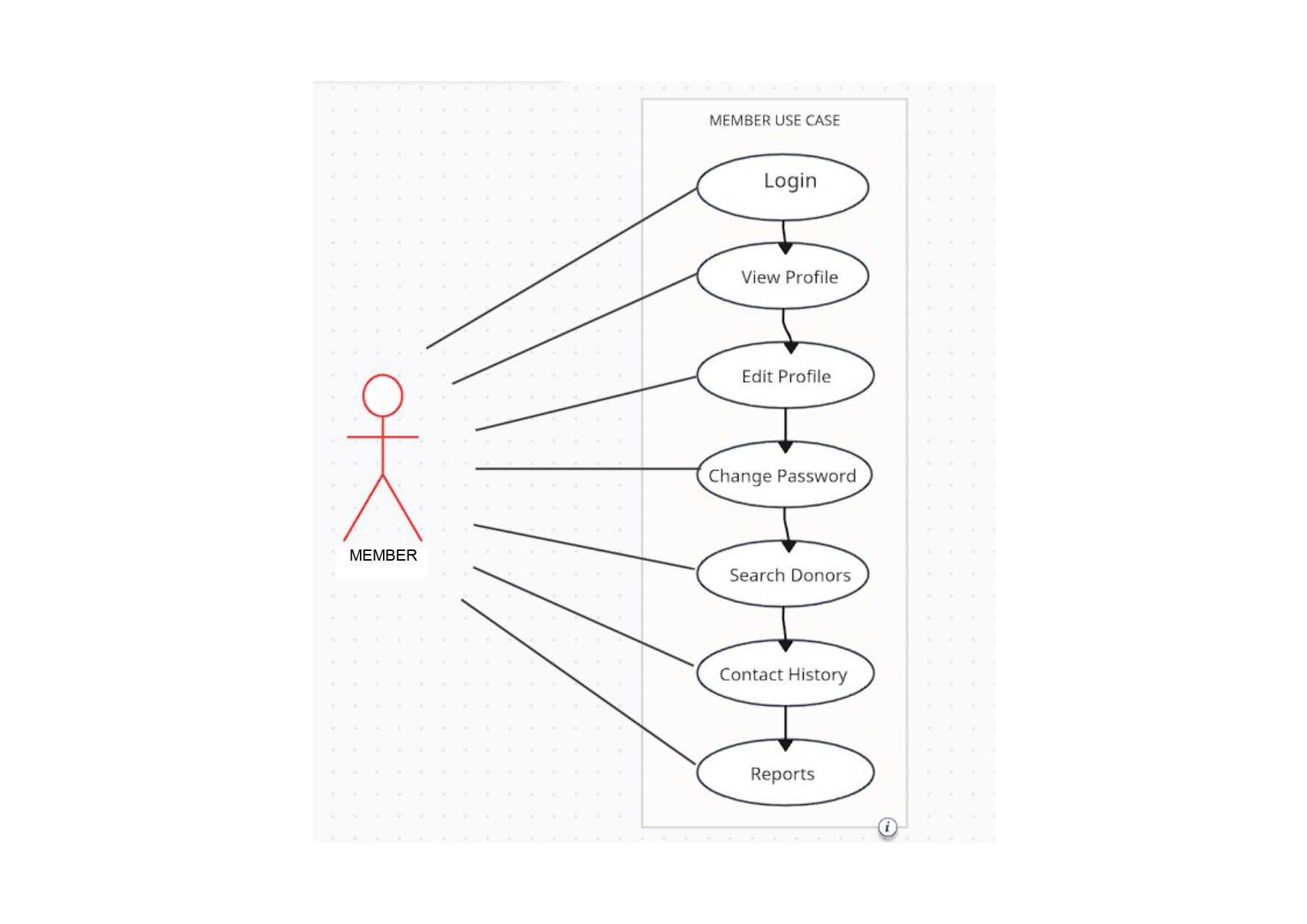

* 1. **Schema:-**

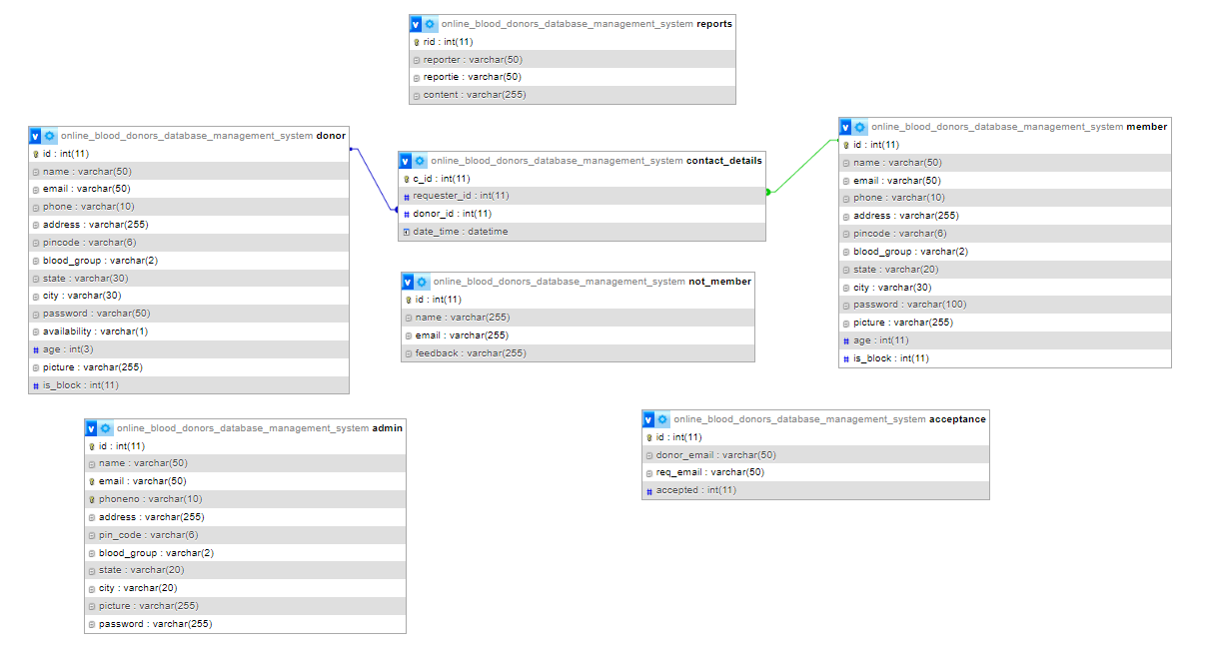

1. **Methodology used for testing and some testing results**

A test plan is a general document for the entire project, which defines the scope, approach to be taken, and schedule of testing, as well as identifying the test item for the entire testing process, and the personal responsible for the different activities of testing. This document describes the plan for testing, the knowledge management tool.

* + **Major testing activities are:**
* Test units
* Features to be tested
* Approach for testing
* Test deliverable
* Schedule
* Personal allocation
  + **Test cases & test result:**

A test case is a document that describe an input, action, or event and expected response, to determine if a feature of an website is working correctly. A test case should contain particular such as test case identifier, test condition, input data Requirement expected results. The process of developing test cases can help find problems in the requirement or design of an website, since it requires completely thinking through the operation of the website.

Testing Steps are:-

* + **Unit Testing (Black Box):** Unit testing focuses efforts on the smallest unit of software design. This is known as module testing. The modules are tested separately. The test is carried out during programming stag itself. In this step, each module is found to be working satisfactory as regards to the expected output from the module.
  + **Integration Testing:** Data can be lost across an interface. One module can have an adverse effect on another, sub functions, when combined, may not be linked in desired manner in major functions. Integration testing is a systematic approach for constructing the program structure, while at the same time conducting test to uncover errors associated within the interface. The objective is to take unit tested modules and builds program structure. All the modules are combined and tested as a whole.[9]

**11.1 *Test Case NO:- 1:-***

**Test Case Name:- Sign up**

|  |  |  |  |  |
| --- | --- | --- | --- | --- |
| **Test Case SLno** | **Test Data** | **Expected** | **Actual** | **Status**  **(pass/ fail)** |
| 1 | <correct name>  <correct email>  <correct phone>  <correct address>  <correct pin code>  <correct blood group>  <correct state>  <correct city>  <correct password>  <correct confirm password>  <correct age> | Successful sign up | Successful sign up | pass |
| 2 | <correct name>  <correct email>  <correct phone>  <correct address>  <correct pin code>  <correct blood group>  <correct state>  <correct city>  <correct password>  **<incorrect confirm password>**  <correct age> | Unsuccessful sign up | Unsuccessful sign up | pass |
| 3 | <correct name>  **<incorrect email>**  <correct phone>  <correct address>  <correct pin code>  <correct blood group>  <correct state>  <correct city>  <correct password>  <correct confirm password>  <correct age> | Unsuccessful sign up | Unsuccessful sign up | pass |

|  |  |  |  |  |
| --- | --- | --- | --- | --- |
| **Test Case NO** | **Test Data** | **Expected** | **Actual** | **Status**  **(pass / fail)** |
| 4 | <correct name>  <correct email>  <correct phone>  <correct address>  <correct pin code>  <correct blood group>  <correct state>  <correct city>  <correct password>  <correct confirm password>  **<incorrect age>** | Unsuccessful sign up | Unsuccessful sign up | pass |

* **Test Case 1 SLNO 1:-**

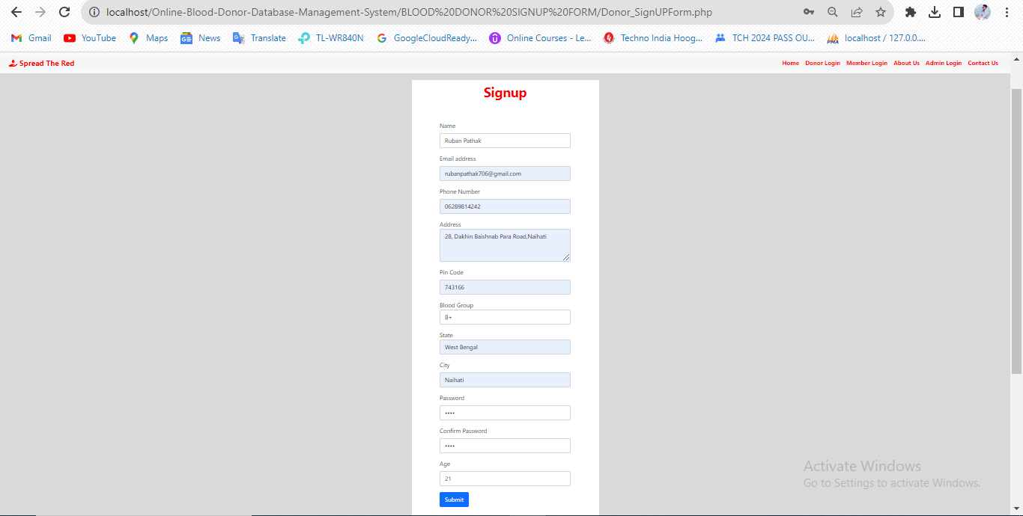

* **Test Case 1 SLNO 2:-**

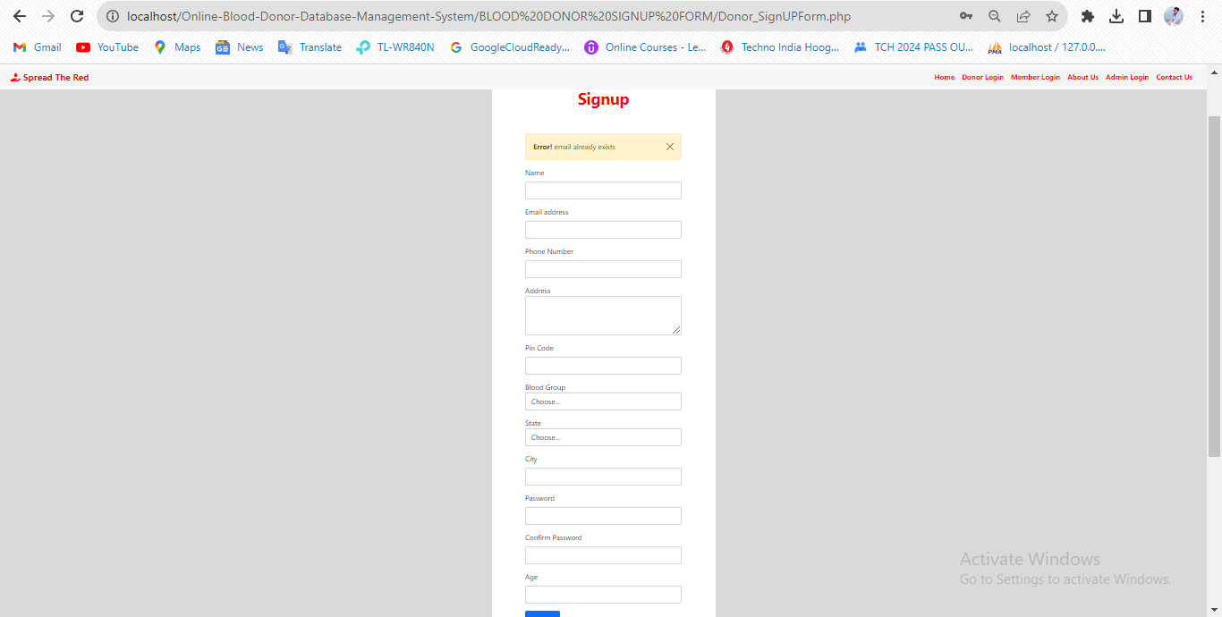

* **Test Case 1 SLNO 3:-**

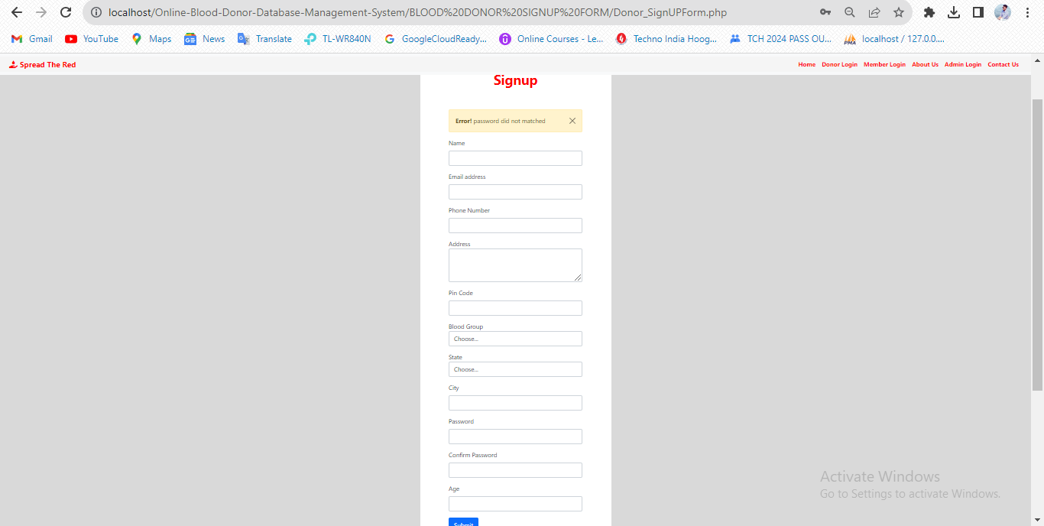

* **Test Case 1 SLNO 4:-**

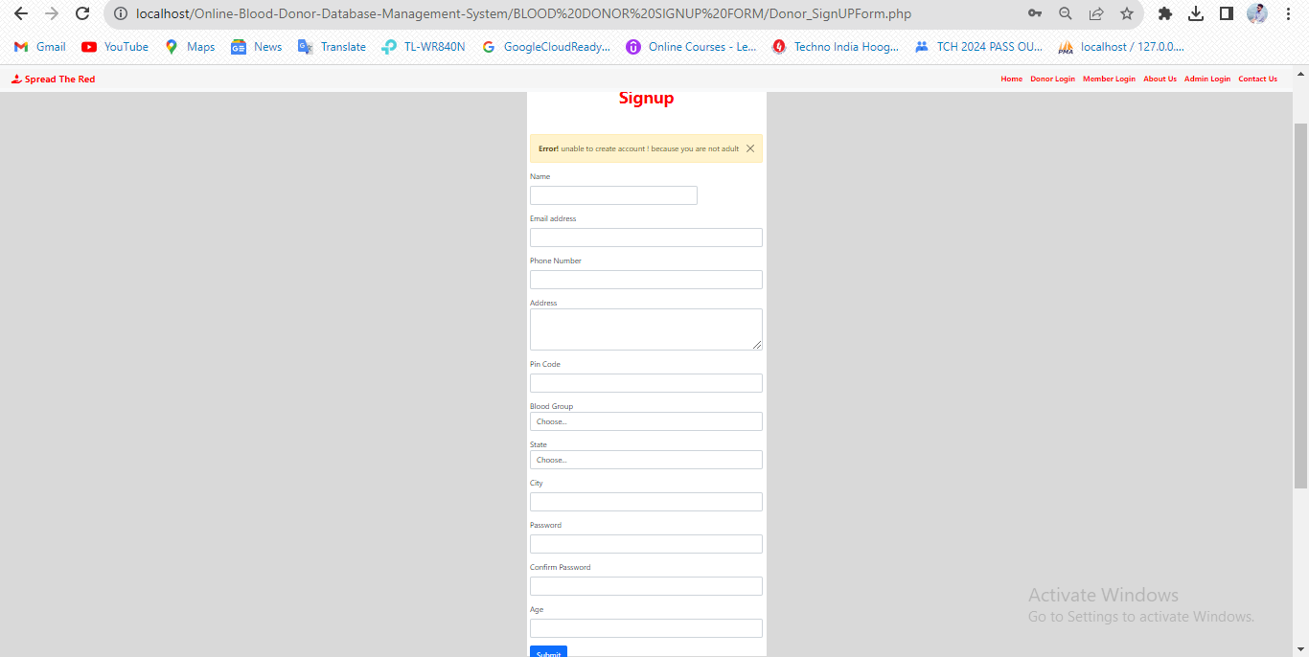

**11.2 *Test Case NO:- 2:-***

**Test Case Name:- Log In**

|  |  |  |  |  |
| --- | --- | --- | --- | --- |
| **Test Case NO** | **Test Data** | **Expected** | **Actual** | **Status**  **(pass / fail)** |
| 1 | <correct email>  <correct password> | Successful log in | Successful log in | pass |
| 2 | **<incorrect email>**  <correct password> | Unsuccessful log in | Unsuccessful log in | pass |
| 3 | <correct email>  **<incorrect password>** | Unsuccessful log in | Unsuccessful log in | pass |
| 4 | <incorrect email>  <incorrect password> | Unsuccessful log in | Unsuccessful log in | pass |

* **Test Case 2 SLNO 1:-**

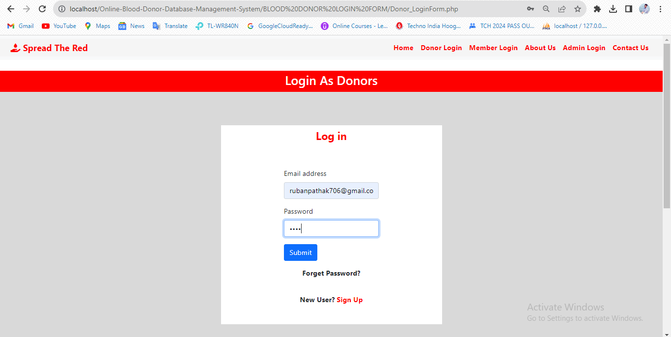

* **Test Case 2 SLNO 2:-**

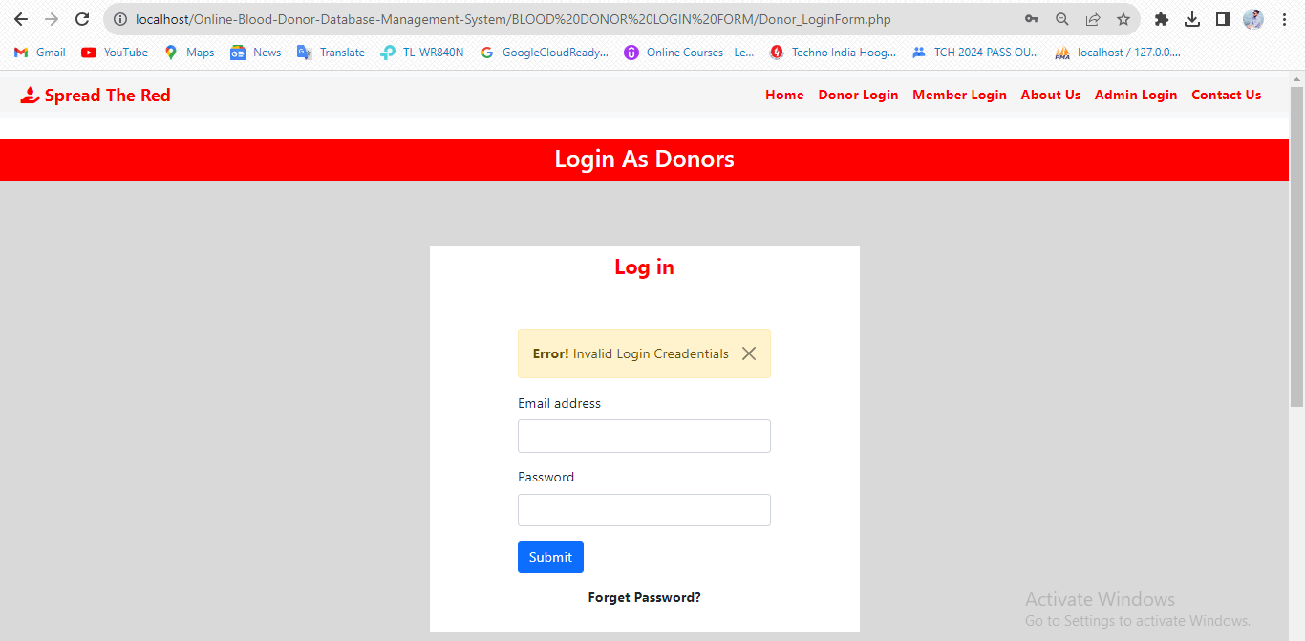

* **Test Case 2 SLNO 3:-**



* **Test Case 2 SLNO 4:-**



**11.3 *Test Case NO:- 3:-***

**Test Case Name:- Forget Password OTP Generate**

|  |  |  |  |  |
| --- | --- | --- | --- | --- |
| **Test Case NO** | **Test Data** | **Expected** | **Actual** | **Status**  **(pass / fail)** |
| 1 | <correct email>  <correct password>  <correct confirm password> | Successful OTP mail sent | Successful OTP mail sent | pass |
| 2 | **<incorrect email>**  <correct password>  <correct confirm password> | Unsuccessful OTP mail did not sent | Unsuccessful OTP mail did not sent | pass |
| 3 | <correct email>  **<incorrect password>**  **<incorrect confirm password>** | Unsuccessful OTP mail did not sent | Unsuccessful OTP mail did not sent | pass |

* **Test Case 3 SLNO 1:-**

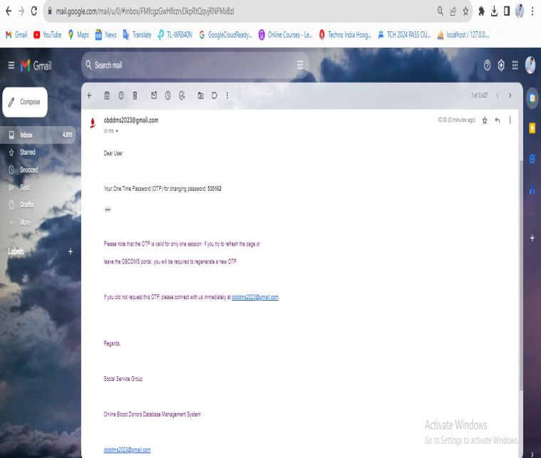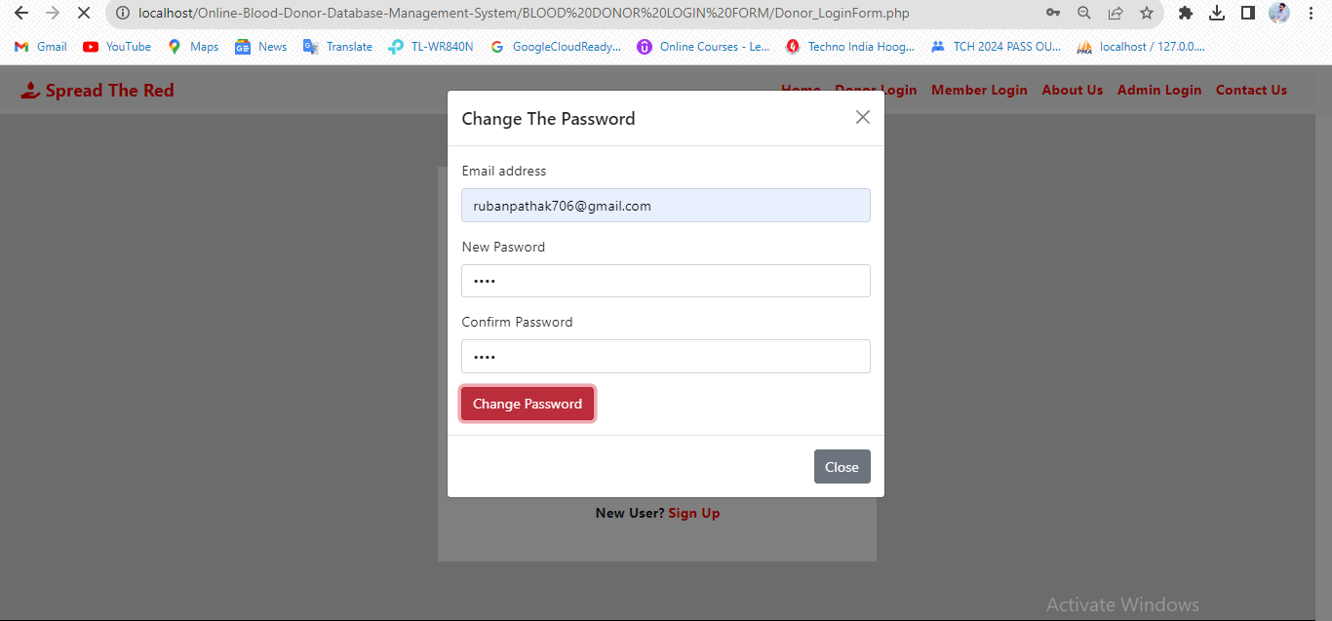

* **Test Case 3 SLNO 2:-**

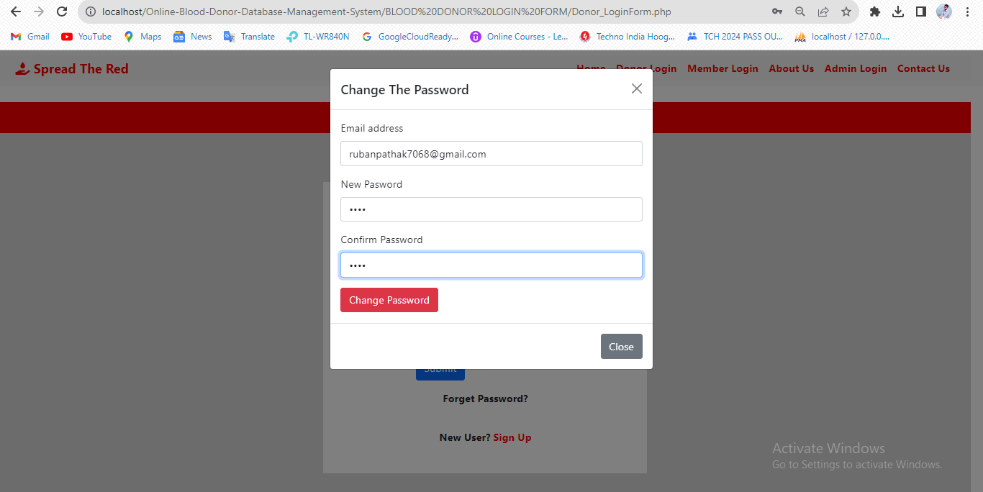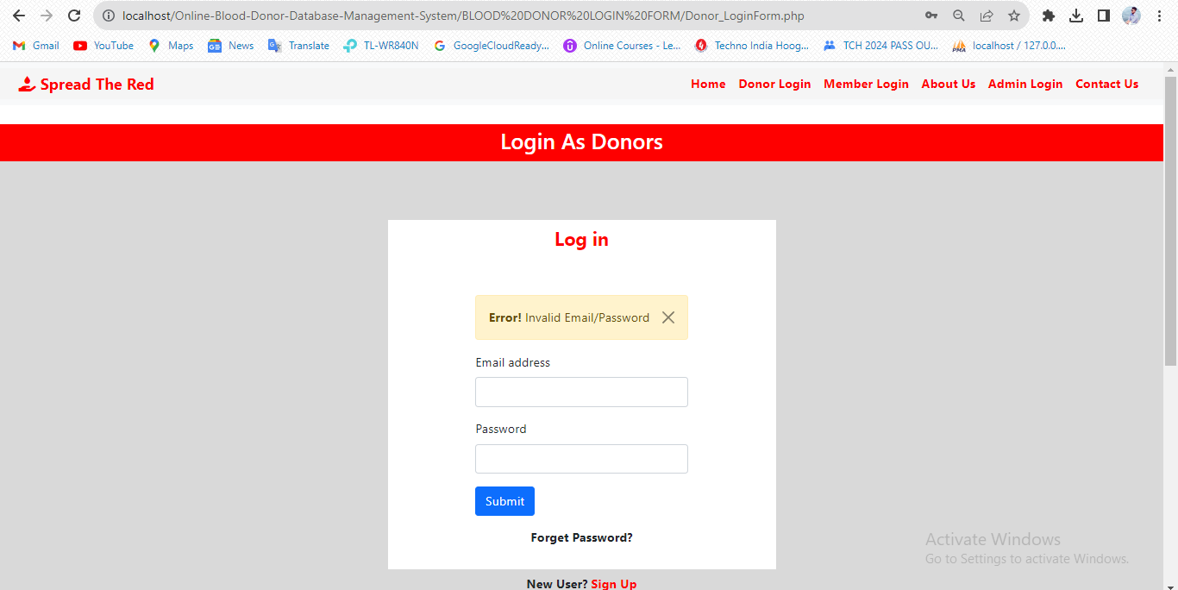

* **Test Case 3 SLNO 3:-**



**11.4 *Test Case NO:- 4:-***

**Test Case Name:- Forget Password OTP Matched**

|  |  |  |  |  |
| --- | --- | --- | --- | --- |
| **Test Case NO** | **Test Data** | **Expected** | **Actual** | **Status**  **(pass / fail)** |
| 1 | <correct OTP> | Successfully Password Changed | Successfully Password Changed | pass |
| 2 | **<incorrect OTP>** | Password did not changed | Password did not changed | pass |

* **Test Case 4 SLNO 1:-**

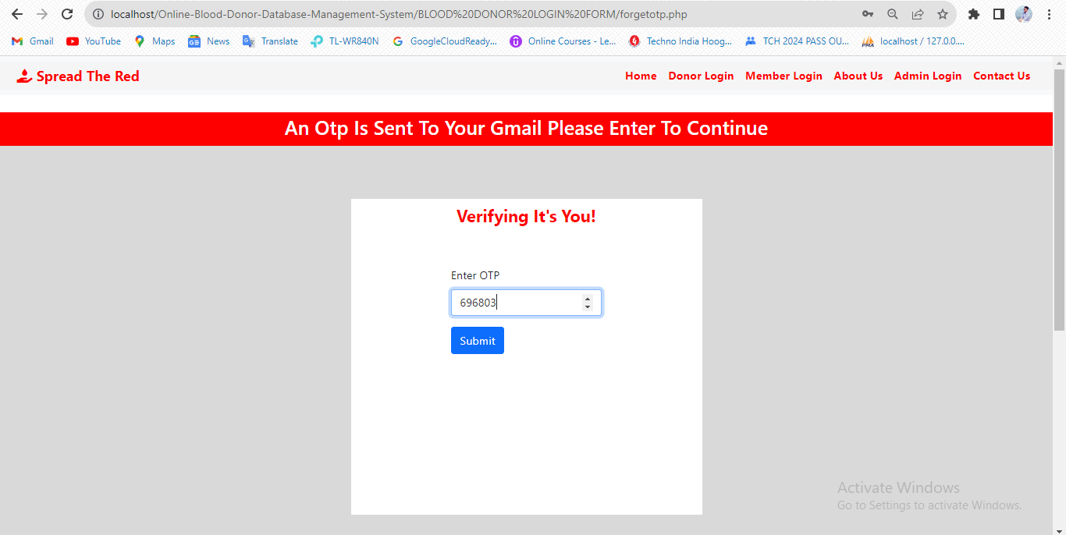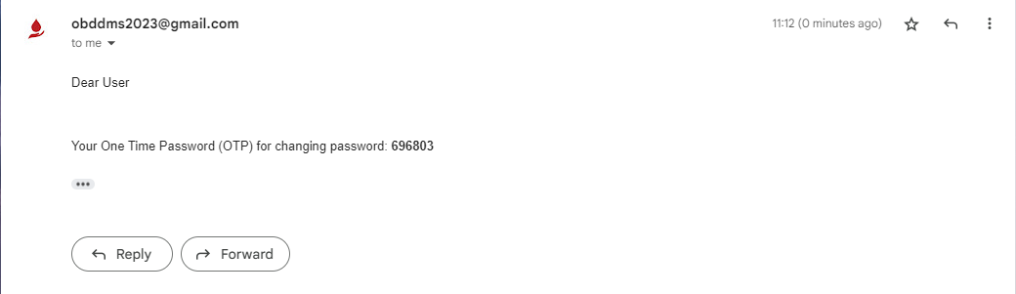

* **Test Case 4 SLNO 2:-**

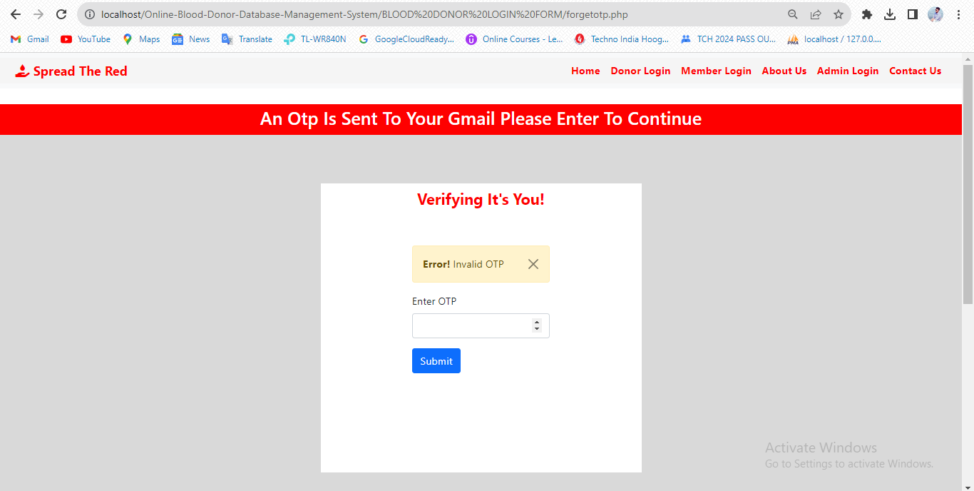

**11.5 *Test Case NO:- 5:-***

**Test Case Name:- Hide donor profile from all requesters (Availability Status)**

|  |  |  |  |  |
| --- | --- | --- | --- | --- |
| **Test Case NO** | **Test Data** | **Expected** | **Actual** | **Status**  **(pass / fail)** |
| 1 | <show profile> | Profile will be visible to all blood requesters | Profile will be visible to all blood requesters | pass |
| 2 | **<hide profile>** | Profile will be hidden to all blood requesters | Profile will be hidden to all blood requesters | pass |

* **Test Case 5 SLNO 1:-**

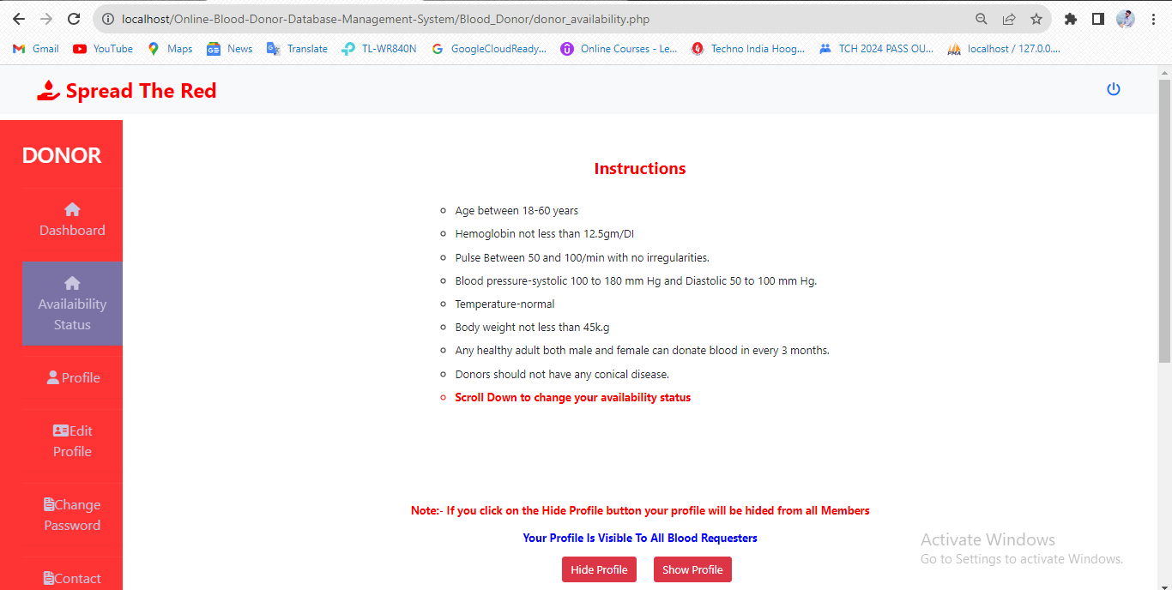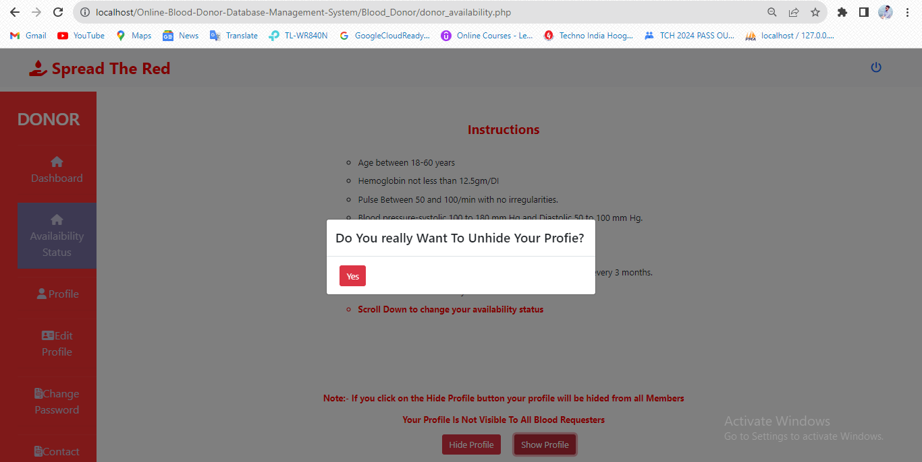

* **Test Case 5 SLNO 2:-**

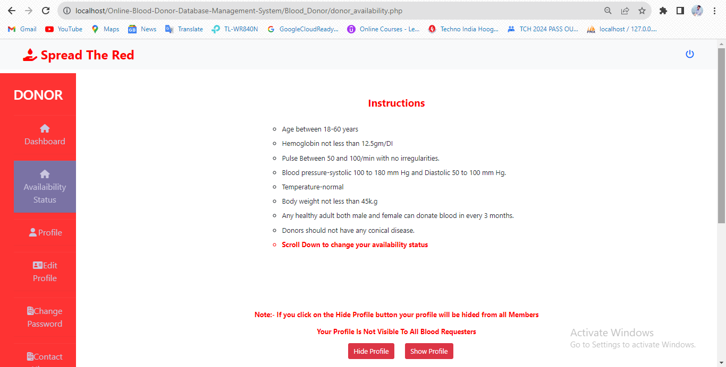

**11.6 *Test Case NO:- 6:-***

**Test Case Name:- Accept Request/Reject Request/Pending Request.**

|  |  |  |  |  |
| --- | --- | --- | --- | --- |
| **Test Case NO** | **Test Data** | **Expected** | **Actual** | **Status**  **(pass/ fail)** |
| 1 | <accept request> | Requester Phone Number Will Be shown and an email will be sent. | Requester Phone Number Will Be shown and an email will be sent. | pass |
| 2 | <reject request> | Requester Phone Number Will Be hided and an email will be sent. | Requester Phone Number Will Be hided and an email will be sent. | pass |
| 3 | <pending request> | Requester Phone Number Will Be hided. | Requester Phone Number Will Be hided. | pass |

* **Test Case 6 SLNO 1:-**

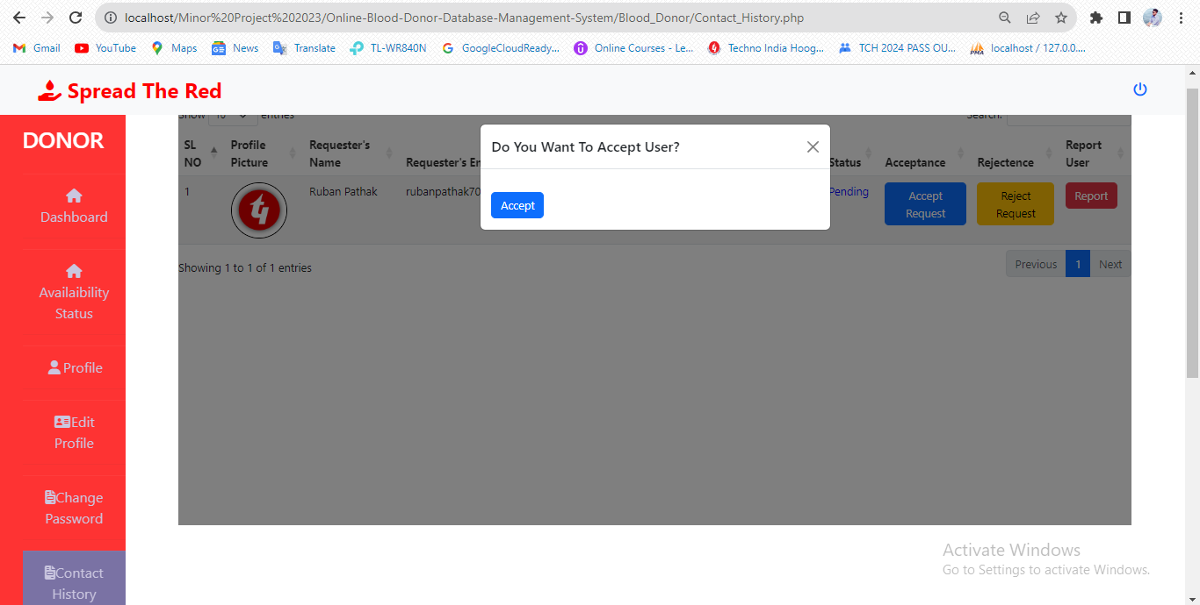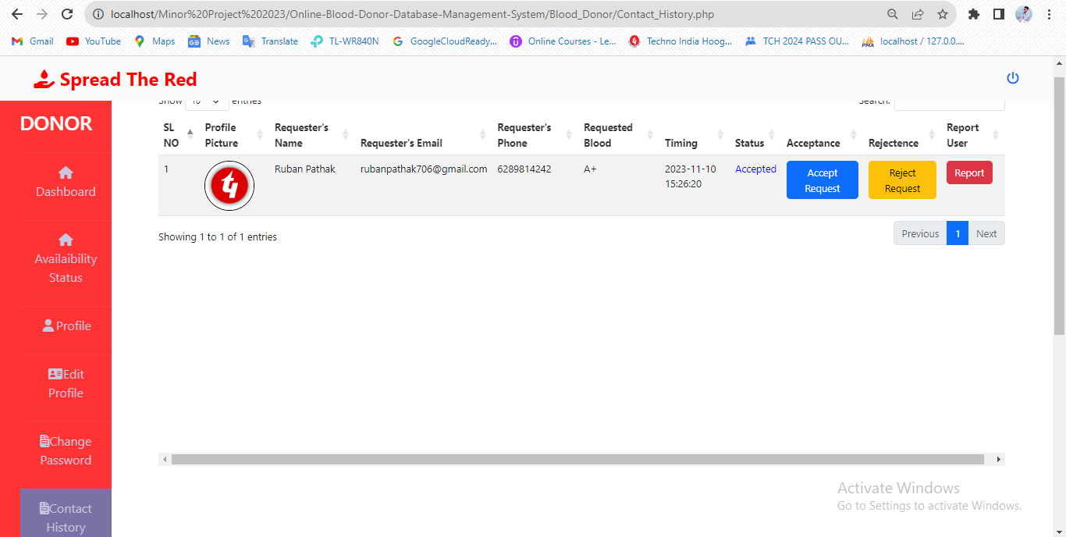

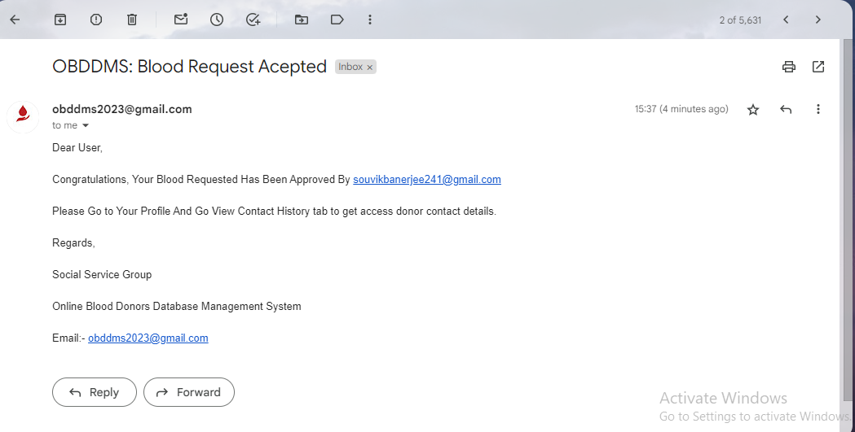

* **Test Case 6 SLNO 2:-**

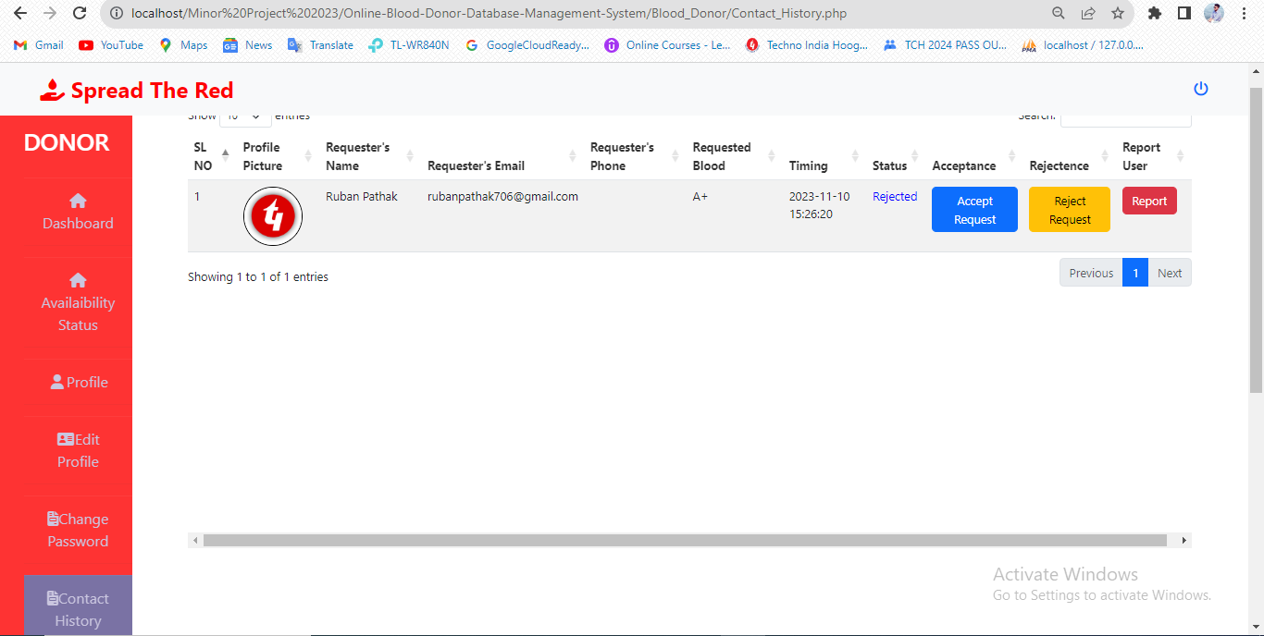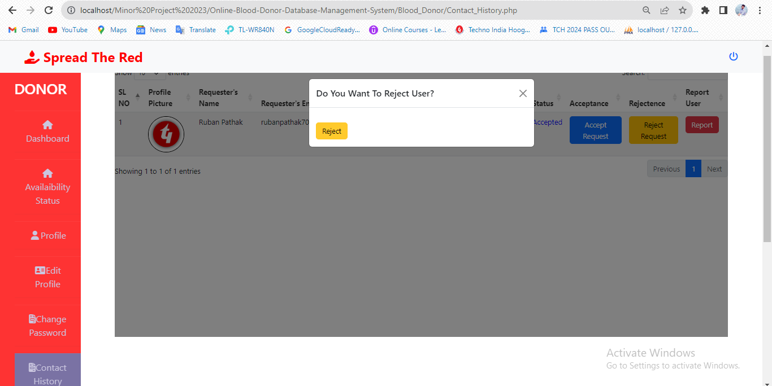



* **Test Case 6 SLNO 3:-**

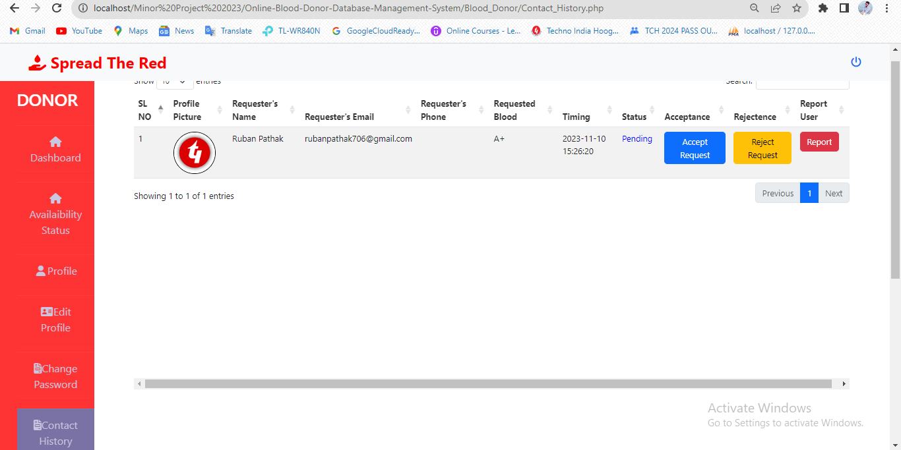

**11.7 *Test Case NO:- 7:-***

**Test Case Name:- Search Facility**

|  |  |  |  |  |
| --- | --- | --- | --- | --- |
| **Test Case NO** | **Test Data** | **Expected** | **Actual** | **Status**  **(pass/ fail)** |
| 1 | <correct blood group>  <correct pin code> | Donors profiles will be available. | Donors profiles will be available. | pass |
| 2 | <incorrect blood group>  <incorrect pin code> | Donors profiles will not be available. | Donors profiles will not be available. | pass |

* **Test Case 7 SLNO 1:-**

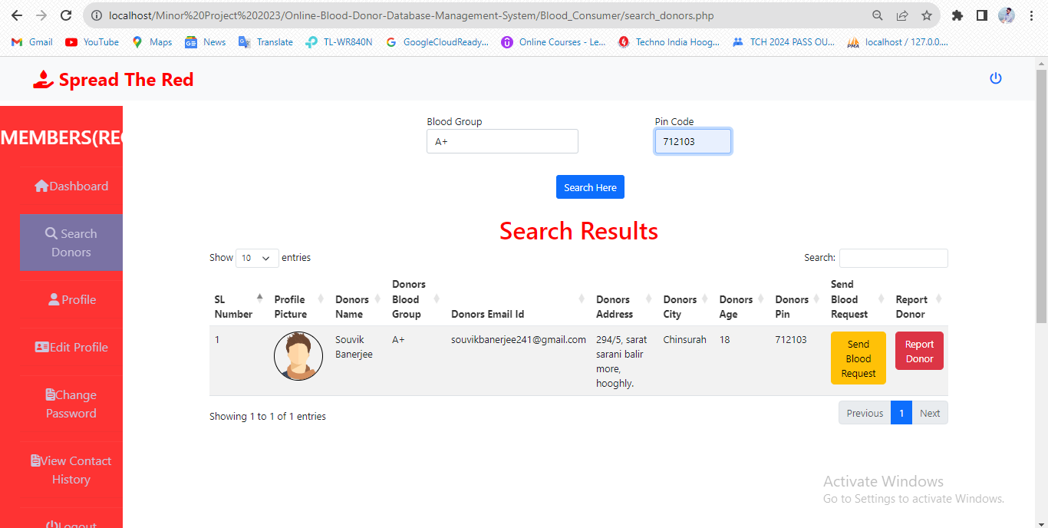

* 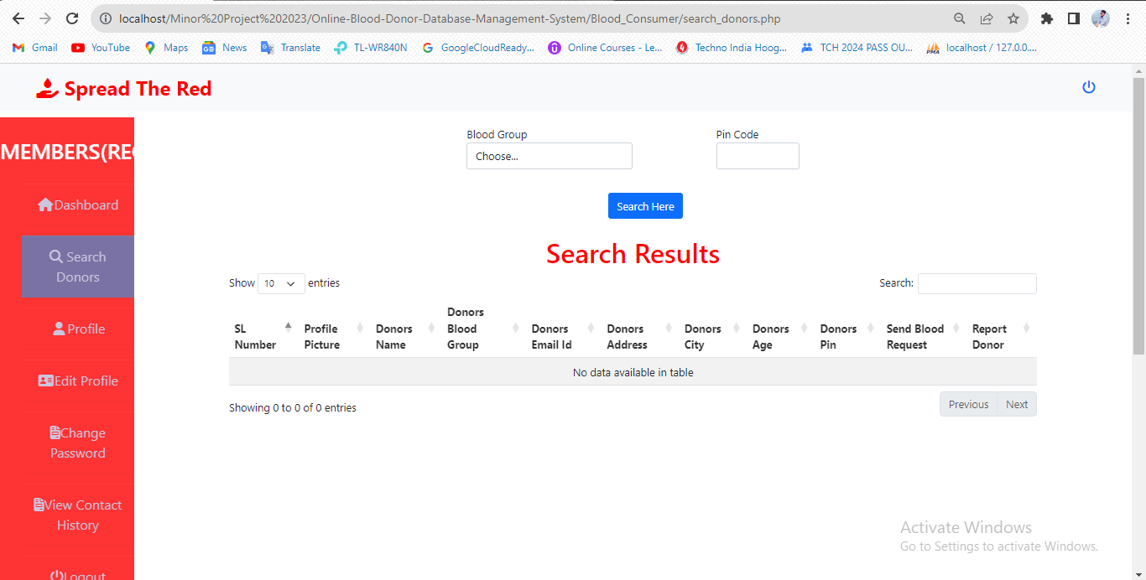**Test Case 7 SLNO 2:-**

**11.8 *Test Case NO:- 8:-***

**Test Case Name:- Send Blood Request And Report Button**

|  |  |  |  |  |
| --- | --- | --- | --- | --- |
| **Test Case NO** | **Test Data** | **Expected** | **Actual** | **Status**  **(pass / fail)** |
| 1 | <Send request button> | An email will sent to the donor. | An email will sent to the donor. | Pass |
| 2 | <Sent report without description> | Report cannot be sent | Report cannot be sent | Pass |
| 3 | <Sent report with description> | Report Sent | Report Sent | Pass |

* 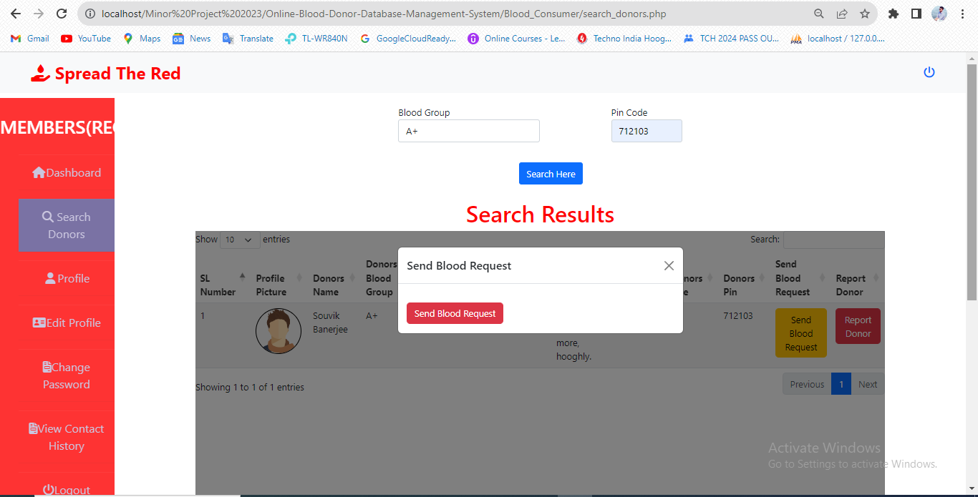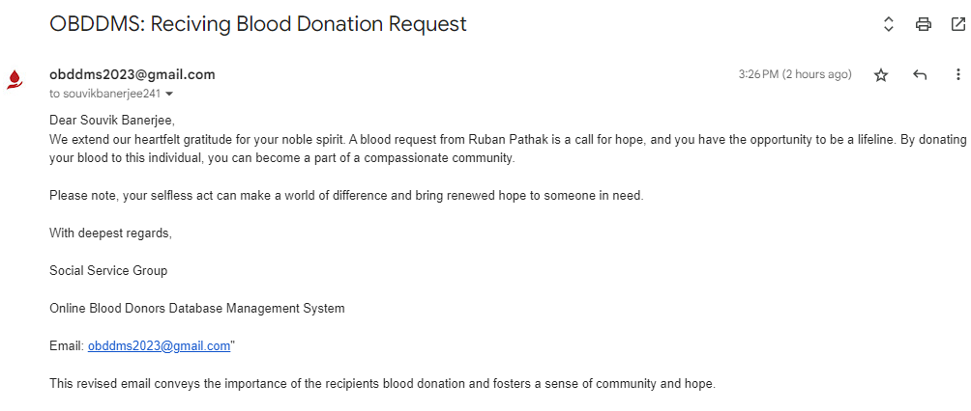**Test Case 8 SLNO 1:-**
* **Test Case 8 SLNO 2:-**

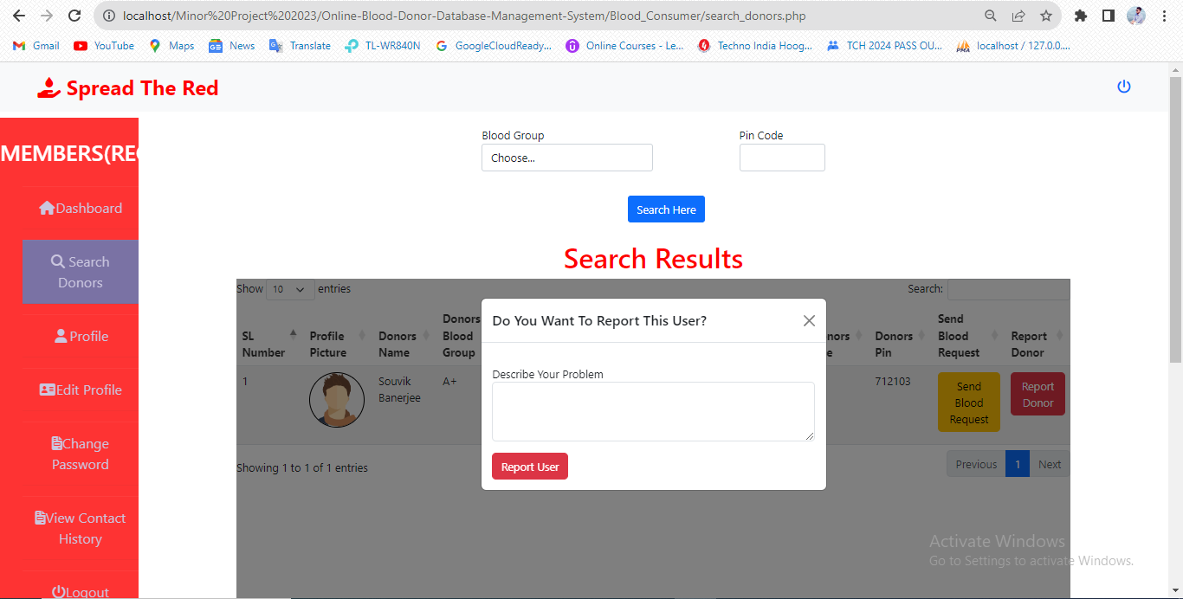

* 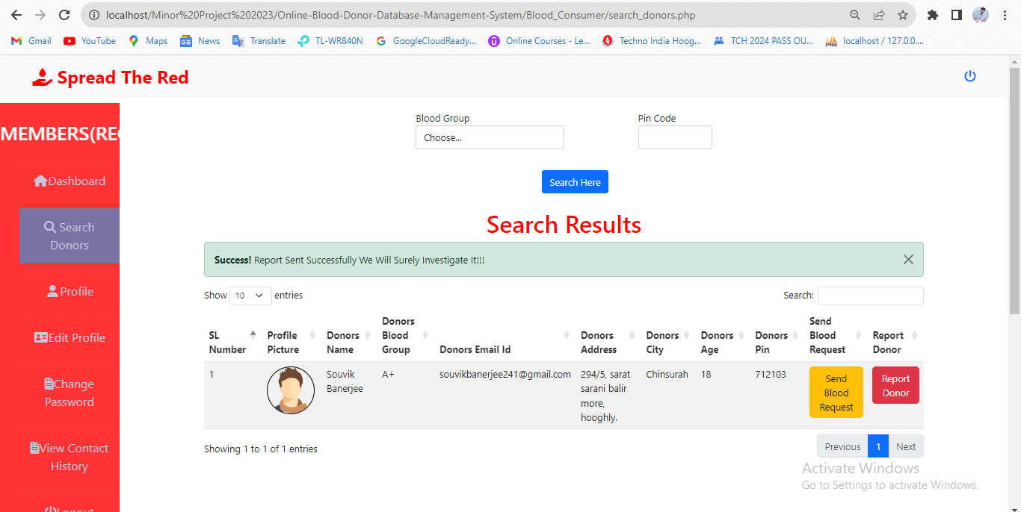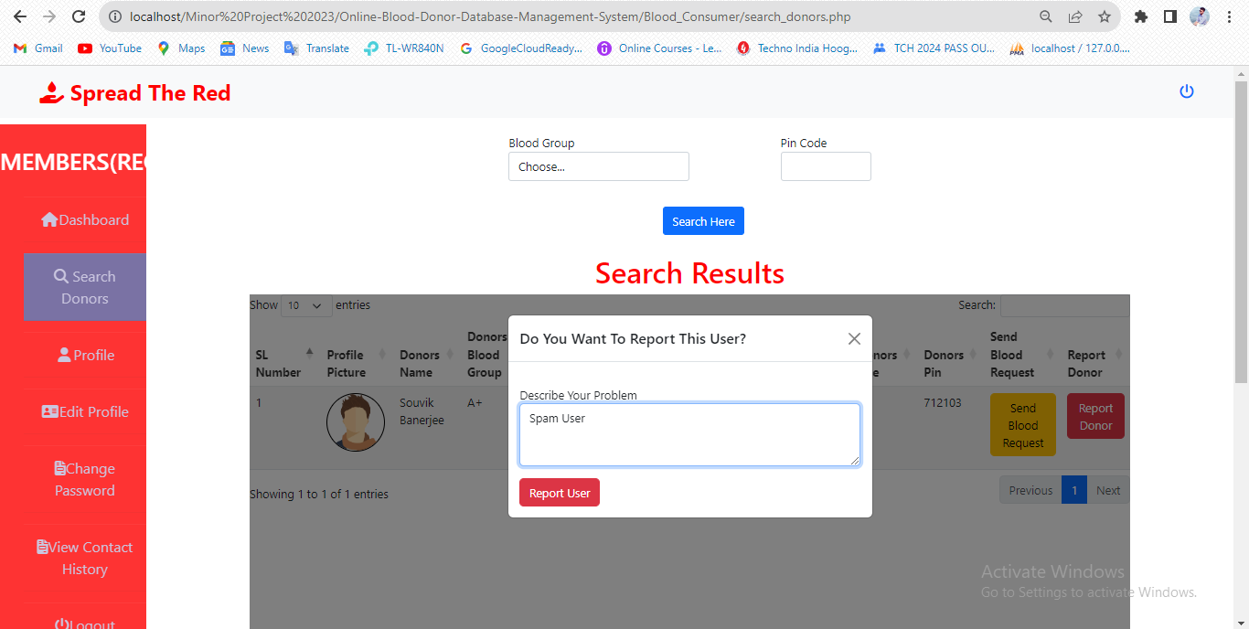**Test Case 8 SLNO 3:-**

**11.9 *Test Case NO:- 9:-***

**Test Case Name:- Pending/Rejected/Accepted Blood Request**

|  |  |  |  |  |
| --- | --- | --- | --- | --- |
| **Test Case NO** | **Test Data** | **Expected** | **Actual** | **Status**  **(pass / fail)** |
| 1 | <Pending> | Donor’s Phone is hidden | Donor’s Phone is hidden | Pass |
| 2 | <accepted> | Donor’s Phone is shown | Donor’s Phone is shown | Pass |
| 3 | <rejected> | Donor’s Phone is hidden | Donor’s Phone is hidden | Pass |

* **Test Case 9 SLNO 1:-**

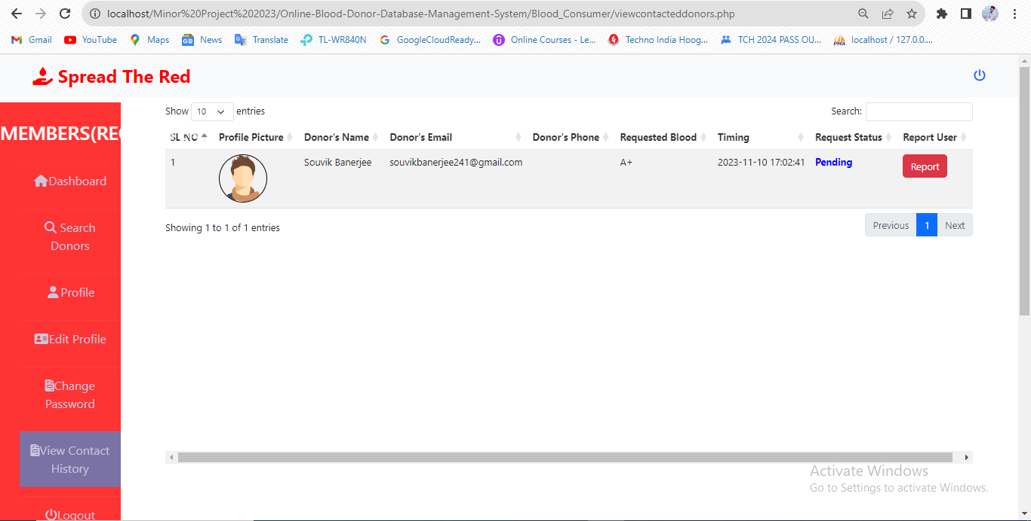

* **Test Case 9 SLNO 2:-**

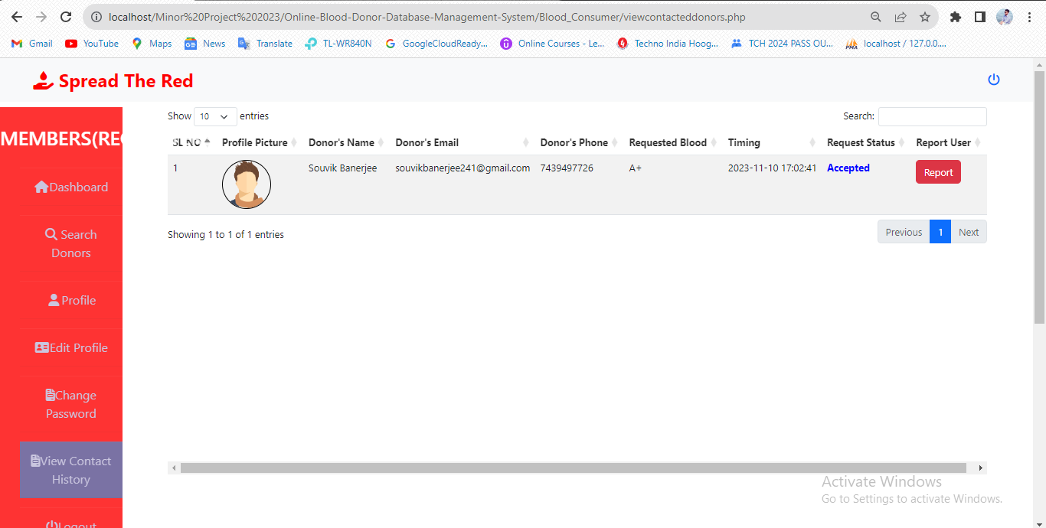

* **Test Case 9 SLNO 3:-**

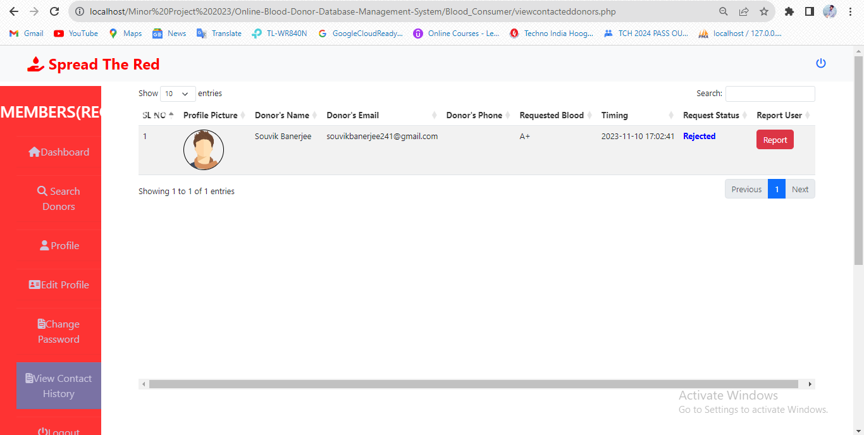

**11.10 *Test Case NO:- 10:-***

**Test Case Name:- Send Warning (Admin Panel)**

|  |  |  |  |  |
| --- | --- | --- | --- | --- |
| **Test Case NO** | **Test Data** | **Expected** | **Actual** | **Status**  **(pass / fail)** |
| 1 | <send warning> | Email Of Warning Can Be Sent | Email Of Warning Can Be Sent | Pass |

* **Test Case 10 SLNO 1:-**

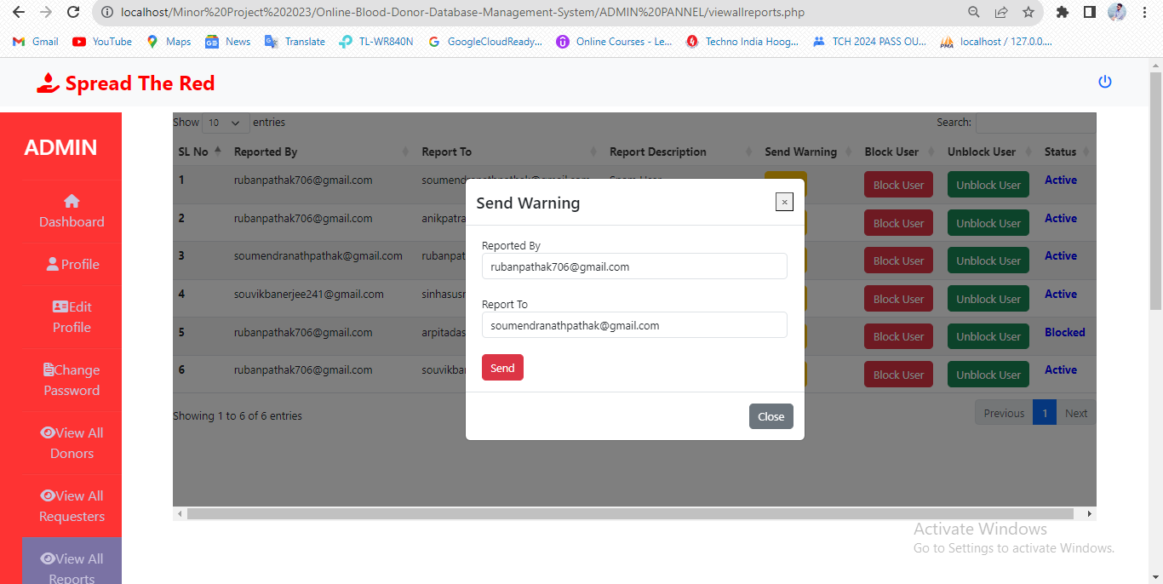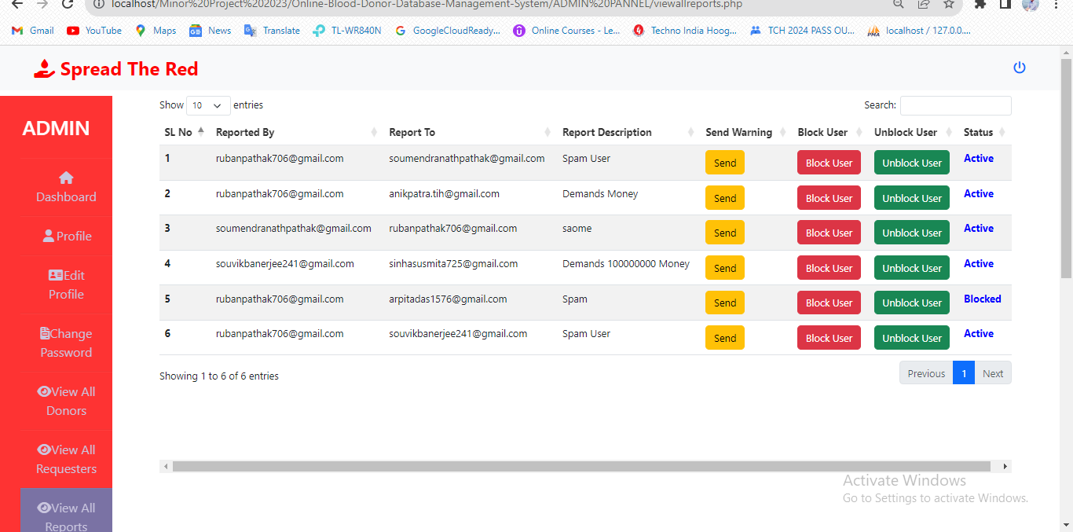

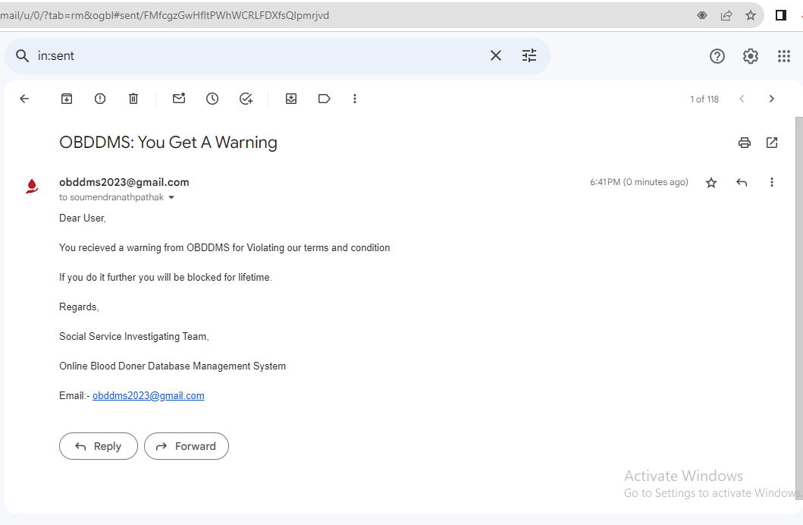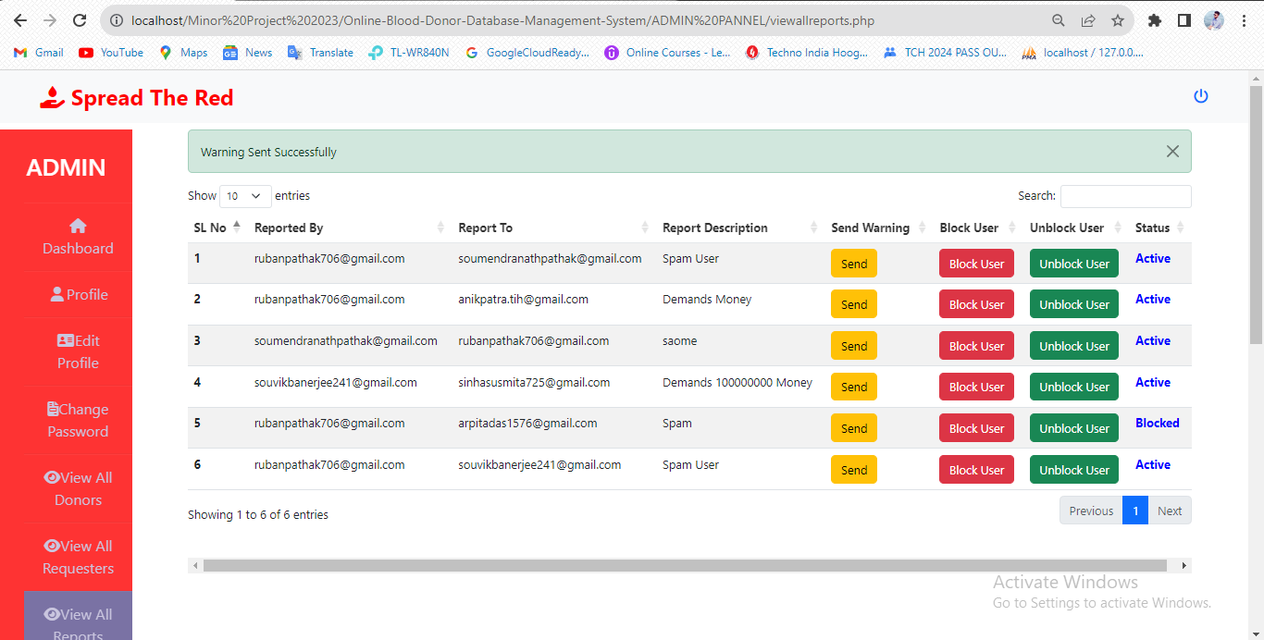

**11.11 *Test Case NO:- 11:-***

**Test Case Name:- Block/Unblock (Admin Panel)**

|  |  |  |  |  |
| --- | --- | --- | --- | --- |
| **Test Case NO** | **Test Data** | **Expected** | **Actual** | **Status**  **(pass / fail)** |
| 1 | <block> | User can be blocked and an email will be sent | User can be blocked and an email will be sent | Pass |
| 2 | <unblock> | User can be unblocked and an email will be sent | User can be unblocked and an email will be sent | Pass |

* 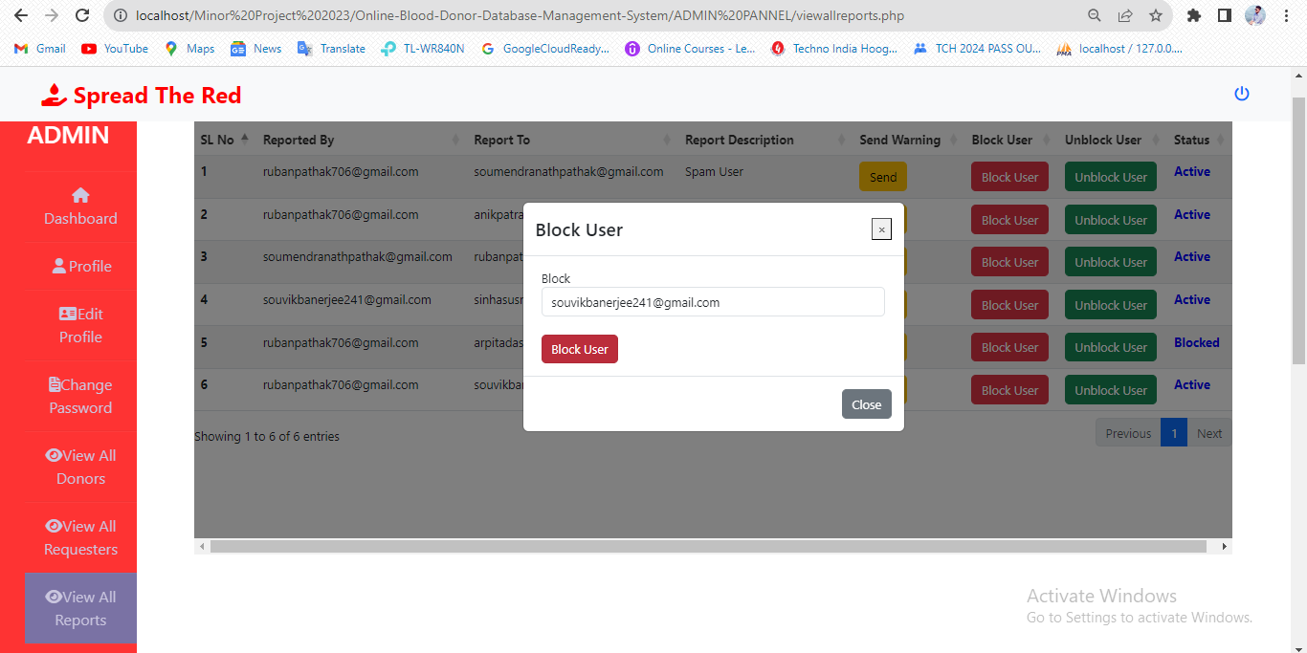**Test Case 11 SLNO 1:-**



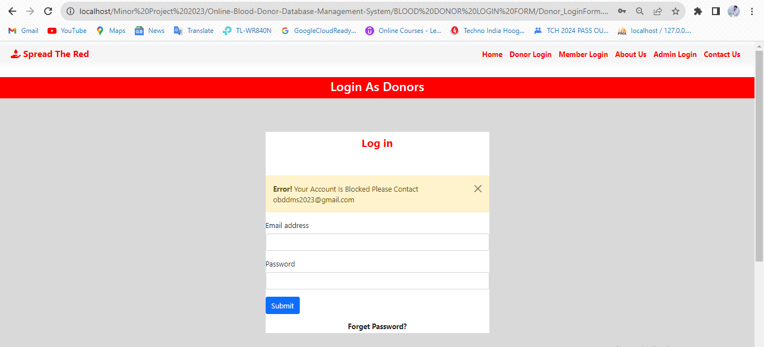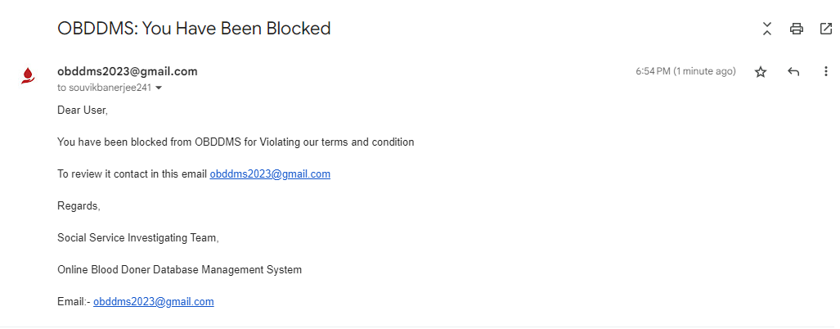

* **Test Case 11 SLNO 2:-**

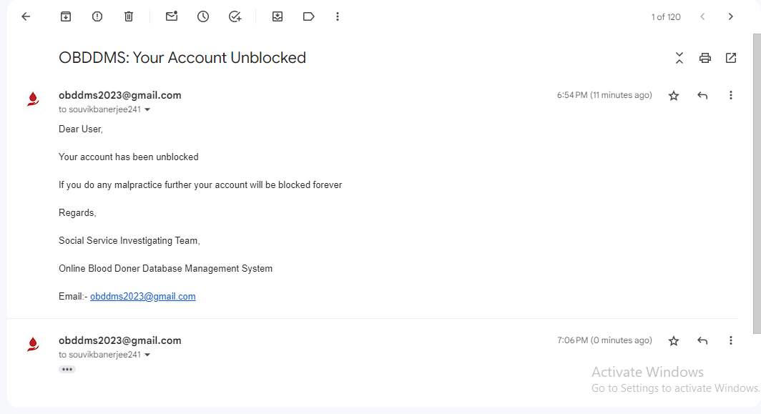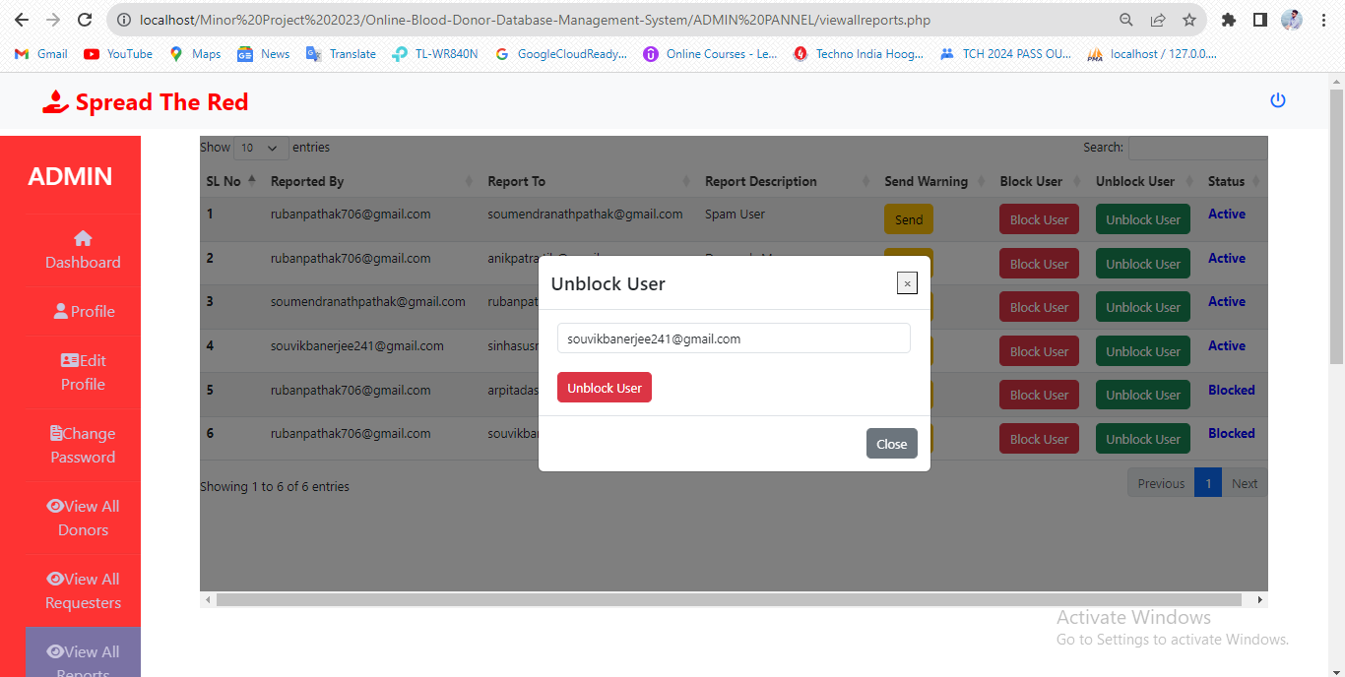

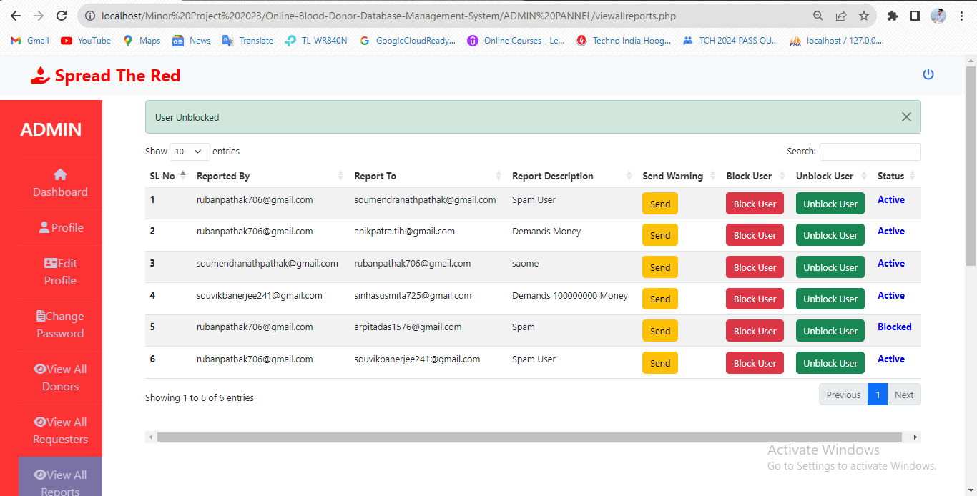

1. **User Manual:-**

**12.1 User Manual For Blood Donor**

1. All new Donors can enter into our website with their basic details like (Name, Email, Phone, Address, Age, Password etc) through this signup page.

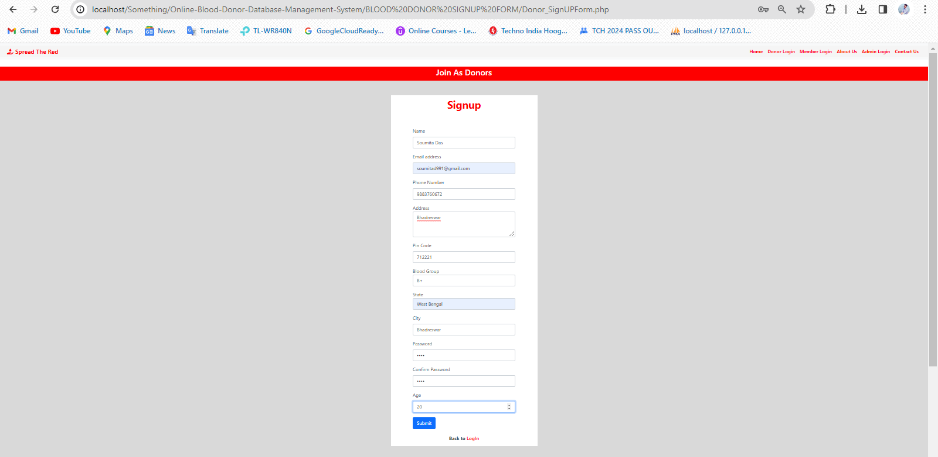

1. After submitting the sign up form, a random 6 digit otp will be sent to the donor’s specified email address.

The donor should put the otp correctly into the otp modal for completing the sign up process.

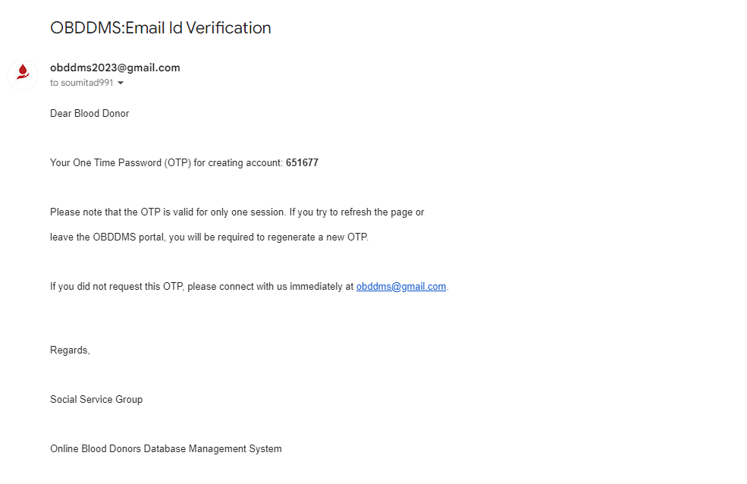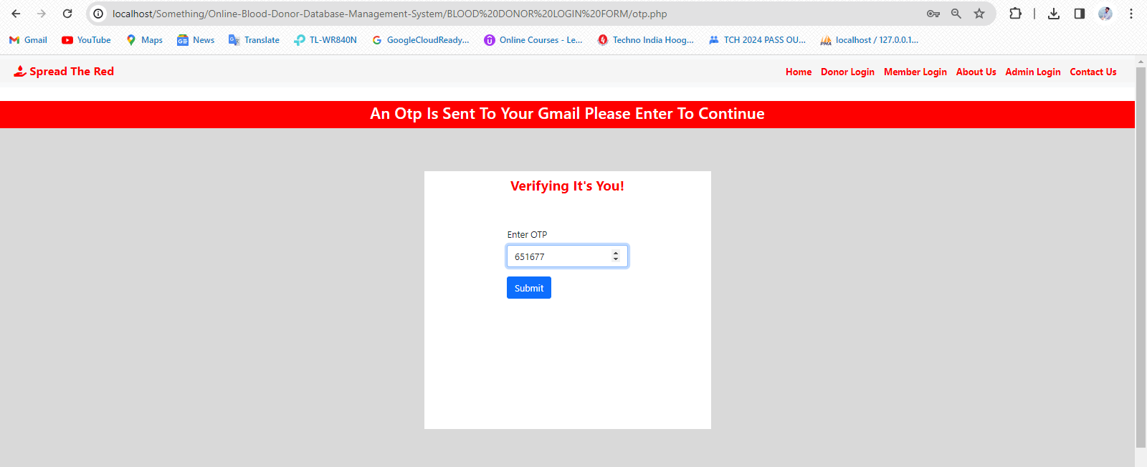

1. If the entered OTP is invalid, an error message will be displayed and donor should enter the correct otp again.

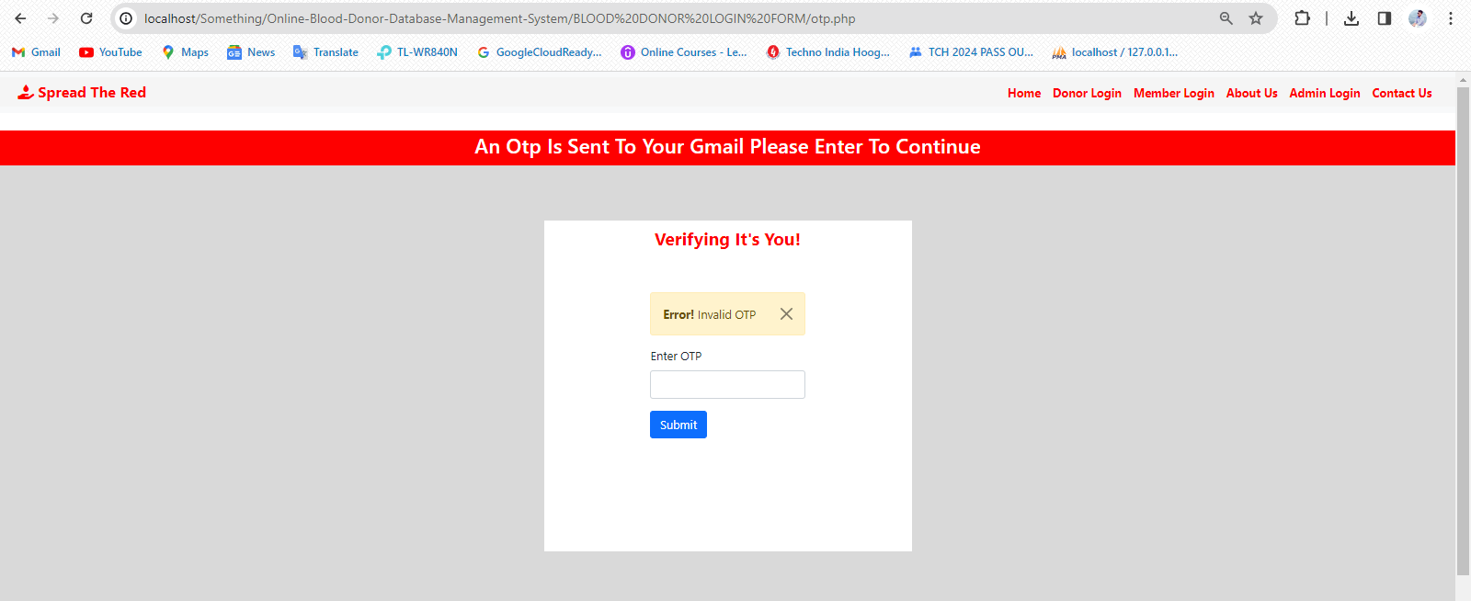

1. Donors will be redirected to the login page after completing the signup process. Where they can put their email address, and password.

If the credentials do not match, an error message will be displayed.

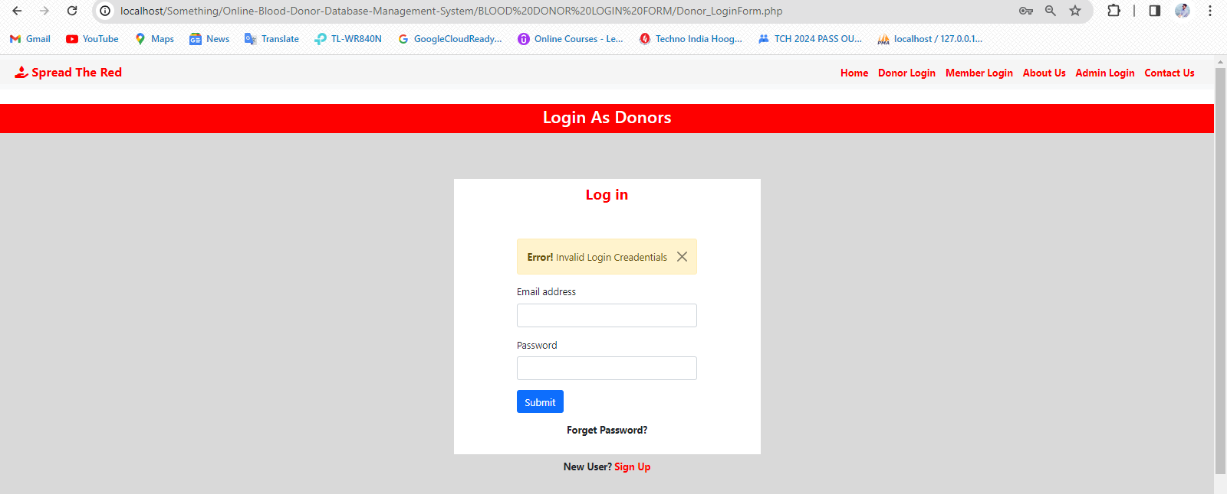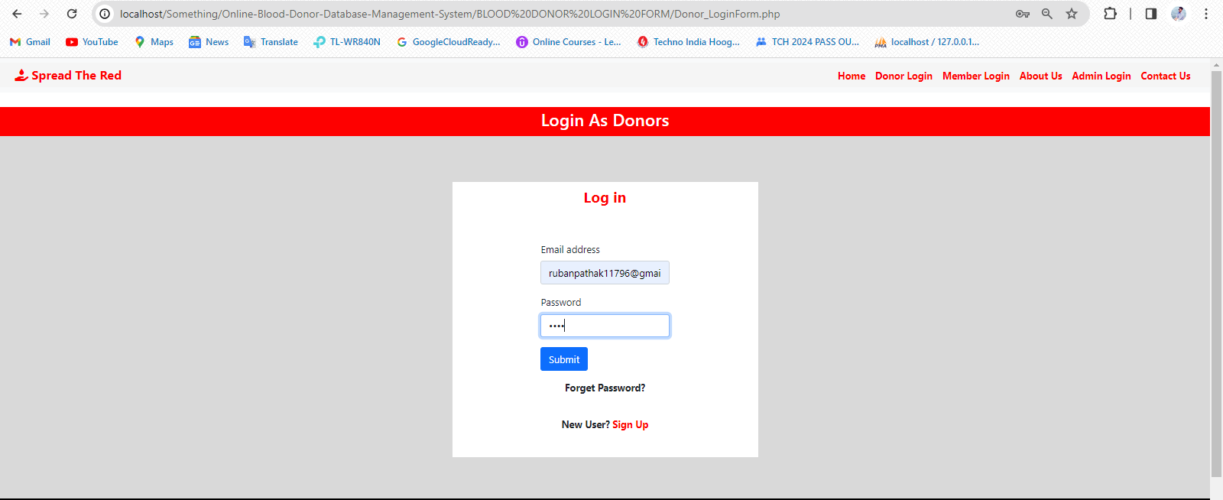

1. Otherwise the login process is complete and the donor will be redirected to the Dashboard.

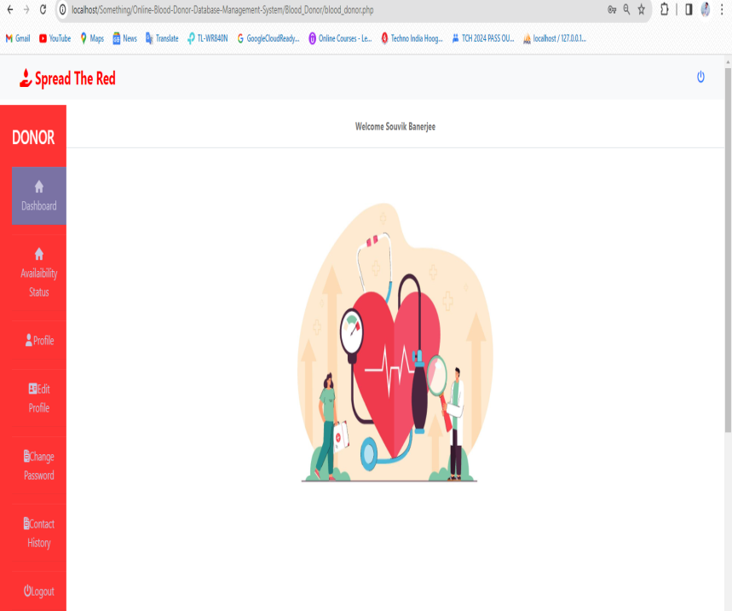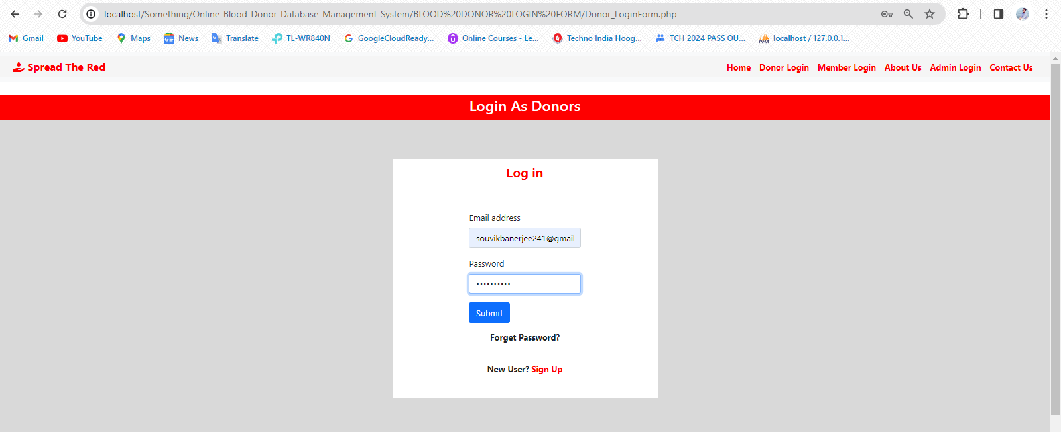

1. In the Availability Status section donors can hide their or show their profile from the other requesters after donating blood.

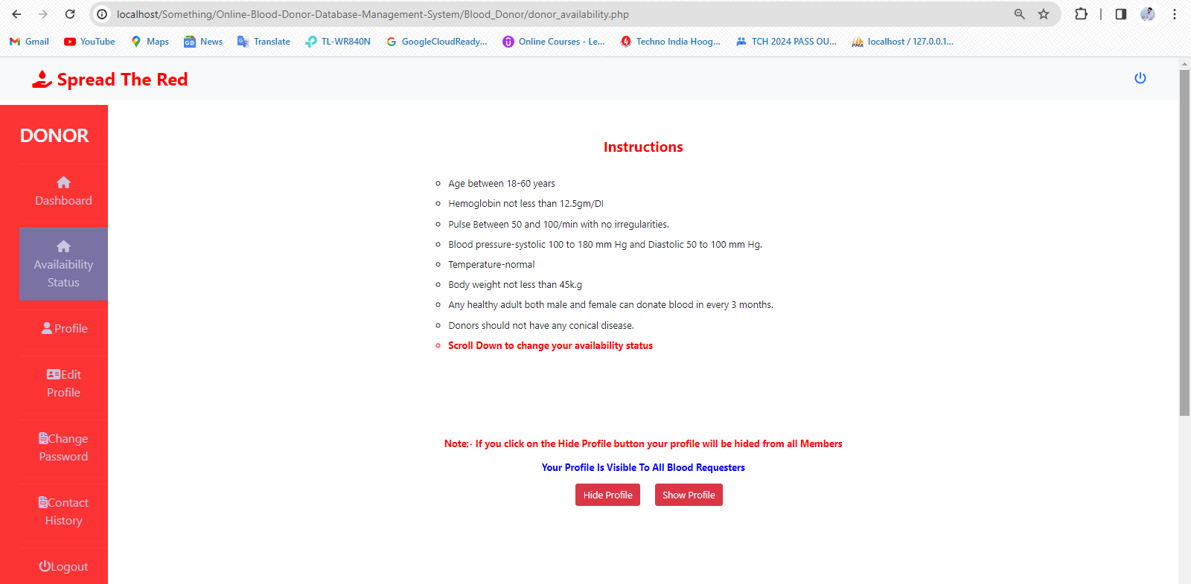

CLICK HERE TO SHOW YOUR PROFILE

CLICK HERE TO HIDE YOUR PROFILE

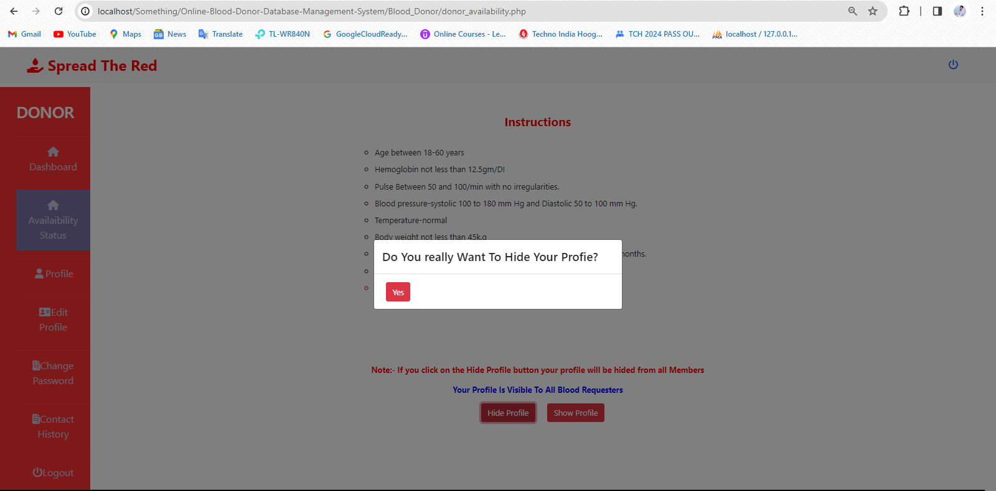

CLICK HERE TO CONFIRMATION FOR HIDE

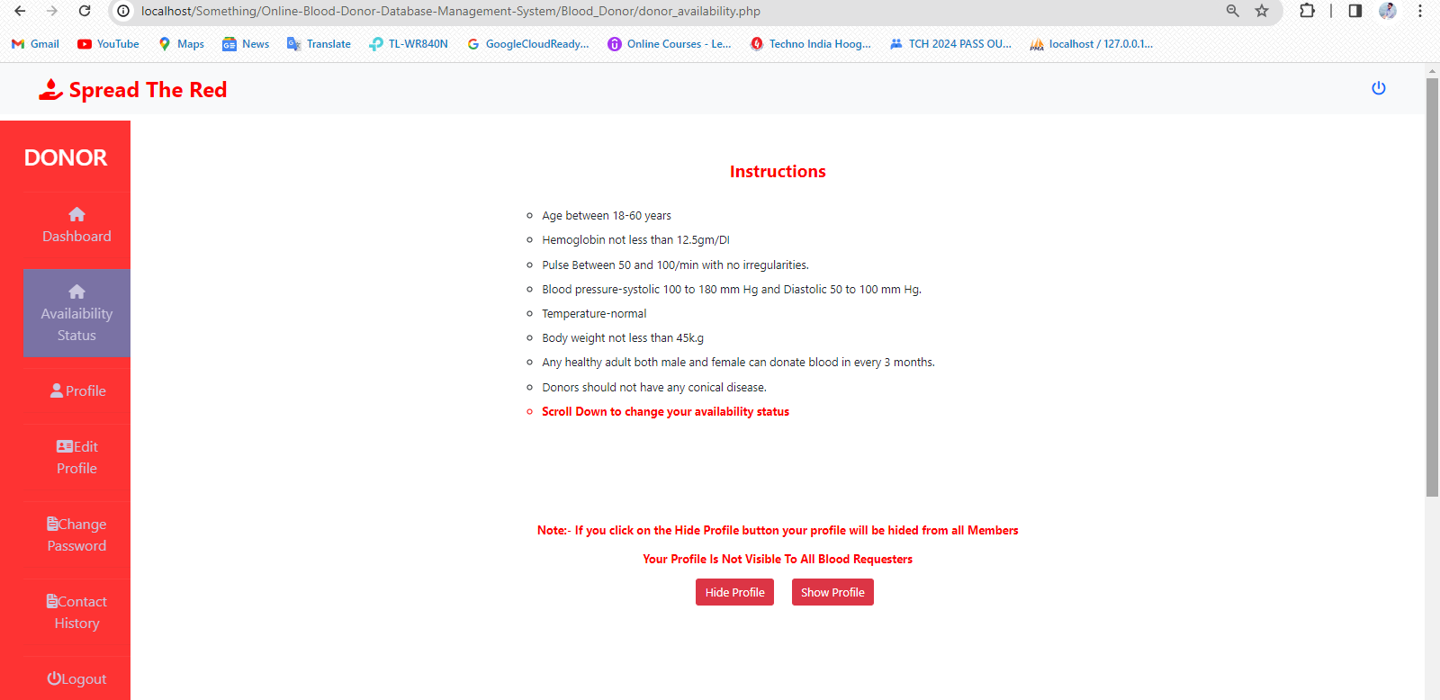

FINALLY YOUR PROFILE WILL BE HIDDEN

1. Now, in the contact history section the donor can accept reject or report that particular requester the process are here:-

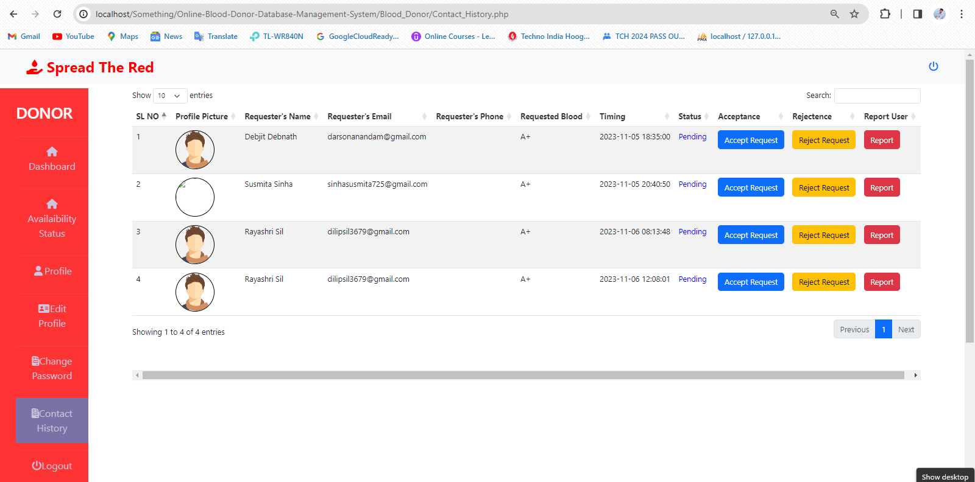

FIRSTLY, SELECT THIS FROM ANY OF THIS PENDING REQUEST (IF YOU WANT TO ACCEPT THIS REQUEST)

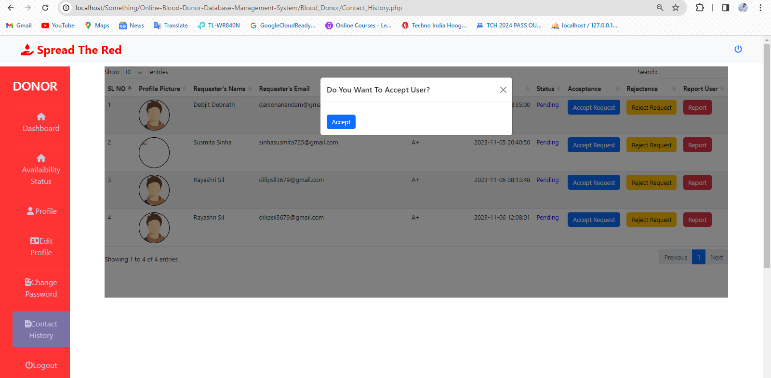

NOW ACCEPT THIS AND WAIT FOR SOME SECONDS BECAUSE AN EMAIL IS SENDING

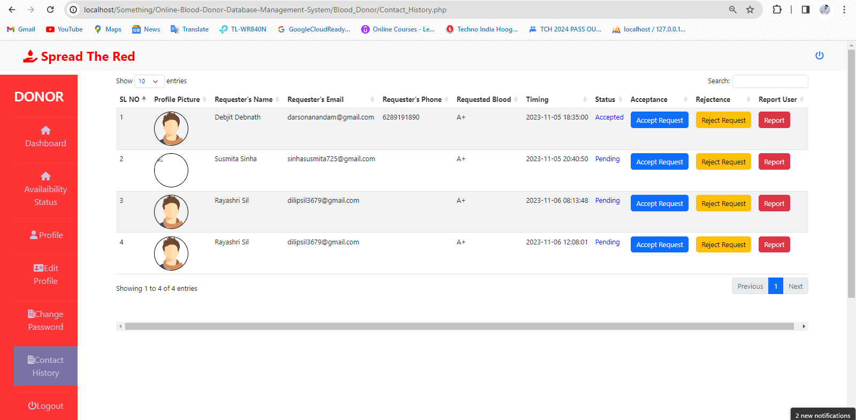

ALSO THE STATUS CAN BE CHANGED TO ACCEPTED

THE REQUESTER’S PHONE CAN BE SHOWN

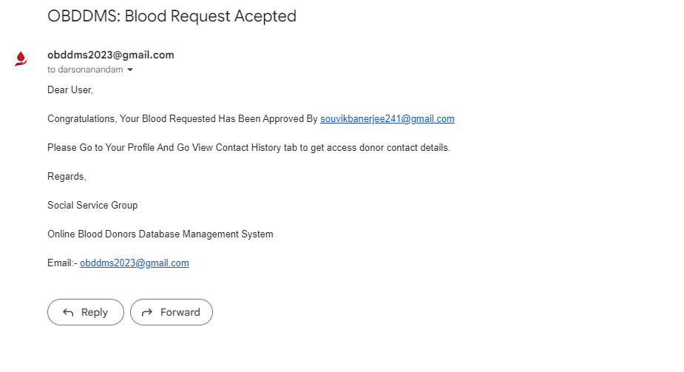

AT THAT TIME THIS EMAIL CAN BE SENT



IF YOU WANT TO REJECT THIS REQUEST CLICK ON THIS

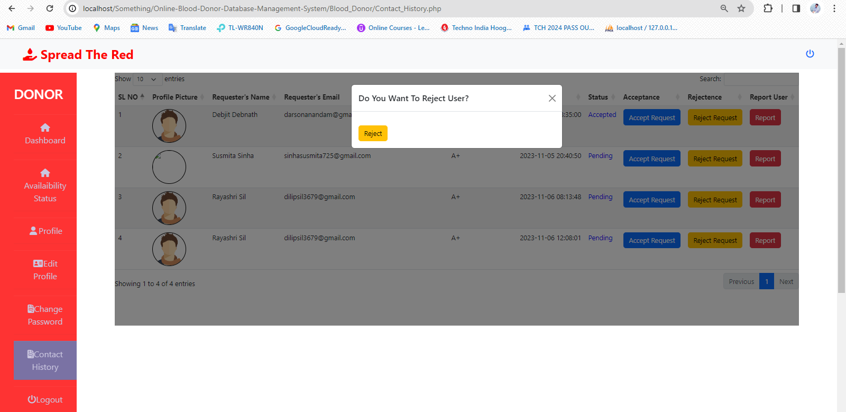

NEXT CLICK ON THIS TO REJECT REQUEST AND WAIT FOR SOME SECOND FOR SENDING EMAIL

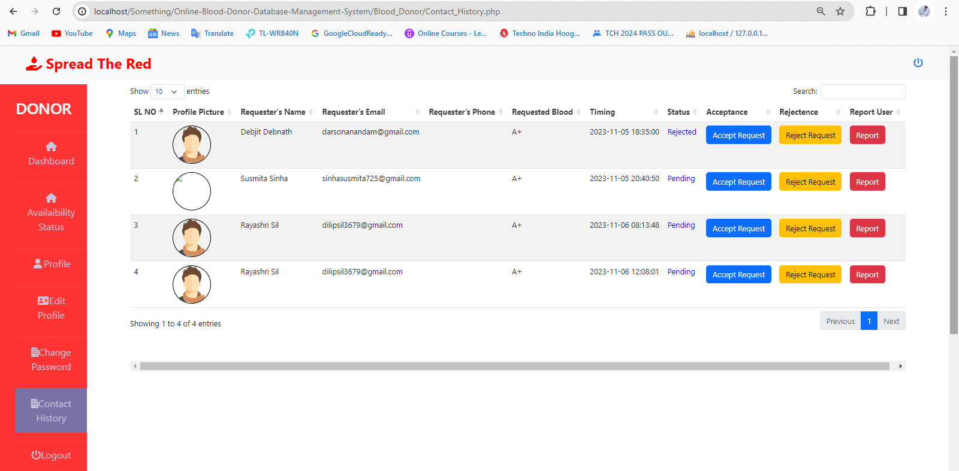

AND THE STATUS CAN BE CHANGED TO REJECTED

NOW THE PHONE NUMBER WILL BE HIDED

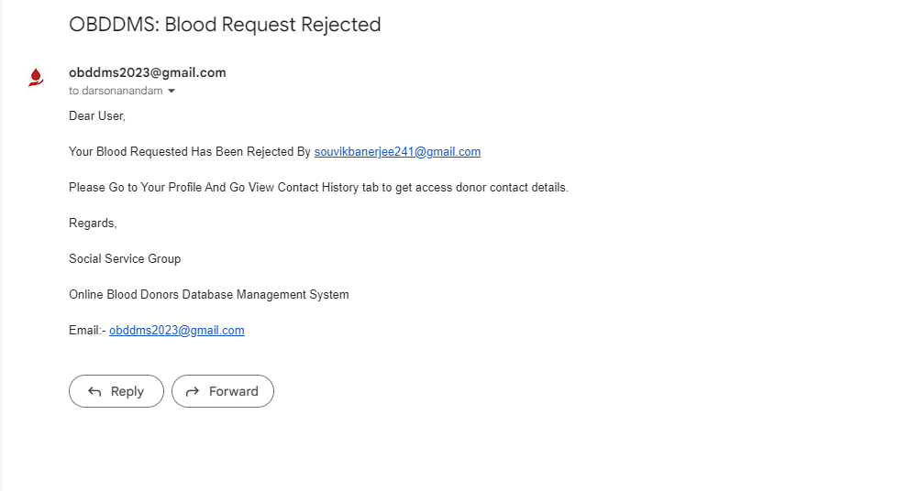

AT THE SAME TIME THIS EMAIL CAN BE SENT TO THAT REQUESTER



TO REPORT THIS BLOOD REQUESTER CLICK ON THE REPORT BUTTON

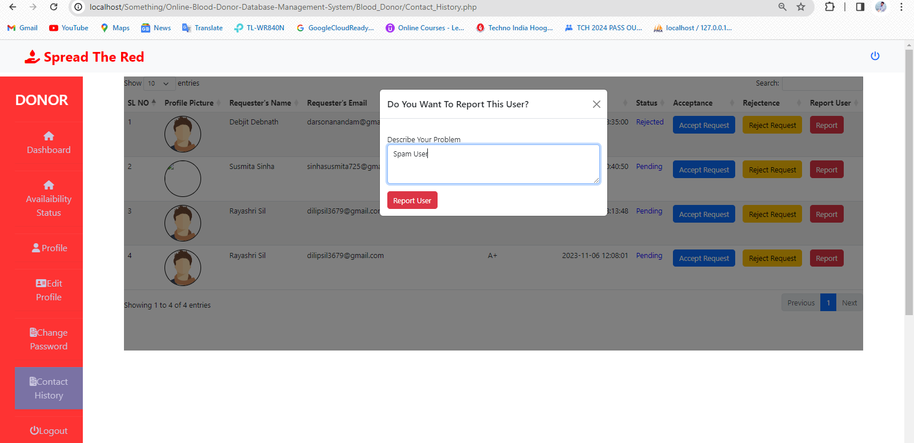

NEXT CLICK ON THIS BUTTON TO SUBMIT REPORT

FILL UP THIS FIELD

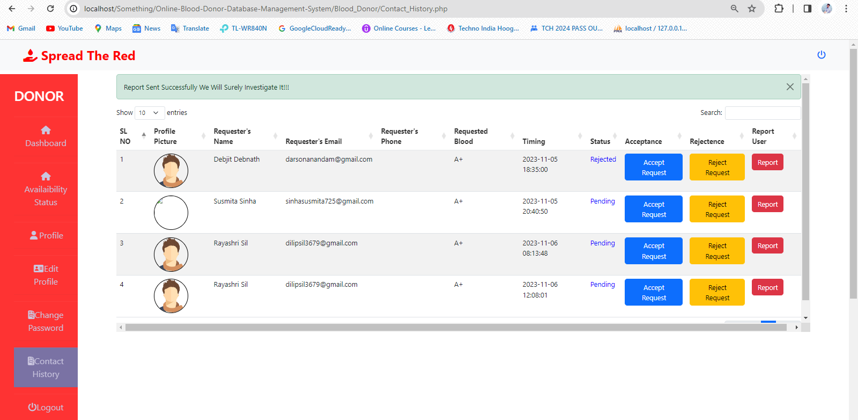

REPORT SUBMITTED SUCCESSFULLY

1. The donor can view their profile through the ‘Profile’ option.

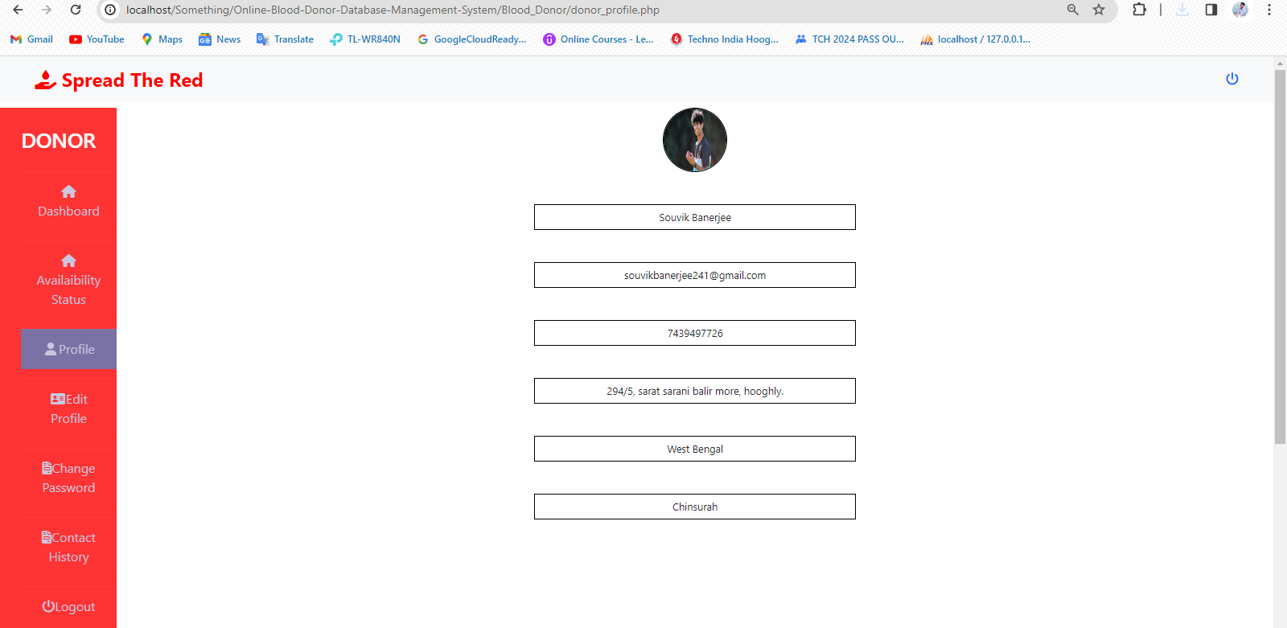

1. Donor also will be able to edit their basic account details via ‘Edit Profile’ option.

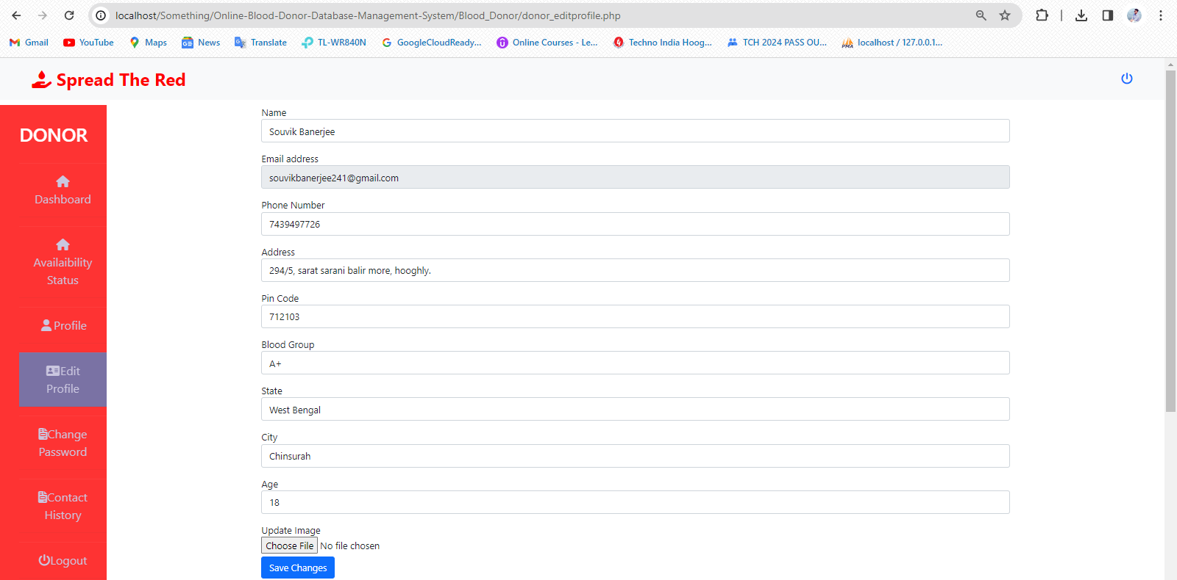

1. Any time a donor can change their password through the ‘Change Password’ option.

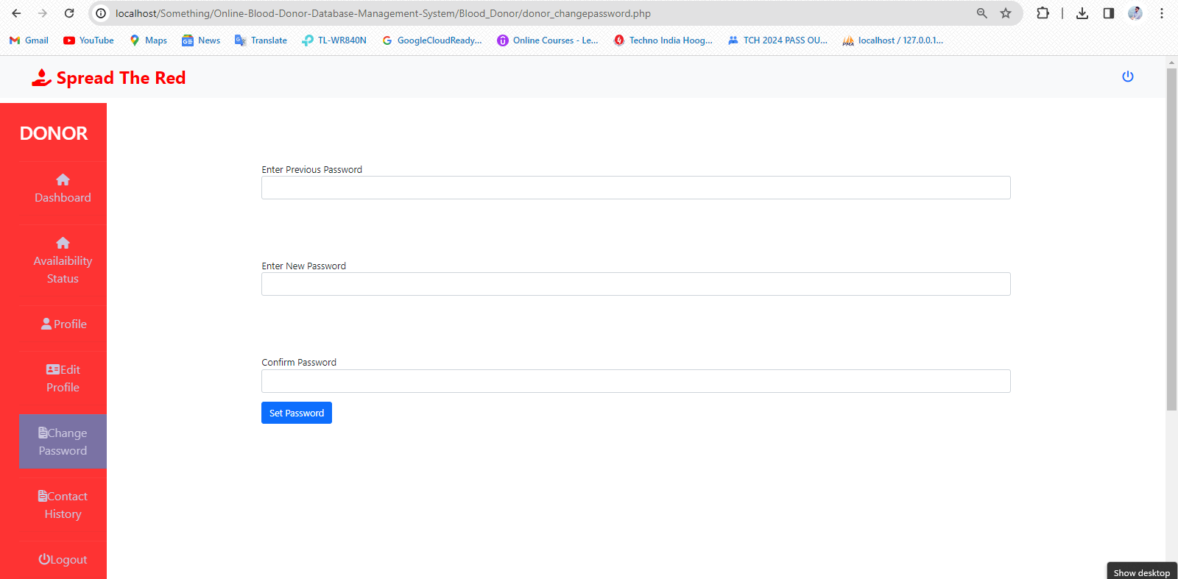

1. Forget password instructions

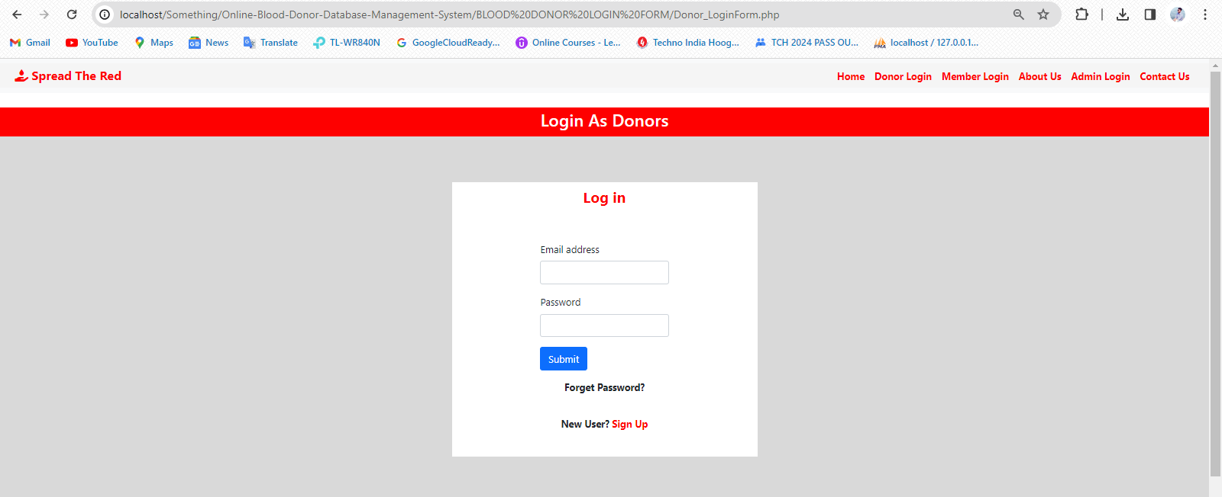

CLICK HERE

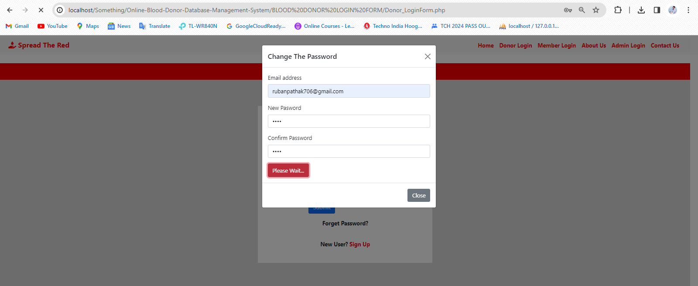

AFTER FILLING UP THE FORM CLICK HERE

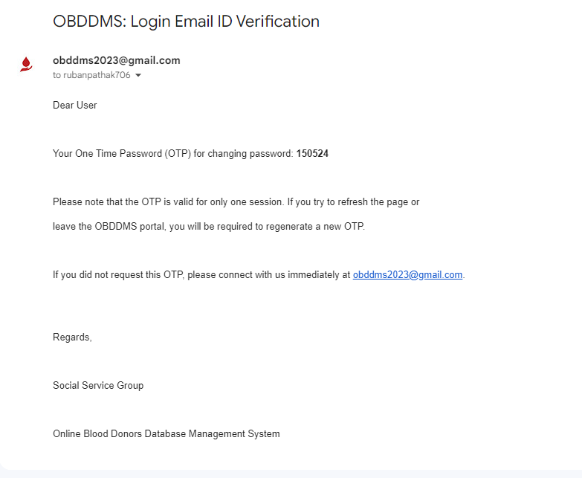

COPY THIS OTP

COPY THIS OTP

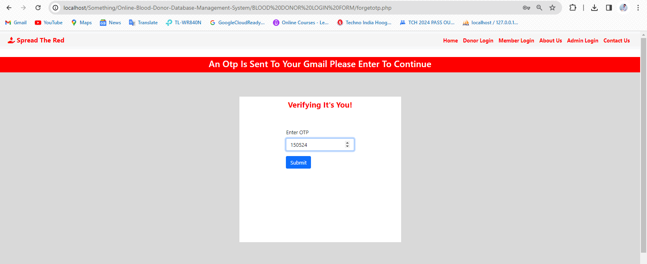

PASTE THE OTP AND SUBMIT THE OTP TO CHANGE YOUR PASSWORD

User Manual

**12.2**  Blood Requester (Member):

1. All new Members can enter into our website with their basic details like (Name,Email,Phone,Address,Age,Password etc) through this signup page.

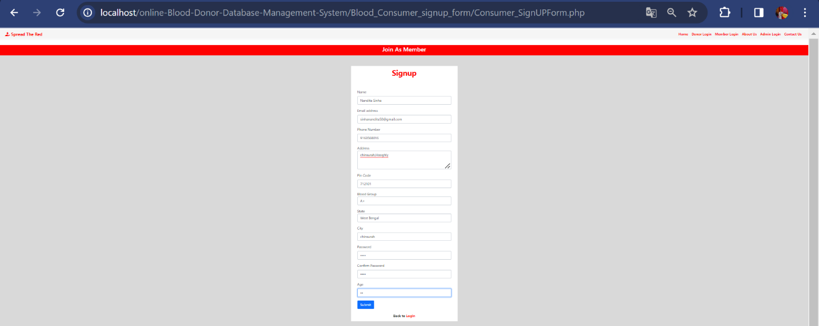

1. After submitting the sign up form, a random 6 digit otp will be sent to the member’s specified email address.

The member should put the otp correctly into the otp modal for completing the sign up process.

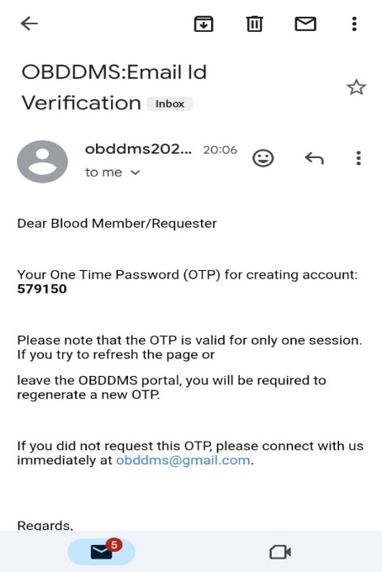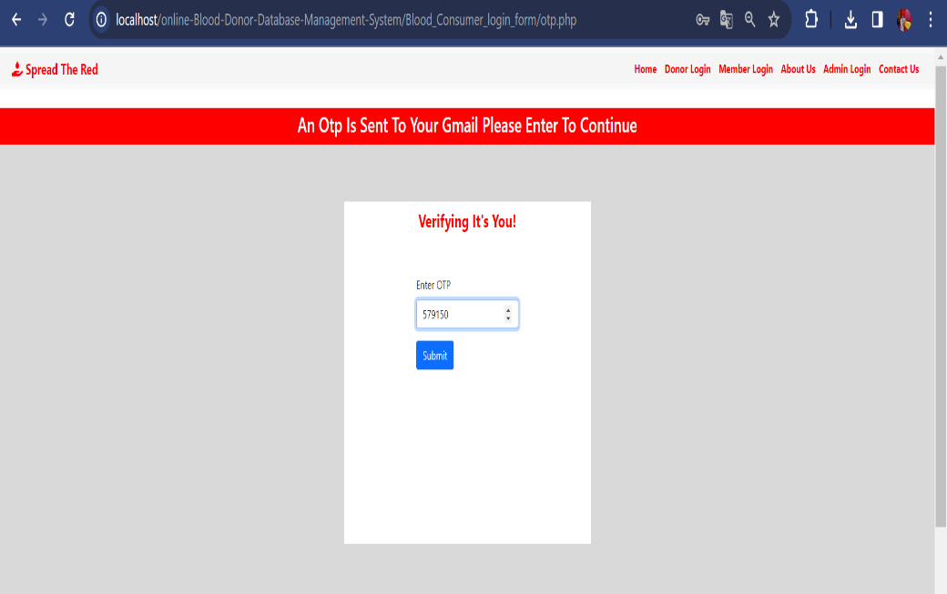

1. If the entered OTP is invalid, an error message will be displayed and member should enter the correct otp again.

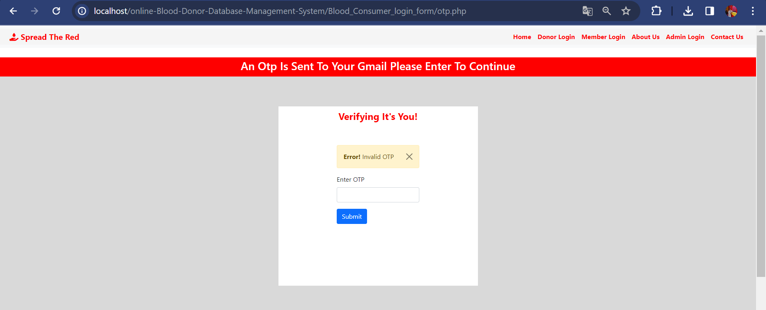

1. Members will be redirected to the login page after completing the signup process. Where they can put their email address, and password.

If the credentials do not match, an error message will be displayed.

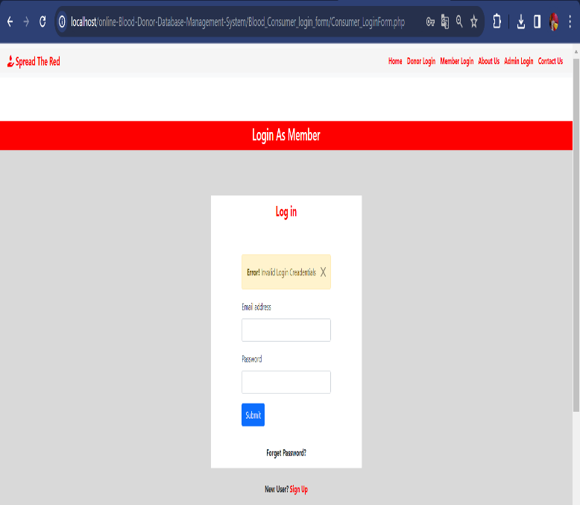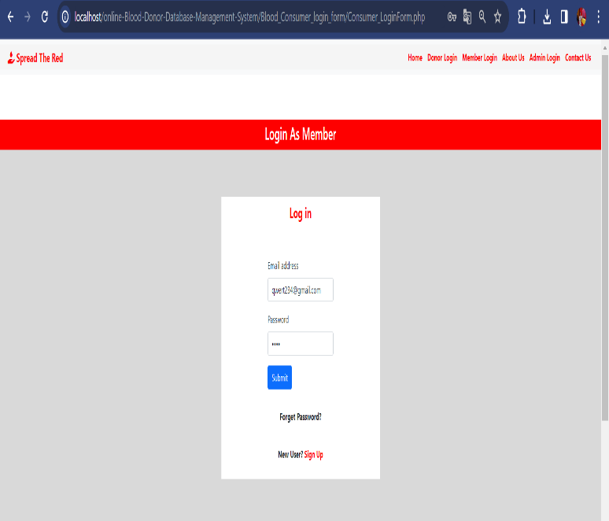

1. 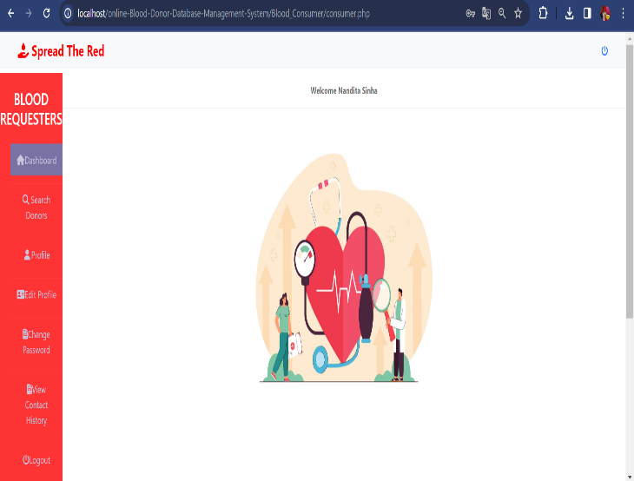Otherwise the login process is complete and the member will be redirected to the Dashboard.

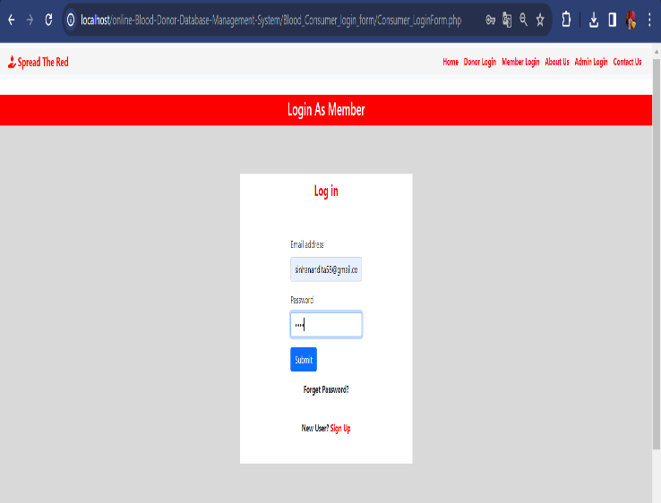

1. 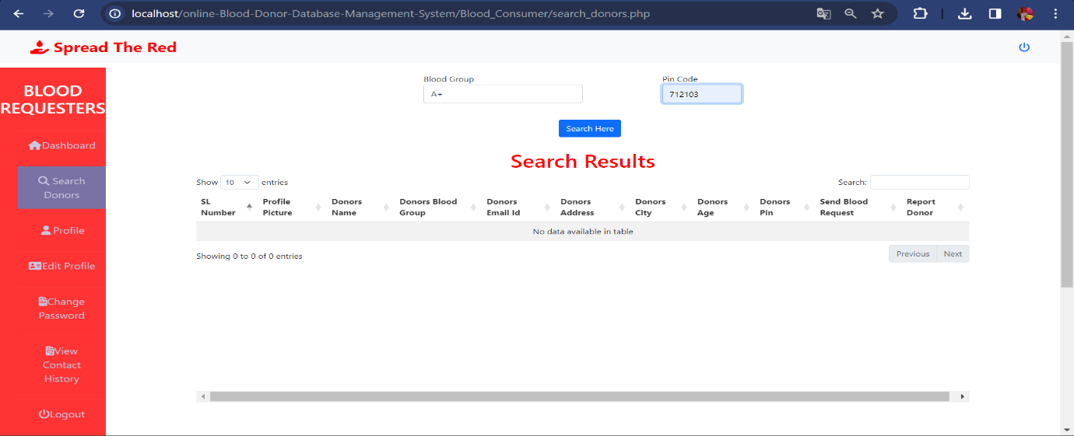In the 'Search Donors' option, members can search for the respective donor based on their required Blood Group and pincode.
2. 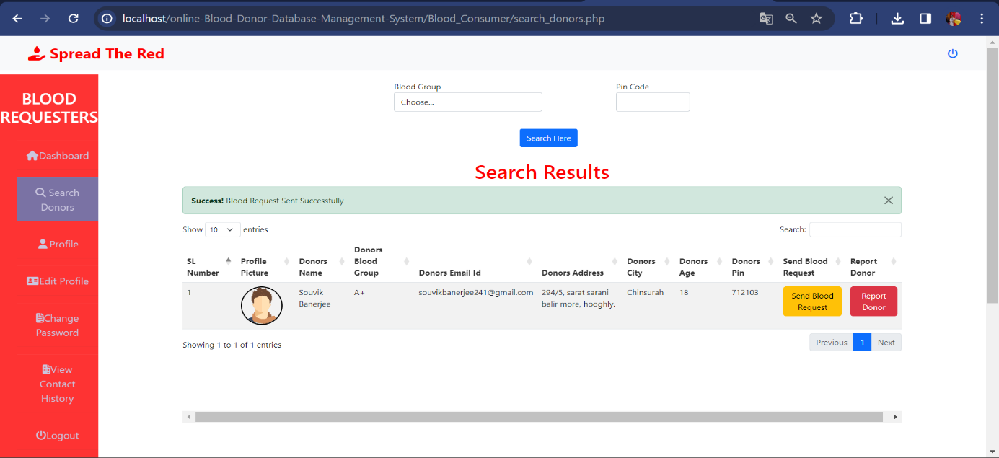The available donor list will be displayed for that particular pin code.
3. If the member sends the request, a request message will be sent to the donor's email address.

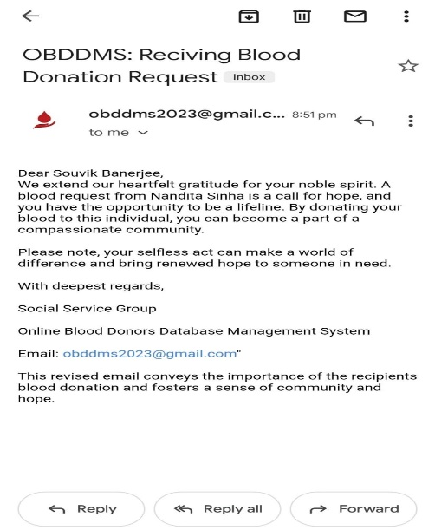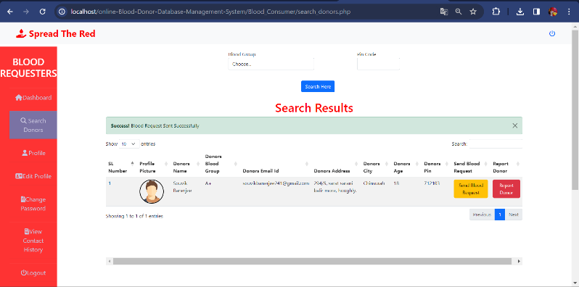

1. Until the donor either accepts or rejects the request, the member's status will be displayed as 'pending'. The donor’s contact no also hidden.

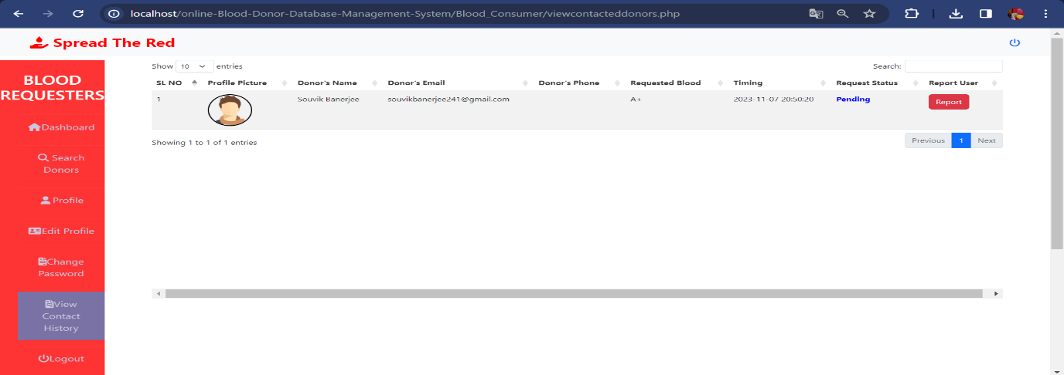

1. When the donor accepts the request, the status will be updated to 'Accepted'. Simultaneously the donor contact will be unhided to that particular member.

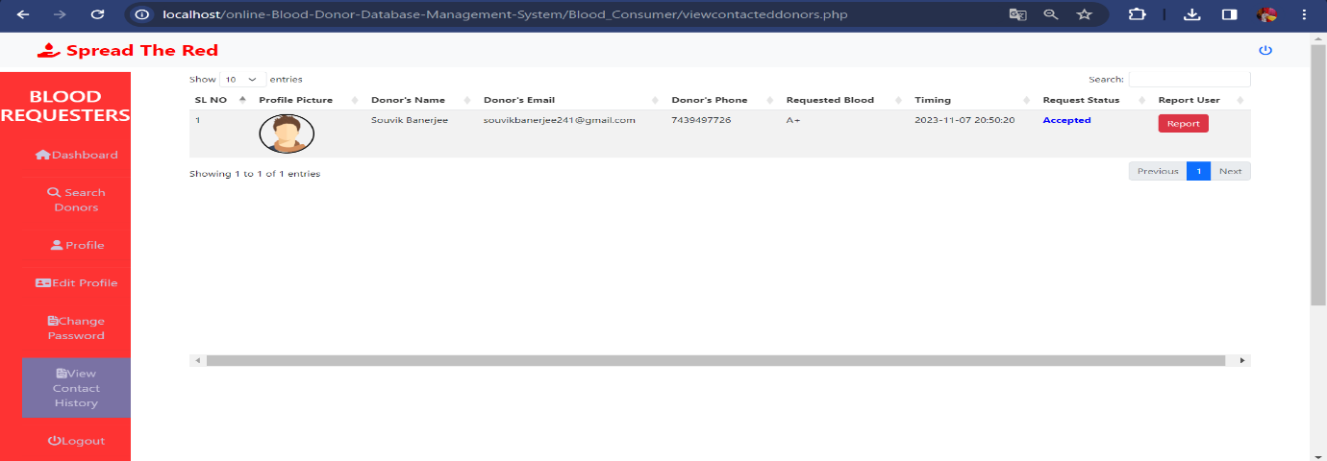A system generated receive request email will be sent to the requester email.

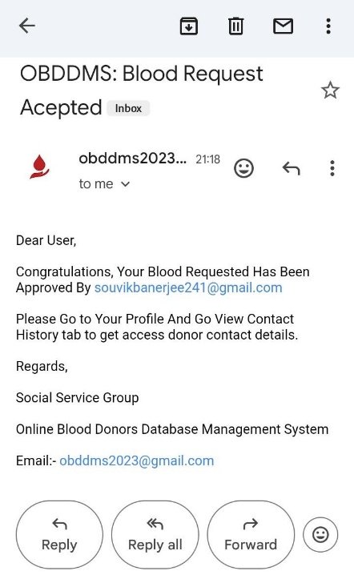

1. 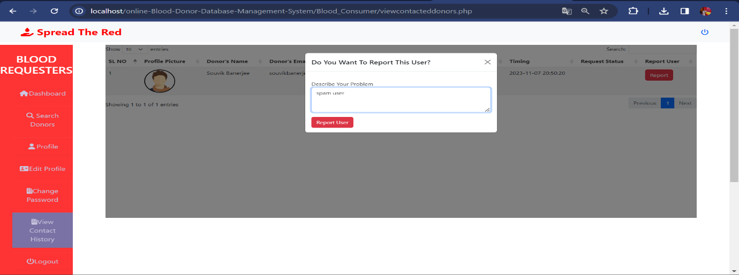We try to increase the security of this whole process and that’s why we add the report feature. In which a particular member can reported against the in-appropriate donor.
2. The report successfully sent to the admin pannel.

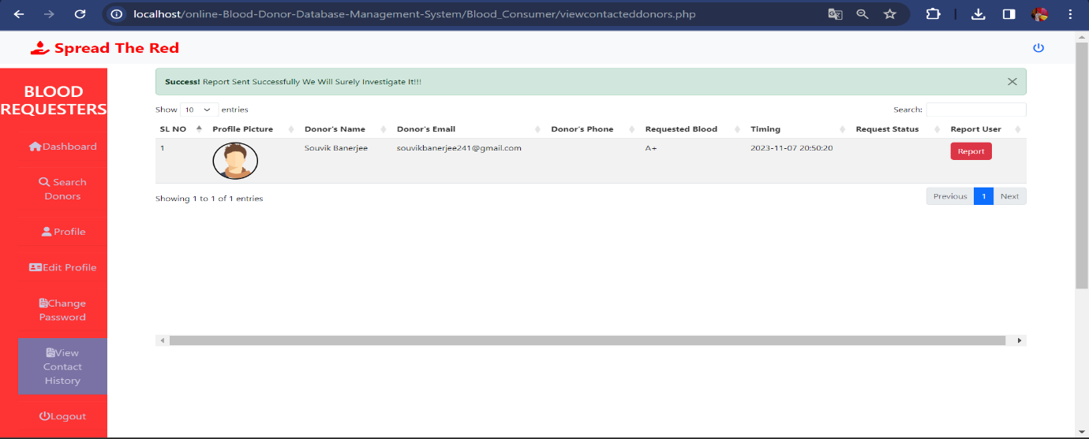

1. The member can view their profile through the ‘Profile’ option.

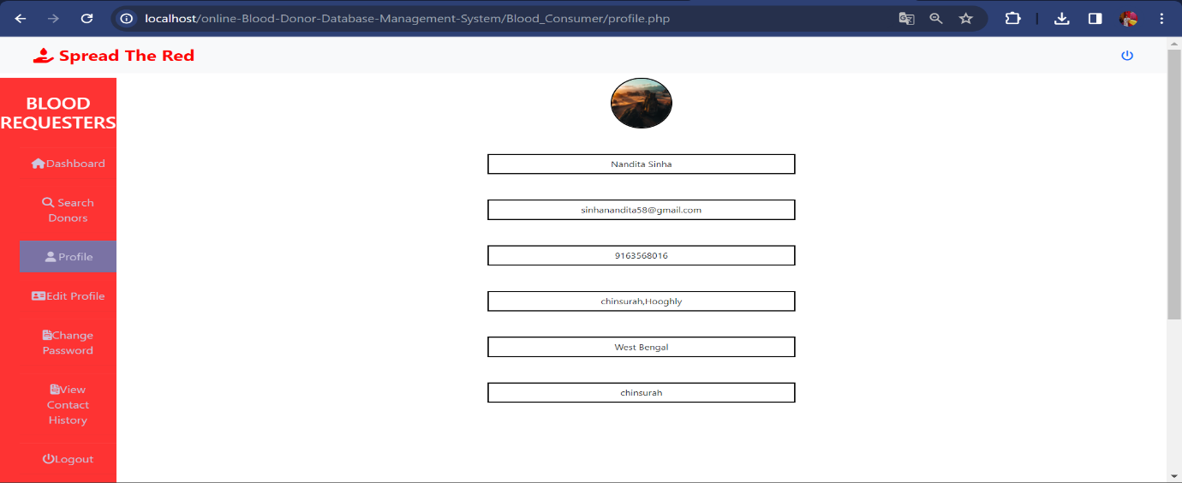

1. Member also will be able to edit their basic account details via ‘Edit Profile’ option.

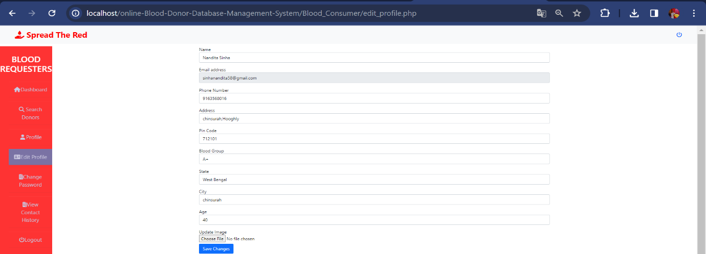

1. 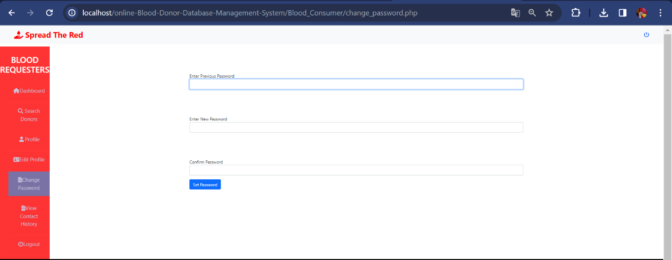Any time a member can change their password through the ‘Change Password’ option.
2. Forget password instructions



CLICK HERE



AFTER FILLING UP THE FORM CLICK HERE



COPY THIS OTP

COPY THIS OTP



PASTE THE OTP AND SUBMIT THE OTP TO CHANGE YOUR PASSWORD

**User Manual For**

**12.3 Admin:**

1. Admin can have a login form for entering to the admin panel. Where they can put their email address, and password.

If the credentials do not match, an error message will be displayed.

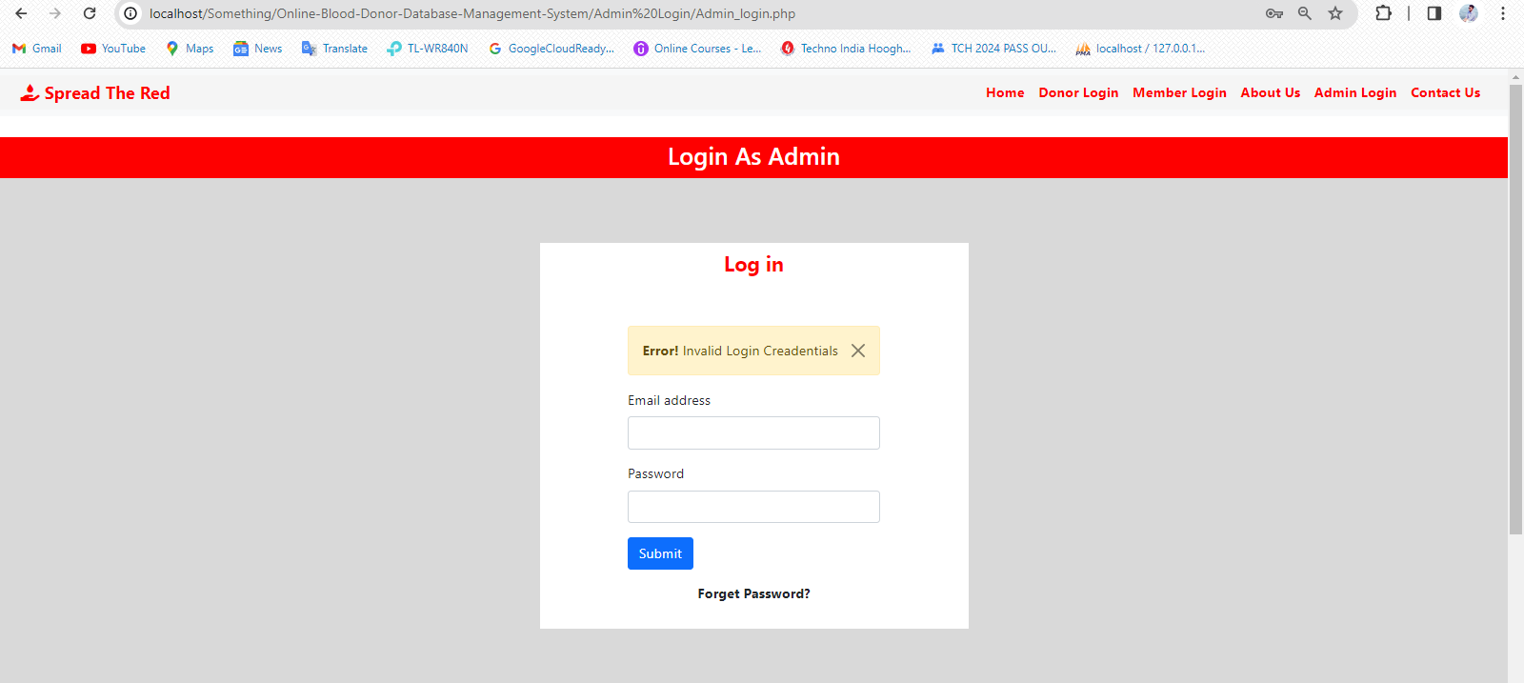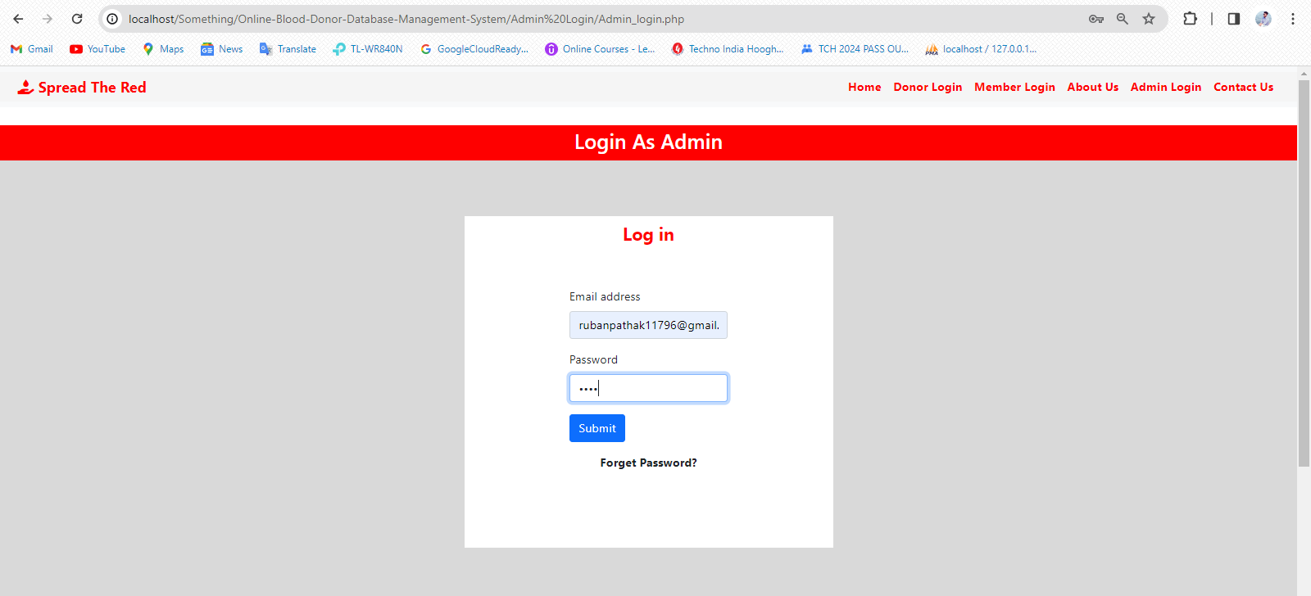

1. 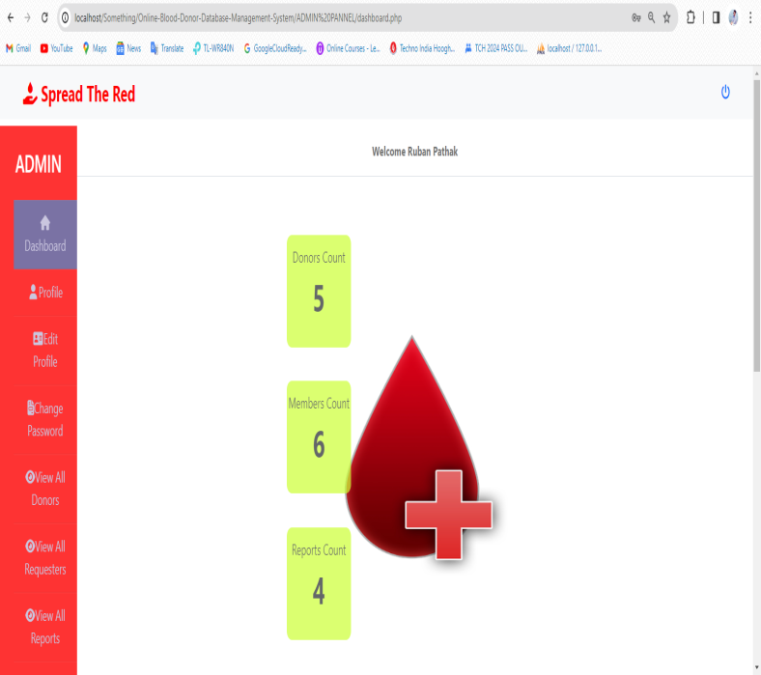Otherwise the login process is complete and the donor will be redirected to the Dashboard.

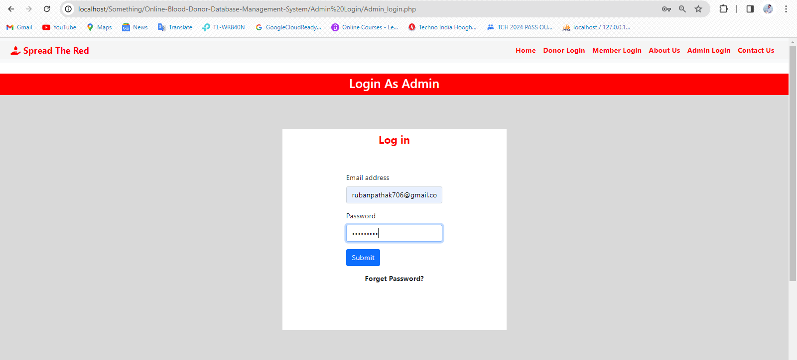

1. In the view all reports section all the reports can be seen and verified by Admin and the admin can sent warning or block or unblock the user.

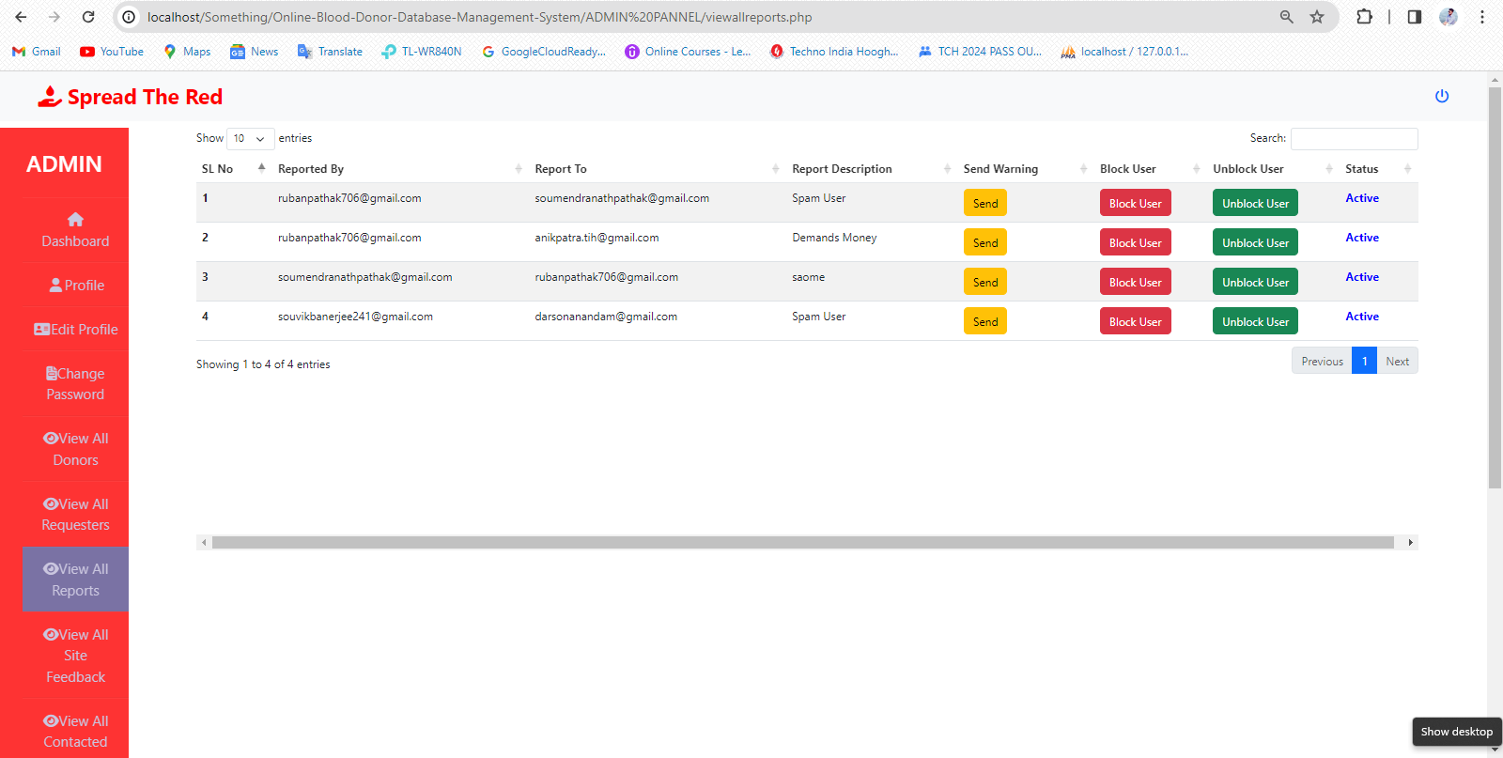

TO SENT A WARNING TO A USER CLICK ON THE SEND BUTTON

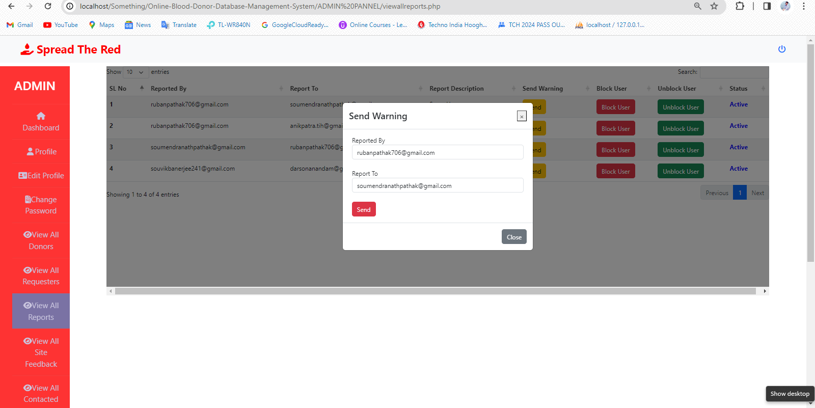

NEXT CLICK ON THIS BUTTON AND WAIT FOR SOME SECONDS

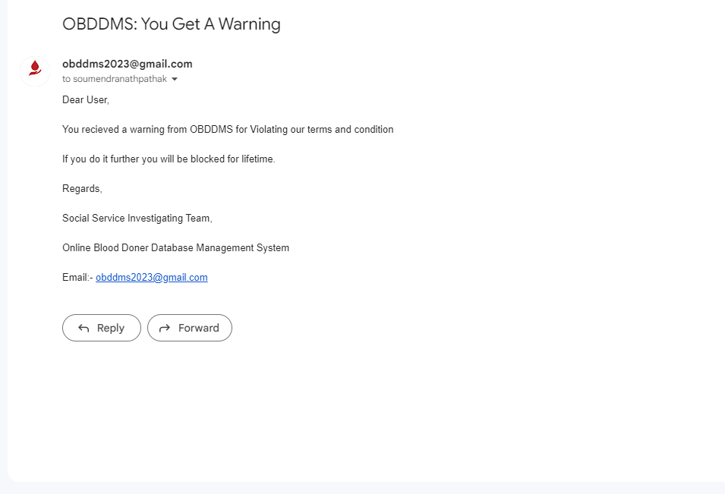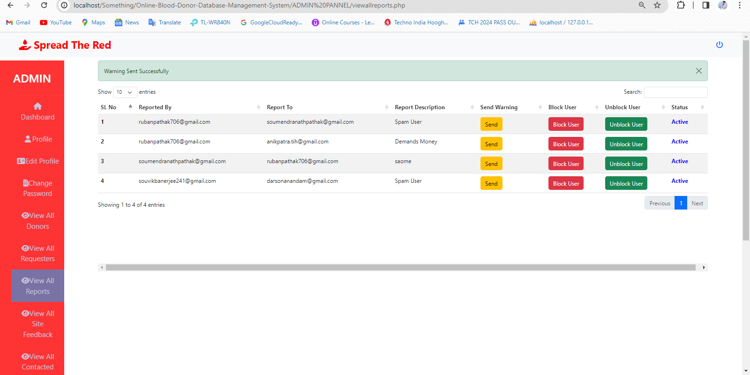



TO BLOCK AN USER CLICK ON THE BLOCK BUTTON

`

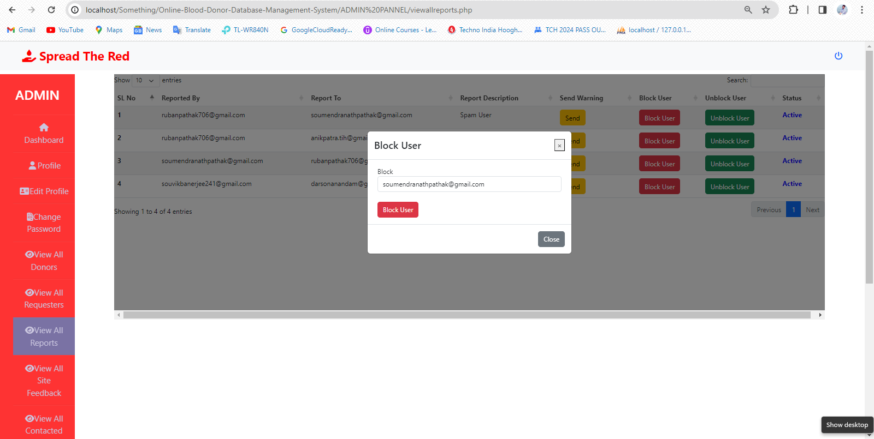

NEXT CLICK ON THIS

BUTTON AND WAIT FOR

SOME SECONDS

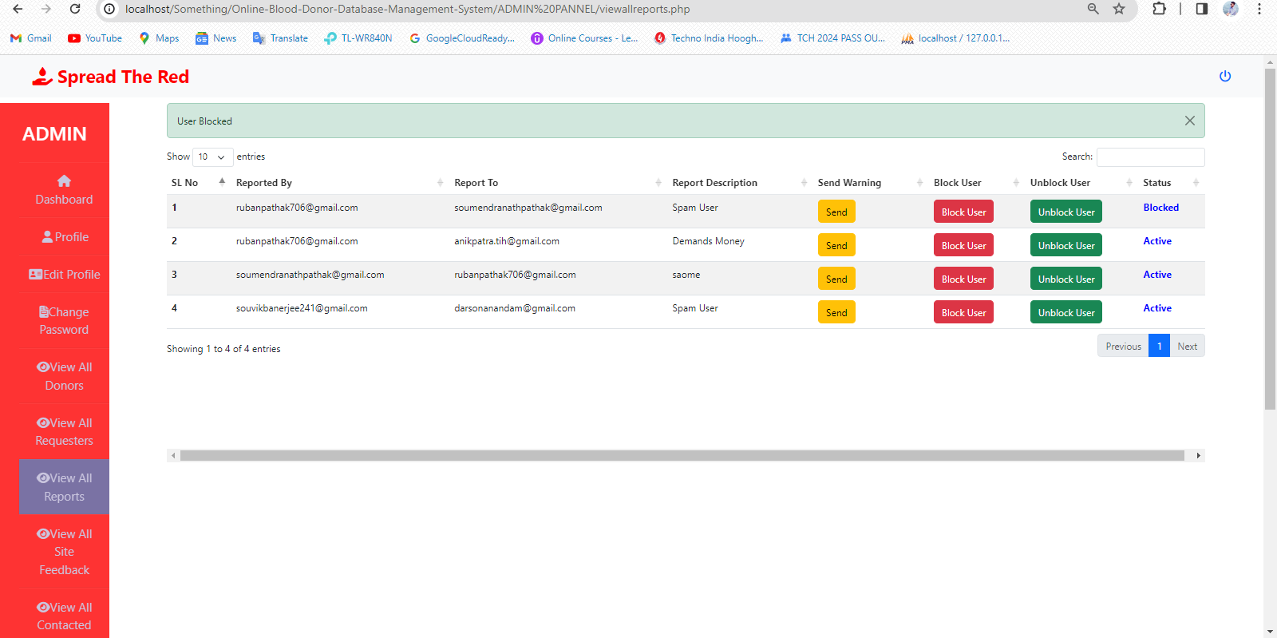

USER CAN BE BLOCKED AND STATUS CAN BE CHANGED TO BLOCKED

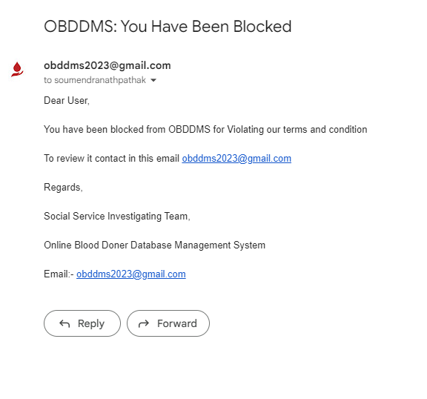

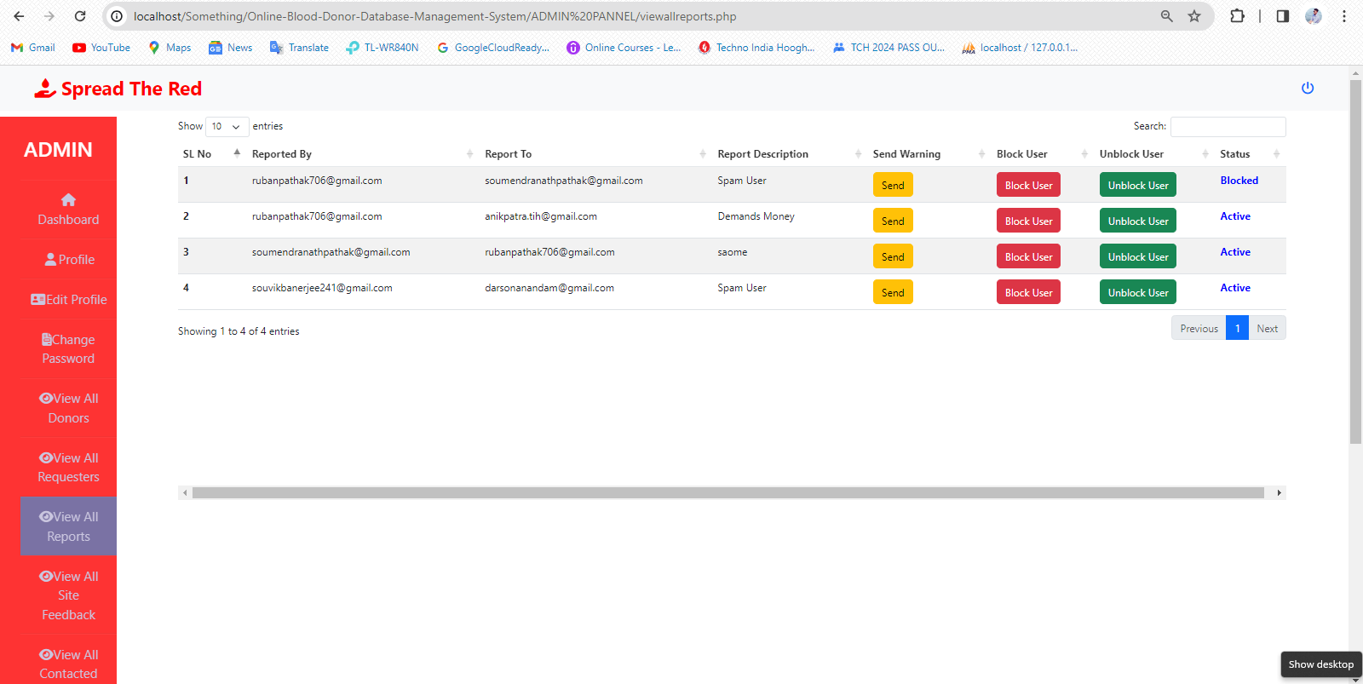

TO UNBLOCK AN USER CLICK ON THE UNBLOCK BUTTON

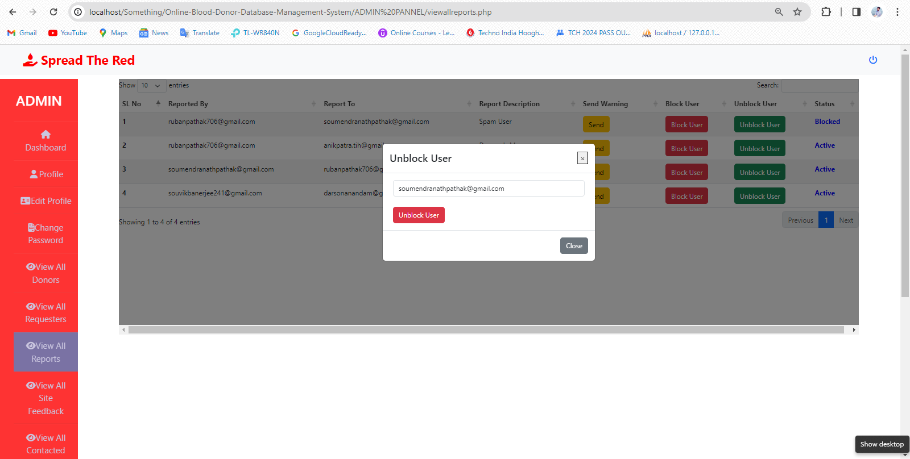

NEXT CLICK IN THIS BUTTON TO UNBLOCK AND WAIT FOR FEW SECONDS

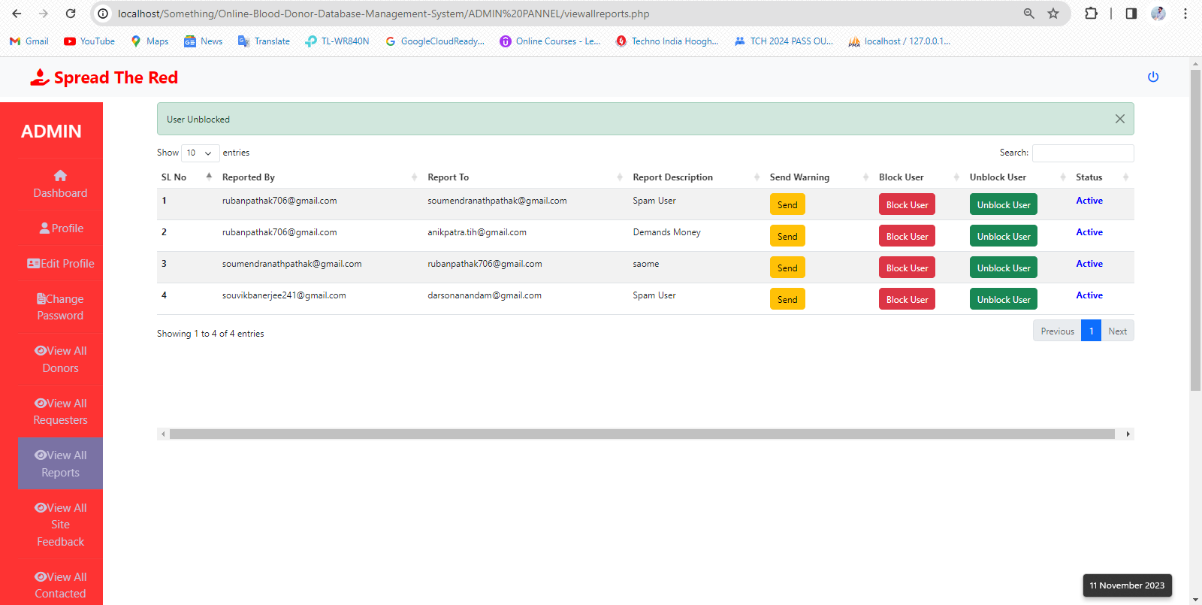

USER CAN BE UNBLOCKED AND THE STATUS CAN BE CHANGED

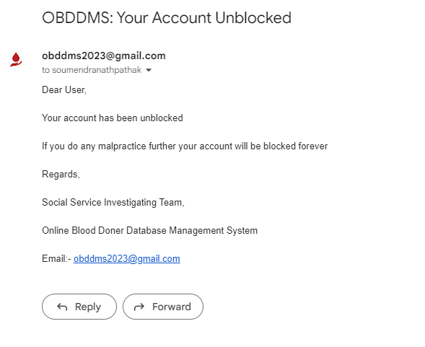

1. 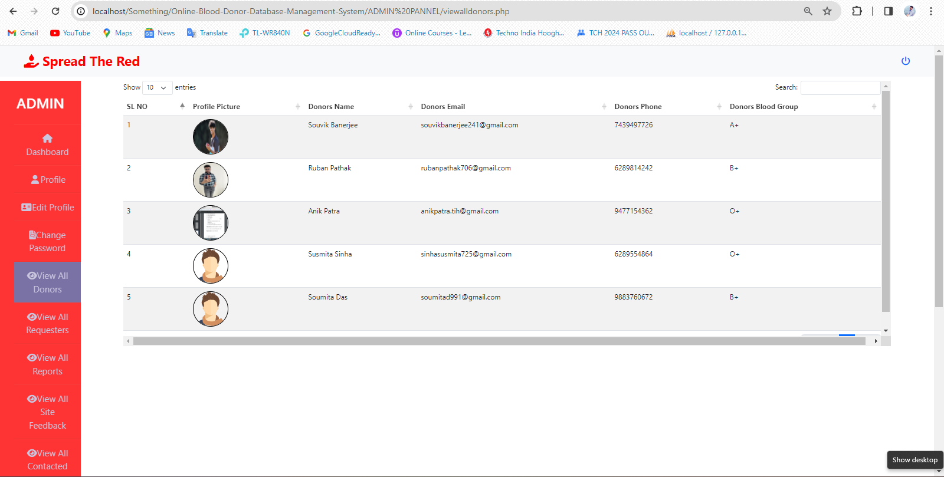Now, in the VIEW ALL DONORS section Admin can see all the donors .

1. In the VIEW ALL MEMBERS section Admin can see all the blood requesters.

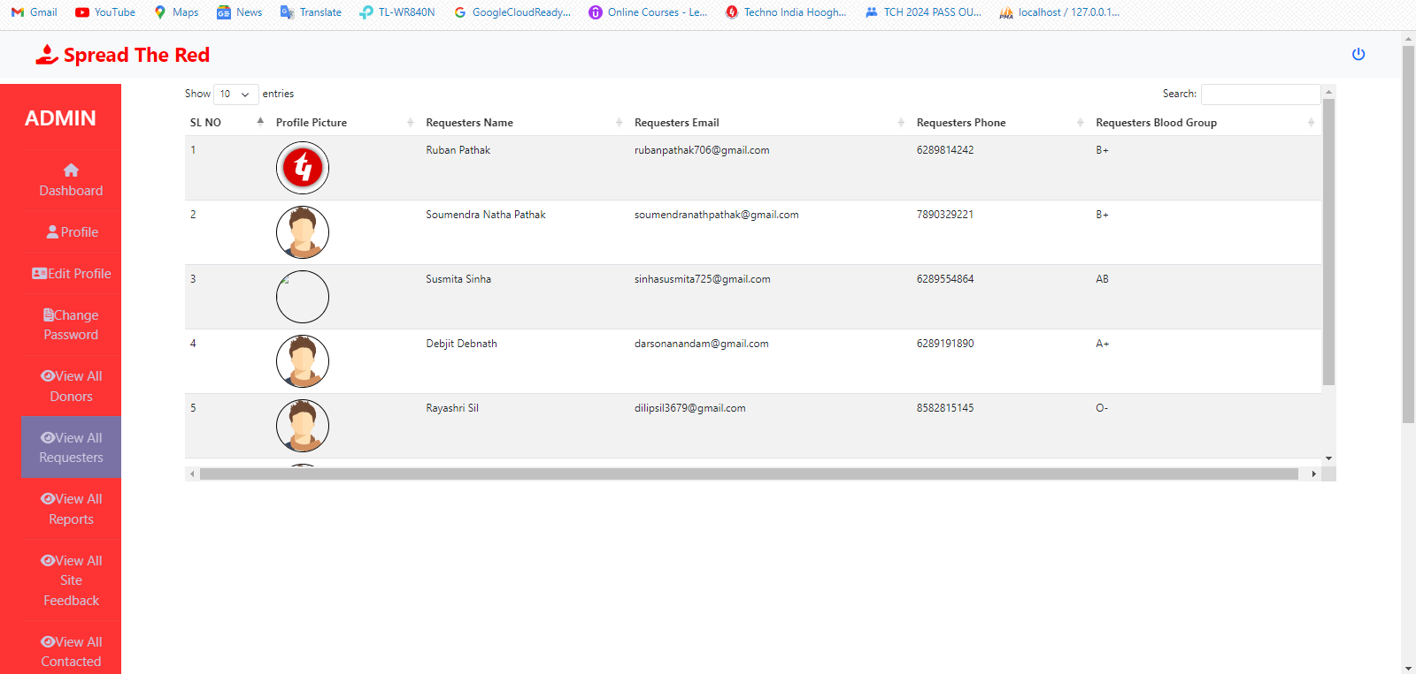

1. In the VIEW ALL SITE FEEDBACK section Admin can see all the feedbacks.



1. In the VIEW ALL CONTACTED PEOPLE section Admin can see all the donors and requesters can contacted with each other and the timings.

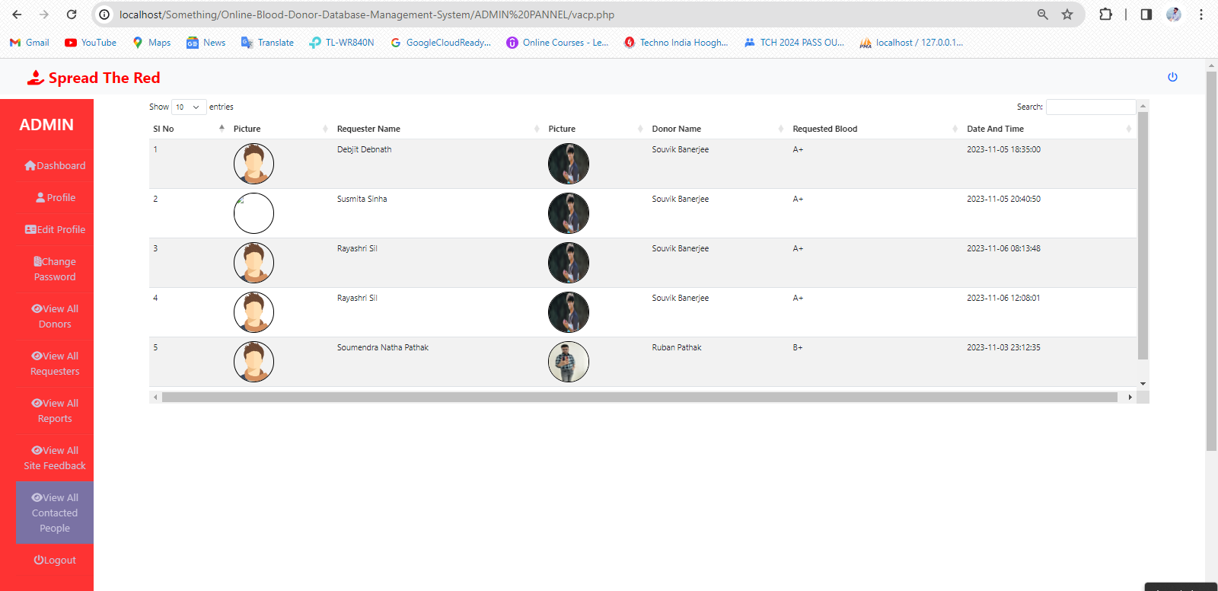

1. Admin can view their profile through the ‘Profile’ option.

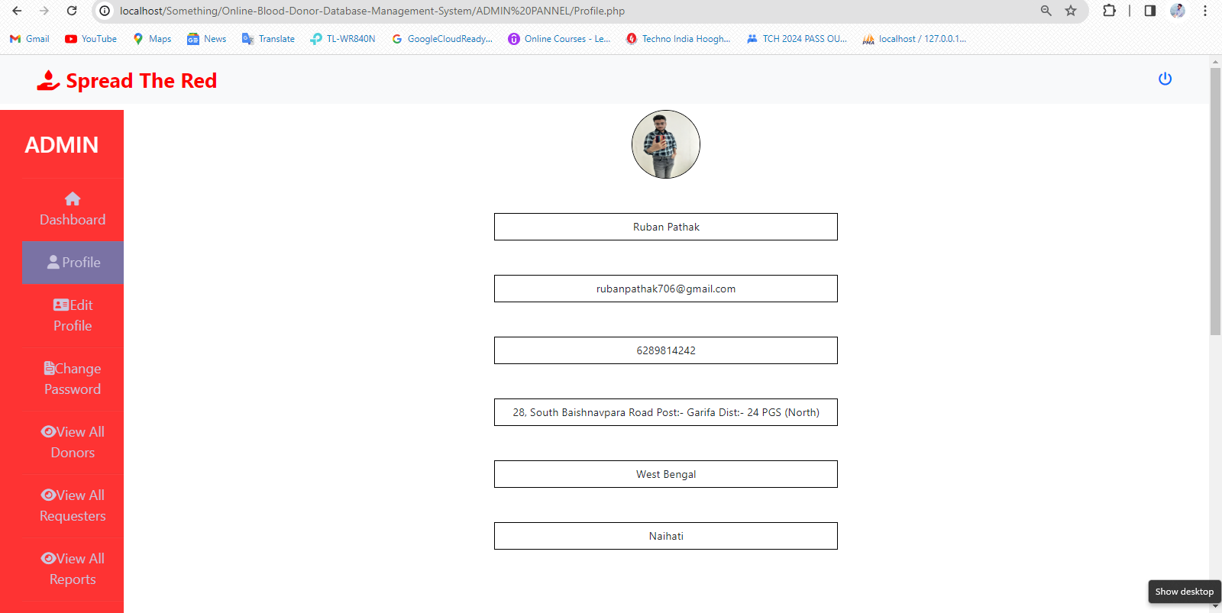

1. 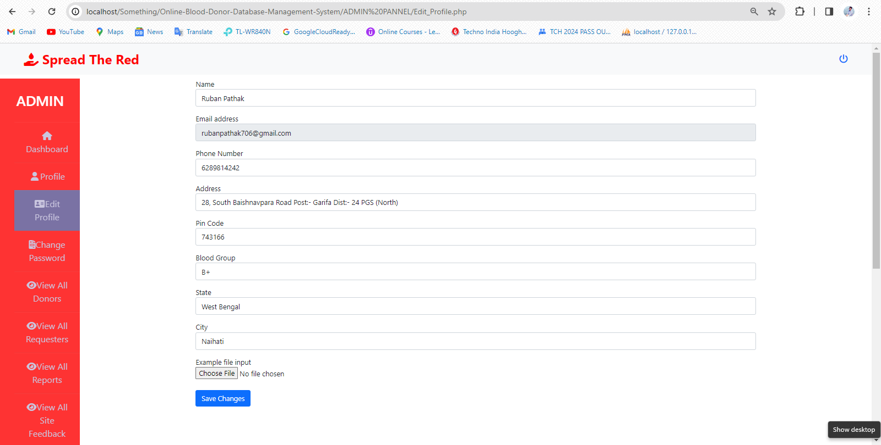Admin also will be able to edit their basic account details via ‘Edit Profile’ option.
2. Any time admin can change their password through the ‘Change Password’ option.

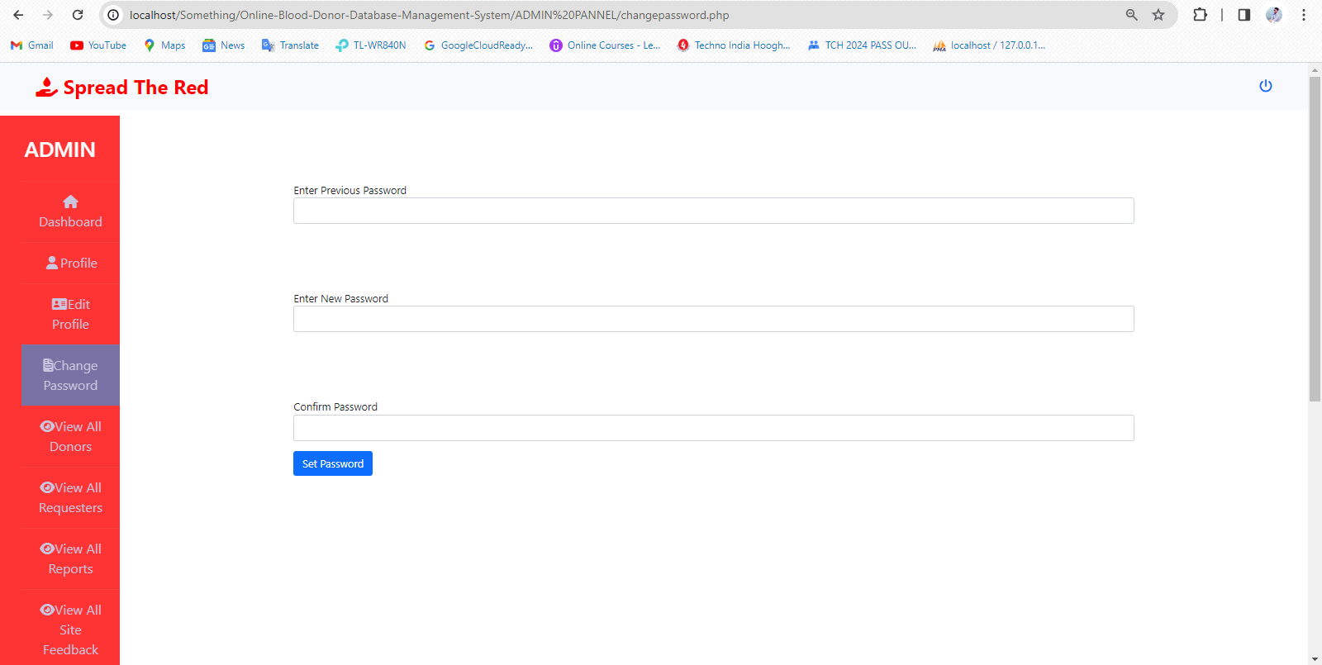

1. Admin can also change there password from forget password section.

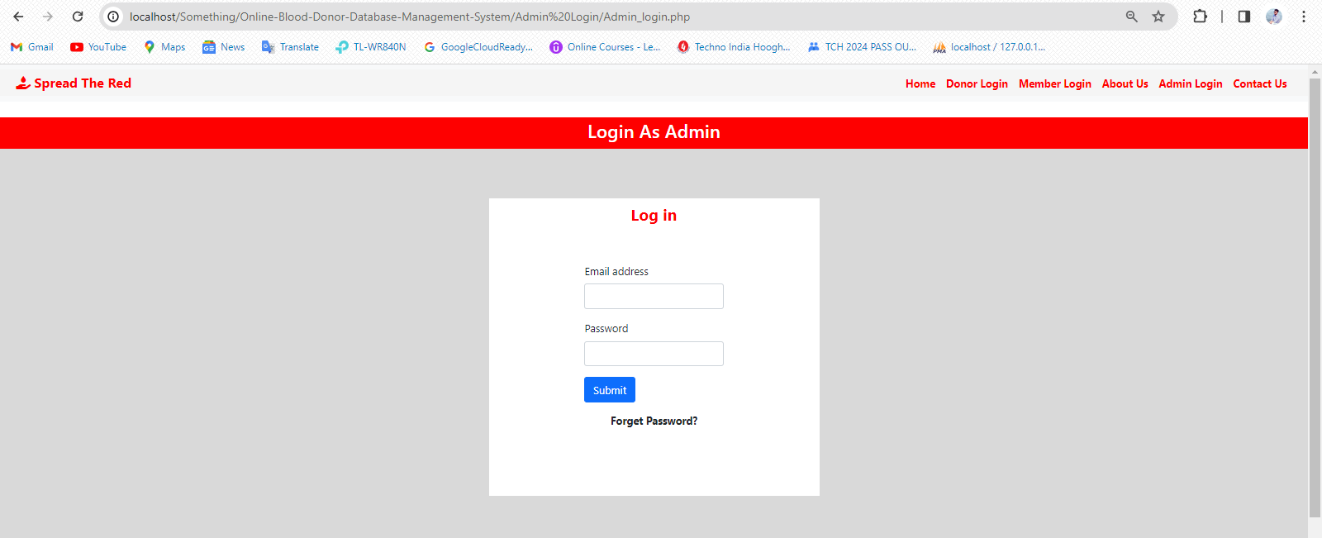

FIRST CLICK HERE



AFTER FILLING UP THE FORM CLICK HERE



COPY THIS OTP



PASTE THE OTP AND SUBMIT THE OTP TO CHANGE YOUR PASSWORD

PASTE THE OTP AND SUBMIT THE OTP TO CHANGE YOUR PASSWORD

**13 . Limitations and future scope:-**

In conclusion, the Software Requirements Specification (SRS) outlines the detailed requirements for an Online Blood Donor's Database Management System. The user interface is designed to provide an engaging experience with a clear navigation structure, motivational quotes, and user-specific login/signup options. The registration process involves verification through email and OTP for both blood donors and blood requesters (members).

The functional requirements cover various aspects, including header, body, footer sections, and specific functionalities for blood donors, blood requesters (members), and the admin. Users can navigate the platform, register, and access features based on their roles. The system ensures security and user verification through OTPs.

For blood donors and requesters (members), specific features are provided post-registration, allowing them to manage their profiles, search for donors, and request blood donations. The eligibility criteria for blood donors are clearly defined, and a contact history feature facilitates communication between donors and requesters.

The admin has a comprehensive set of features in the admin panel, including a dashboard displaying key metrics, the ability to view all donors, requesters, reports, site feedback, and contacted persons. The admin can review reports, issue warnings, and ensure the accuracy and integrity of the platform.

Overall, the SRS provides a detailed blueprint for the development of the Online Blood Donor's Database Management System, emphasizing user-friendly interfaces, secure registration processes, and comprehensive functionalities for donors, requesters (members), and the admin.

**14 . References:-**

[1] Frontend vs Backend Geeks For Geeks 18 Apr, 2023 contributed by palaksinghal9903 [https://www.geeksforgeeks.org/frontend-vs-backend/]

[2] 14 Days of Bootstrap 4 – Introduction April 11, 2022 by Cristina

Conacel [ https://bootstrapbay.com/blog/14-days-bootstrap-4/]

[3] Eloquent JavaScript: A Modern Introduction to Programming 3rd

Edition by Marijn Haverbeke [ Book Published: 4 December 2018]

[4] Modern PHP: New Features and Good Practices by Josh Lockhart

[ Book Published: Released February 2015]

[5] High Performance MySQL 3rd Edition by Baron Schwartz, Peter

Zaitsev, and Vadim Tkachenko [Book Published: March 2012]

[6] What is a feasibility study? [https://uk.indeed.com/career- advice/career-development/feasibility-study]

[7] Introduction to ms office project 2007 : Microsoft Ignite [https://learn.microsoft.com/en-us/previous-versions/office/]

[8] Fundamentals of Software Engineering, 5th Edition by Rajib Mall [ Book Published: 30 November 2018]

[9] Apache Spark in Action 2nd Edition by Jean-Georges Perrin [ Book Published: June 2, 2020 ]

**14 . Glossary:-**

1. SRS :- Software Requirement Specification

2. NGO :- Non-Governmental Organization

3. REQ :- Requirement

4. OBDDMS: Online Blood Donor’s Database Management System

5. OTP :- One Time Password

6. HTTP :- Hyper Text Transfer Protocol

7. SMTP :- Simple Mail Transfer Protocol

8. D.I :- Diabetes insipidus

9. H.G :- Hyperemesis gravidarum

10. K.G :- Kilogram

11. M.M :- Millimeter

12. NFR :- Non Functional Requirements

13. UX :- User Experience